02.13 Water Balance, 2022

Summary
How much rain seeps into the ground in the Tiergarten? How much evaporates from the Tempelhofer Feld? And how much ends up in the sewer system at Potsdamer Platz? These are some of the questions explored in this topic. It combines data from the DWD (Germany’s National Meteorological Service) and the BWB (Berlin’s water supply and wastewater treatment company) with detailed knowledge of local site conditions. For example, far more water infiltrates into the soil and evaporates in a park than on a paved parking lot.
Effective water management in a major city requires an understanding of where water infiltrates into the ground and where groundwater is recharged. To investigate this in detail, the city was divided into 25,000 individual areas. Using the Berlin Water Balance Model (ABIMO), six years of data were simulated to determine the long-term average fate of rainfall in the area.
Overall, nearly two-thirds of Berlin’s rainfall returns to the atmosphere through evaporation. Of the remaining amount, about two-thirds seeps into the ground, while the rest flows into the sewer system.
Berlin residents can also play a role in improving the city’s water balance. Green roofs, for example, encourage evapotranspiration by holding rainwater and preventing it from entering gutters and the sewer system. Their impact was included in the model starting in 2017.
The maps presented here for 2022 form part of the results from the AMAREX research project (AMAREX is the acronym for the German translation of ‘adaptation of stormwater management to extreme events’). This joint project is funded by the Federal Ministry of Research, Technology and Space (BMFTR) within the hydrological extreme events (WaX) funding programme (funding reference: 02WEE1624A-H). The initiative operates under the umbrella of the federal water programme Wasser: N and is part of the BMFTR’s Research for Sustainability Strategy (FONA).

For further findings from the AMAREX project beyond the scope of the water balance, see Environmental Atlas Map 02.25 (available in German only) or visit www.amarex-projekt.de/en.

Overview
A comprehensive understanding of the water balance is essential for planning and managing water resources in line with the principles of sustainability. In Berlin, this is particularly important because the city has comparatively limited water resources. There is a clear mismatch between the available supply, the number of the city’s inhabitants and their needs for drinking and service water, and the resulting wastewater volumes. For this reason, accurately quantifying the components of the water balance is crucial.
In addition:
- For surface water protection, it is important to estimate how much surface water is discharged into local water bodies, as rainwater can carry significant pollutant loads.
- For groundwater protection, it is important to understand the infiltration capacity of soils, since contaminants from polluted soils are largely transported through infiltrating water.
- For nature conservation and landscape management, it is important to assess the water available to vegetation from groundwater recharge and from capillary rise at the groundwater table.
The water an area receives through precipitation is distributed among the various components of the water balance in varying amounts, depending on climatic conditions and local characteristics. These components include evapotranspiration, surface runoff, sub-surface runoff (infiltration or groundwater recharge), and changes in water storage. The first parameter to be determined is total runoff, which represents the sum of surface and sub-surface runoff.
According to the general water balance equation, total runoff equals the difference between precipitation and actual evapotranspiration. In this calculation, evapotranspiration is the key factor and, under natural conditions, is largely controlled by vegetation, climate, and soil characteristics.
In urban areas, actual evapotranspiration is strongly influenced by local conditions and can differ markedly from that in the surrounding countryside. Buildings and paved surfaces greatly reduce the amount of water returned to the atmosphere compared with vegetated areas. While plants continuously release moisture through their foliage via transpiration, only a small fraction of rainwater remains on buildings and paved surfaces, where it can evaporate. As a result, total runoff is much higher in urban areas than in vegetated areas.
In Berlin, green roofs have increasingly been used in recent years as a measure of rainwater management. They help reduce runoff and provide additional surfaces for evapotranspiration. To account for this effect, Berlin’s green roofs (see Environmental Atlas Map 06.11) have been included in the Environmental Atlas water balance maps since 2017.
The maps presented here for 2022 form part of the results from the AMAREX research project (AMAREX is the acronym for the German translation of ‘adaptation of stormwater management to extreme events’). This joint project is funded by the Federal Ministry of Research, Technology and Space (BMFTR) within the hydrological extreme events (WaX) funding programme (funding reference: 02WEE1624A-H). The initiative operates under the umbrella of the federal water programme Wasser: N and is part of the BMFTR’s Research for Sustainability Strategy (FONA).
The Berlin Water-Balance Model ABIMO 3.2 (AbflussBIldungsMOdell) was released as open-source software prior to the start of the project (https://github.com/umweltatlas/abimo, available in German only). During the project, ABIMO 3.2 was extensively tested and further developed by the Berlin Centre of Competence for Water (KWB) (https://www.kompetenz-wasser.de/en). The following presents key developments and newly introduced parameters, which are discussed in more detail in the Methodology section:
- Validation of the model’s calculations by comparing them with discharge data from Berlin’s wastewater treatment plants (see Excursus).
- Conversion of the former C++ application into an R-based version.
- Separate water balance modelling for block (segment) areas and road areas.
- Correction of an error in the earlier infiltration calculation for block (segment) areas containing both road and non-road surfaces, which had led to an overestimation of the proportion of pervious surfaces.
- Integration of the influence of green roofs into the water balance modelling of the R-based application.
- Option to include the effects of infiltration basins (these were not shown in the citywide maps due to insufficient data; however, the AMAREX Webtool allows users to incorporate infiltration basins into their planning).
- Use of the Green Volume Number (GVZ) from 2020 (see Environmental Atlas Map 05.09) to determine specific evaporation parameters for each block (segment) or road area, replacing the previous standard assignment by land-use category.
- Development of the new parameter ΔW (Delta W), expressing the deviation of the water balance from natural conditions as a percentage.
- Generalisation of the model logic to improve its transferability to other locations (Berlin-specific input variables, such as urban structure type and land-use category, were removed. Instead, parameters derived from these, such as yield and irrigation, were included directly as input variables. This allowed the model to be successfully transferred and applied to the city of Cologne.)
- Development of the AMAREX Webtool (https://amarex-staging.netlify.app/amarex, available in German only): a planning tool that enables users to select any area within Berlin and apply various measures, such as removing impervious soil covers, adding green roofs, or connecting areas to infiltration basins. For the selected measures chosen for planning, the tool displays water-balance parameters both for the current situation and the scenario after implementation. Results can be saved, reloaded, and printed as a report.
The version of ABIMO that was further developed within the AMAREX project is published at https://github.com/KWB-R/kwb.rabimo.
For further findings from the AMAREX project beyond the scope of the water balance, see Environmental Atlas Map 02.25 (available in German only) or visit www.amarex-projekt.de/en.
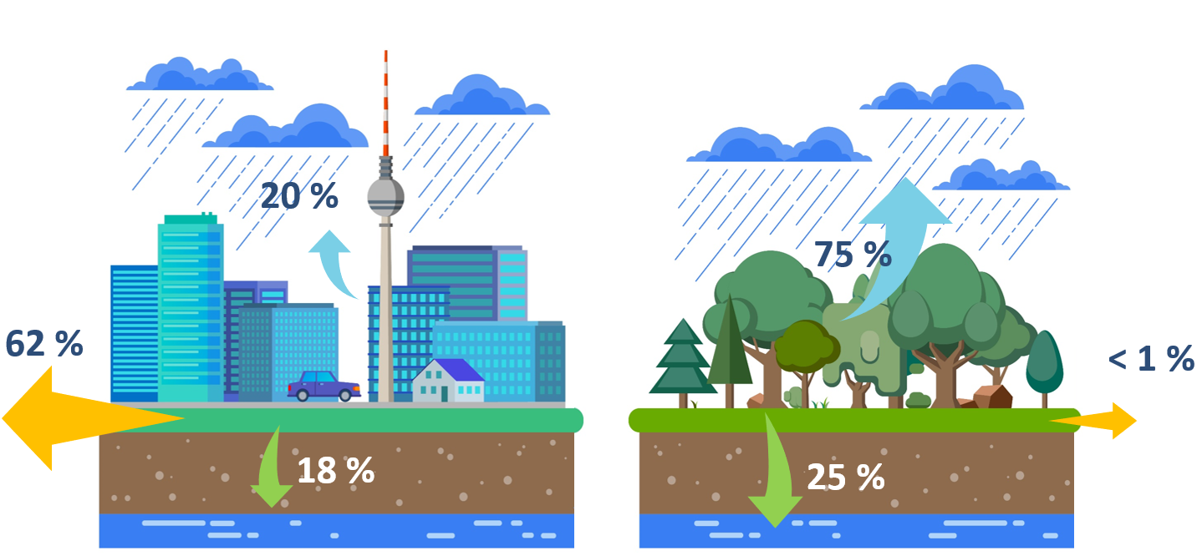
Fig. 1: Typical water balance for impervious versus vegetated surfaces (blue arrows: evapotranspiration; yellow arrows: surface runoff; green arrows: infiltration) (© KWB)
Total runoff is the best parameter to capture hydrological conditions of individual sections and catchment areas. For a catchment with defined boundaries, the sum of the runoff generated by all sections corresponds to the total surface and sub-surface runoff of the area, representing the available water resources.
In urban areas with impervious surfaces, part of the total runoff reaches watercourses directly via discharge points, or indirectly through wastewater treatment plants, depending on whether these surfaces are connected to the sewer system. (Translator’s note: ‘sewer system’ refers throughout this document to combined or separate sewer systems, with the focus on rainwater rather than wastewater.) The remaining runoff infiltrates into the ground at the edges of impervious areas or within partially permeable areas, percolating into deeper soil layers below the zone influenced by evaporation and thereby recharging the groundwater. Where sewer system information is available, infiltration and groundwater recharge can be determined by subtracting the volume of water discharged into the system from the total runoff.
The resulting values for infiltration and surface runoff are primarily relevant for water management purposes and form important parameters for describing the urban water balance.
When assessing soil performance for precautionary soil protection or evaluating environmental impacts under the Federal Nature Conservation Act (BNatSchG), the infiltration rate of pervious or unpaved soils plays a key role. This parameter allows, on the one hand, the identification of differences in soil infiltration capacity, and on the other, an assessment during the planning process of how impervious surface materials might affect the infiltration capacity within a given planning area. Such assessments cannot be made using the values shown in Map 02.13.2 (Percolation from Precipitation), since the reference areas depicted represent averages for segments containing both impervious and pervious surfaces – including portions that are connected to the sewer system and those that are not.
For this reason, in addition to Map 02.13.2, infiltration on pervious surfaces has been separately determined and illustrated in Map 02.13.4. The maps show precipitation infiltration without taking impervious cover into account. Within the framework of the AMAREX research project, the assumptions underlying this representation were revised. As before, the proportion of impervious cover was set to 0 % for all areas. In addition, for areas that are impervious in reality, an urban park area with a mix of vegetated and tree-covered surfaces was assumed. For vegetated areas with higher vegetation intensity (previously indicated by the parameter ‘yield class’) than an urban park, such as forests, no changes were made. The infiltration of precipitation on pervious soils is represented in the Regulatory Function for the Water Balance Map (Environmental Atlas Map 01.12.4), which is part of the broader Soil Functions mapping.
According to the technical rule DWA M 102-4, deviations from the natural water balance should be kept to a minimum in new development projects. To quantify such deviations, the AMAREX research project developed the parameter ΔW (Map 02.13.6), based on the three water-balance components: surface runoff, evapotranspiration, and infiltration. This parameter expresses the percentage deviation from the water balance of a natural reference scenario, defined as an urban park area with a mix of vegetated and tree-covered surfaces. By definition, the reference scenario is pervious or unpaved and undeveloped.
Groundwater recharge refers to the process by which infiltrating precipitation contributes to groundwater formation. The volume of groundwater recharge differs from the total amount of percolating water, as it is reduced by the fraction of interflow, the portion of runoff that moves laterally through the upper soil layers into receiving waters.
Understanding the magnitude of groundwater recharge is particularly important given expected changes to the water balance resulting from climate change. It is a key factor for the long-term, sustainable use of groundwater resources and is also essential for assessing the potential risk of pollutant transport from the unsaturated zone into the groundwater (Verleger & Limberg 2013; Löschner 2008).

Statistical Base
The data used to calculate runoff volumes was provided by the Berlin Urban and Environmental Information System (ISU5, 2020) for around 25,000 block (segment) areas, and for the first time also for roughly 32,000 road areas within the ISU spatial reference system.
The 2020 land-use data is based on the evaluation of aerial imagery and additional geodata (see Environmental Atlas maps 06.01, 06.02 and 06.08). It distinguishes 22 land-use categories and 52 area types. This information plays an important role in the water-balance model. Where location-specific data is not available for core input parameters, standard averages for each land-use category or area type are applied at block or block-segment level. For 2022, this mainly concerns the allocation of sewer system connection rates (see below).
As part of the AMAREX research project, the ABIMO model’s evapotranspiration parameters were assigned to each block (segment) and road area on the basis of the Green Volume Number (GVZ) from 2020 (see Environmental Atlas Map 05.09). This replaced the previous standard assignment based solely on land use.
Long-term mean precipitation for the period from 1991 to 2020, including both annual averages and averages for the summer season (May to October), were aggregated from HYRAS-DE-PRE data provided by Germany’s National Meteorological Service (DWD) for block (segment) and road areas (see Environmental Atlas Map 04.08). These were then used in the water-balance modelling.
Long-term means of potential evapotranspiration, calculated using the TURC method and increased by 10 %, were derived from climate station observations across the Berlin region. For the city area, borough-level averages between 660 and 672 millimetres per year and between 505 and 513 millimetres for the summer season (May to October) were assigned.
The degree of impervious coverage was determined using multiple methods: evaluating ALKIS data (Official Real Estate Cadastre Information System) for built-up impervious areas, analysing high-resolution multispectral satellite imagery and other geodata for undeveloped impervious areas, and assessing road-survey data for road areas collected for the Environmental Atlas (see Environmental Atlas Map 01.02, 2021). The dataset distinguishes between built-up impervious areas (roof areas) and undeveloped impervious areas (such as parking lots and footpaths). For undeveloped impervious areas, the proportion of each surface material present was an important input variable. The materials were grouped into four pavement classes, and five classes for road areas (see Table 2). They were measured in the field at representative sites for each area type and then applied to all block (segment) areas of the same type.
The soil-scientific characteristic data on the available water capacity of soils in the shallow-root zone (0 to 30 cm) and the deep-root zone (0 to 150 cm) was taken from the Soil Association Map of Berlin – Available Water Capacity of Soils (see Environmental Atlas map 01.06.2, 2020).
Water table measurements from 2009 were used, representing a year with average groundwater levels (see Environmental Atlas Map 02.07).
Information on the sewer system was taken from the Map Management of Rain and Waste Water (see Environmental Atlas Map 02.09, 2022). For the first time, block (segment) areas were evaluated based on connection points, recording whether rainwater from each block (segment) area is discharged into the sewer system. In addition, data from the BWB (2022) was used to assess road areas for the first time, showing whether a road section is connected to the sewer system. As the classification was carried out at block (segment) level, all impervious surfaces within a block (segment) area are treated as connected to the sewer system in the water-balance model, even though, some parts may not actually be connected. This also applies to areas subject to decentralised rainwater management, for which no comprehensive Berlin-wide data was available at the time of mapping.
The Type of Drainage Map does not indicate the extent to which rainwater from built-up or impervious areas is actually discharged into the sewer system. To address this, an in-depth analysis was carried out for the 2005 water-balance mapping. Two data sources were available for estimating actual sewer system connection rates. The first was the set of standard values for each area type determined in a 1997 diploma thesis by Bach. The second data source was compiled by the BWB as part of the reorganisation of the wastewater charge structure. This involved a property-level survey of impervious areas, distinguishing between those connected and not connected to the sewer system. The aim of the survey was to allocate the costs of rainwater disposal as accurately as possible according to the polluter-pays principle. This data was also captured in mapped form and aggregated to the reference areas of the ISU spatial reference system before being shared with the Senate Department. However, analysis revealed that the BWB’s mapped data did not cover the entire city. Therefore, the raw data could not be used in the Environmental Atlas water-balance model without further processing. Based on the assumption that the connection rate is closely linked to the age and structure of built-up areas, means were therefore calculated for each area type using the BWB data, combined with the urban structure type maps covering the entire urban area (see Environmental Atlas maps 06.07 and 06.08, 2010). These means were then applied as standard parameters to all areas connected to the sewer system of the same area type. The results are summarised in Table 1. A comparison of these values with those determined by Bach (1997) showed good overall agreement. Only the connection rates for some of the undeveloped impervious areas in green and open spaces with little or no building development deviated significantly from Bach’s figures. Since the analysis of the BWB dataset indicated that undeveloped impervious surfaces – especially in these areas – were poorly or incompletely recorded, Bach’s original values were retained for this urban structure type. The actual connection rates for road areas could, for the first time, be adopted without modification from the BWB (2022) data. Where a road section was identified in this dataset as connected to the sewer system, it was included at 100 % in the water-balance modelling. Table 1 presents the standard connection rates by area type that were incorporated into the 2022 water-balance calculations.
Type | Area type | Connection rate – built-up impervious areas | Connection rate – undeveloped impervious areas
1 | Dense block development, closed rear courtyard (1870s - 1918), 5-6 storeys | 98 | 75
2 | Closed block development, rear courtyard (1870s - 1918), 5 storeys | 95 | 70
3 | Closed and semi-open block development, decorative and garden courtyard (1870s-1918), 4 storeys | 85 | 55
6 | Mixed development, semi-open and open shed courtyard, 2-4 storeys | 75 | 54
7 | De-cored block-edge development, post-war gap closure | 94 | 65
8 | Heterogeneous inner-city mixed development, post-war gap closure | 94 | 75
9 | Large estate with tower high-rise buildings (1960s-1980), 4-11 storeys and more | 95 | 64
10 | Block-edge development with large quadrangles (1920s-1940s), 2-5 storeys | 93 | 46
11 | Free row development, landscaped residential greenery (1950s-1970s), 2-6 storeys | 86 | 50
12 | Old school (built before 1945) | 87 | 66
13 | New school (built after 1945) | 90 | 68
16 | Sport facility, covered | 68 | 51
17 | Sport facility, uncovered | 99 | 83
21 | Village-like mixed development | 49 | 46
22 | Row houses and duplex with yards | 49 | 41
23 | Detached single-family homes with yards | 38 | 30
24 | Villas and town villas with park-like gardens (mostly 1870s-1945) | 56 | 45
25 | Densification in single-family home area, mixed development with yard and semi-private greening (1870s to present) | 60 | 38
27 | Cemetery | 63 | 56
29 | Core area | 94 | 84
30 | Commercial and industrial area, large-scale retail, sparse development | 76 | 70
31 | Commercial and industrial area, large-scale retail, dense development | 86 | 80
32 | Utility area | 82 | 78
33 | Non-residential mixed use area, sparse development | 73 | 62
36 | Tree nursery / horticulture | 55 | 59
37 | Allotment garden | 59 | 54
38 | Non-residential mixed use area, dense development | 86 | 82
41 | Security and order | 82 | 75
43 | Administrative | 88 | 77
44 | University and research | 82 | 66
45 | Culture | 89 | 70
46 | Hospital | 73 | 61
47 | Children’s day care centre | 89 | 48
49 | Church | 76 | 57
51 | Other youth facility | 64 | 49
53 | Park / green space | 71 | 60
54 | City square / promenade | 84 | 72
55 | Forest | 0 | 0
56 | Agriculture | 0 | 0
57 | Fallow area | 71 | 67
58 | Camping ground | 99 | 52
59 | Weekend cottage and allotment-garden-type area | 70 | 67
60 | Other and miscellaneous public facility / special use area | 81 | 69
72 | Parallel row buildings with architectural green strips (1920 - 1930s), 2-5 storeys | 80 | 46
73 | Rental-flat buildings of the 1990s and later | 76 | 55
91 | Parking area | 70 | 68
92 | Railway station and railway ground, without track area | 86 | 78
93 | Airport | 99 | 92
94 | Other traffic area | 84 | 66
98 | Construction site | - | -
99 | Track area | 73 | 70
100 | Body of water | 0 | 0
 | Road areas | 100 | 100
Tab. 1: Actual sewer system connection rates of impervious areas, by differentiated area type in Berlin (analysis as of 2012; area types as of 2010; connection rates from 1997 and 2003; includes road areas from the BWB)
To incorporate green roofs, the model used approximately 550 hectares of extensive and intensive roof greenery, as shown on Environmental Atlas Map 06.11 (2020).

Methodology
In the mid-1990s, a model was developed, programmed, and applied in collaboration with the Federal Institute of Hydrology (Berlin Branch) to calculate the key components of the water balance.
The water-balance model ABIMO, designed by Glugla, was based on models originally developed in the 1970s to calculate available groundwater resources. It was subsequently expanded with modules to address the specific conditions of urban environments. This development was supported by expert reviews performed by the TU Berlin’s Institute of Ecology (Soil Science), and by a diploma thesis completed at the FU Berlin’s Department of Geography. The computational implementation, carried out by an external software company, was also adapted to the particular data environment of Berlin. Since 2022, ABIMO has been available as open-source software (version 3.2) at https://github.com/umweltatlas/abimo (available in German only).
As part of the AMAREX research project, ABIMO 3.2 was further developed, including the conversion of the application from C++ to R. This updated version is also available as open-source software at https://github.com/KWB-R/kwb.rabimo. The updated model was used to revise the 2022 water-balance maps. An overview of the workflow is shown in the 2025 Flow Chart.
The calculation process first determines actual evapotranspiration, in order to compute total runoff (precipitation minus evapotranspiration). In a second step, surface runoff is calculated as part of the total runoff. The difference between total runoff and surface runoff represents the infiltration component. Figure 2 illustrates the complexity of this process.

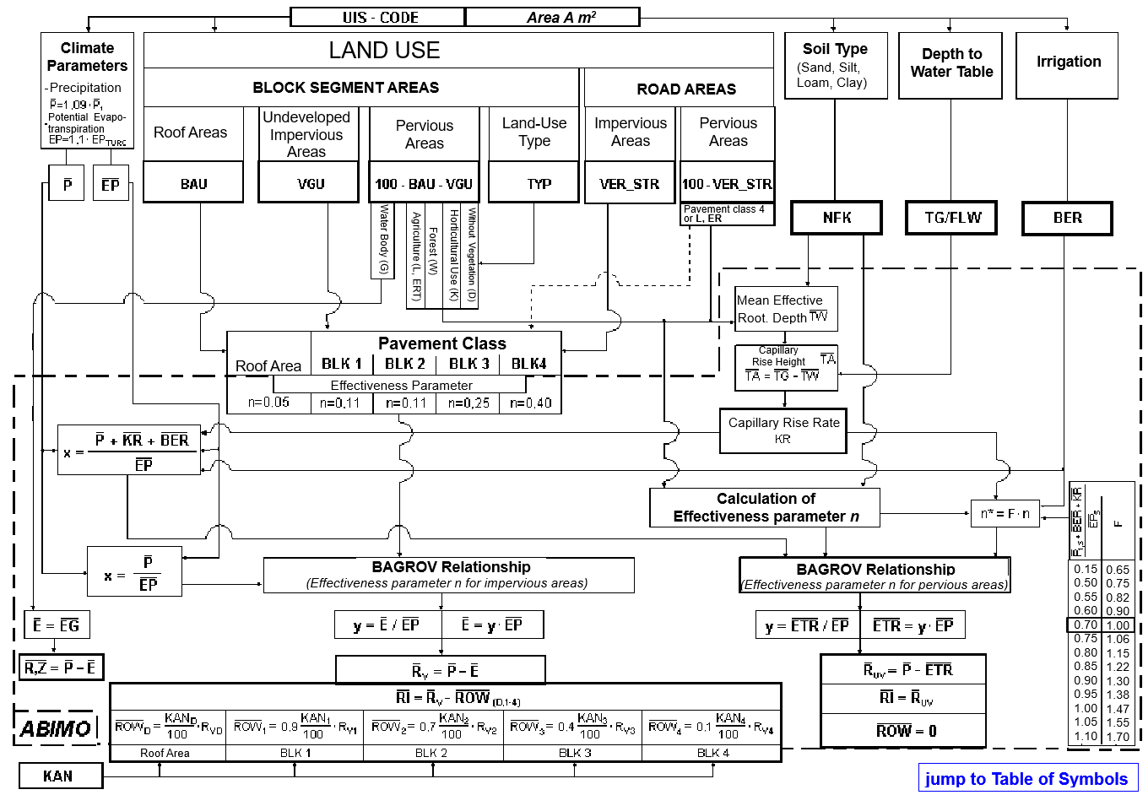

Annual means (mm/a)
 | precipitation (measured at 1 m above ground)
 | ground-level precipitation
 | capillary rise from shallow ground water
 | potential evapotranspiration $\overline{EP}= 1.1 ×{\overline{EP}}_{TURC}$)
 | actual evapotranspiration from vegetated areas
 | evaporation from bodies of water
actual evaporation from impervious areas and areas without vegetation
(incl. water bodies)
 | irrigation amount
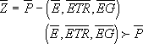 | abstraction from groundwater and surface water sources
 | total runoff (impervious area)
 | total runoff (pervious area)
 | rainwater and/or snowmelt runoff from impervious areas into the sewer system (receiving waters)
 | infiltration into the soil (below the zone influenced by evaporation)

Impervious areas (in %)
BAU | roof area
VGU | courtyard and paved area (undeveloped impervious area)
VER_STR | road area
BLK 1, ..., 4 | pavement class of undeveloped impervious areas
KAN | percentage of impervious areas connected to the sewer system
Land use of pervious areas
L | agricultural use (incl. pastures)
W | forest use (assuming an even age-class distribution)
K | horticultural use (model assumption: BER = 75 mm/a)
D | area without vegetation
G | water body
Soil type
NFK | available water capacity of soils (difference between water capacity of soils (in vol%) and permanent wilting point)
S, U, L, T | specification of soil type (sands, silts, loams clays;
N, H | low-moor bog, raised bog) for determining capillary rise
Depth to groundwater and capillary rise
TG | depth to the water table (expressed as FLW in m) for determining the capillary rise (KR)
TA | capillary rise height (in m), TA = TG - TW
TW | mean extraction depth / mean effective rooting depth (in m)
Fig. 2: Flow chart of the ABIMO model (modified from Bach, 1997)
Total runoff is estimated by subtracting actual evapotranspiration from the long-term annual mean precipitation. Actual evapotranspiration reflects average conditions across sites and regions and depends mainly on precipitation, potential evapotranspiration, and the average storage capacity of the surfaces where evapotranspiration takes place. When moisture is sufficient in these surfaces, actual evapotranspiration approaches potential levels, with greater storage capacity (such as higher soil water retention or deeper rooting) leading to higher evapotranspiration rates.
The relationship between the long-term means of actual evapotranspiration on the one hand and precipitation, potential evapotranspiration, and site evapotranspiration effectiveness on the other conforms to the Bagrov relationship (see Glugla et al. 1971, 1976; Bamberg et al. 1981; Fig. 3). This relationship, derived from long-term lysimeter experiments, expresses how actual evapotranspiration responds nonlinearly to precipitation, depending on site characteristics. Based on the Bagrov relationship, and given the climatic parameters precipitation P and potential evapotranspiration EP (expressed as the P/EP ratio), together with the site-specific effectiveness parameter n, the ratio of actual to potential evapotranspiration (ER/EP) can be determined. This makes it possible to calculate actual evapotranspiration ER for sites and regions not influenced by groundwater. For areas affected by groundwater, a modified version of the Bagrov method is applied, which adds the mean capillary rise from the groundwater to the precipitation input.

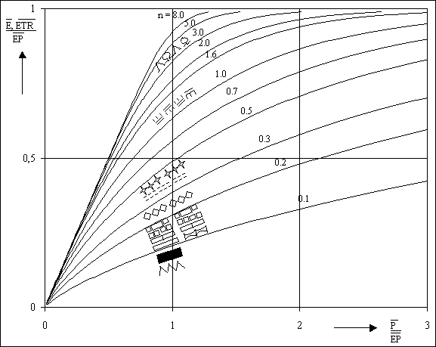
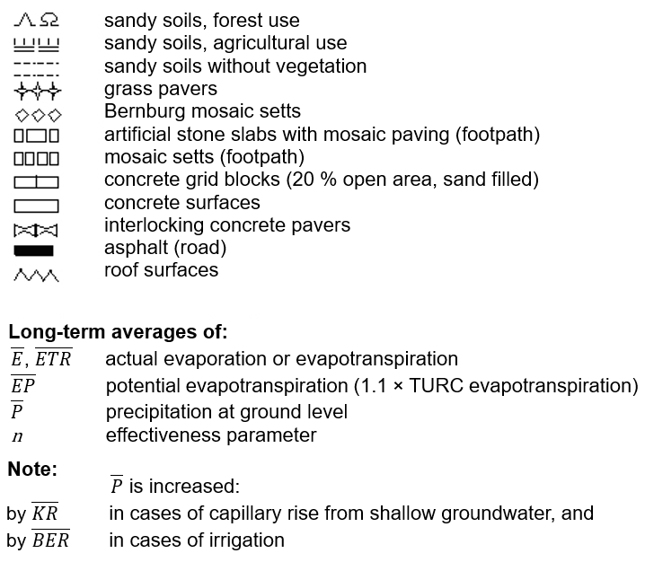
Fig. 3: Representation of the Bagrov relationship for selected values of the parameter n, and dependence of n on land use and soil type (after Glugla et al., 1995)
As precipitation P increases, actual evapotranspiration ER approaches potential evapotranspiration EP, so that the ratio ER/EP tends towards 1. When precipitation P decreases (P/EP approaches 0), actual evapotranspiration ER approaches the amount of precipitation P itself. How quickly these values are reached depends on the storage capacity of the evaporating surface, expressed by the effectiveness parameter n.
A site’s ability to store water is mainly determined by its land use and soil type. In terms of land use, storage capacity generally increases in the following order: impervious areas, fallow areas, agricultural areas, horticultural and forest areas. With respect to soil type, storage capacity improves as the soil’s binding capacity increases.
Storage capacity in pervious soils is expressed as the available water capacity, defined as the difference between soil moisture at field capacity (the onset of percolation) and at the permanent wilting point (when plants experience irreversible drought stress). Other land-use factors, such as yield per hectare, tree species and age, also influence the value of n. The parameter was established through analysis of data from numerous lysimeter stations, both domestic and international, and from water-balance studies in river catchments.
In areas with shallow groundwater, evaporation increases in the soil zone affected by evaporation due to capillary rise from the groundwater. The extent of this rise depends on groundwater depth and soil properties. As a result, runoff generation decreases. Where actual evapotranspiration exceeds precipitation, water is consumed from the soil, and runoff can become negative, as occurs, for example, in river and lake lowlands.
Over water surfaces, potential evaporation is higher than over land because of the greater heat supply, that is, lower reflectivity of incoming radiation. Actual evaporation from water bodies is generally assumed to be approximately equal to this higher potential evaporation.
Localised infiltration, such as that from groundwater recharge facilities operated by waterworks, was not taken into account. For horticultural uses (allotment gardens, weekend cottages, parks, cemeteries, tree nurseries/horticulture, and for some residential or public/special uses), an approximate value of 50 to 100 millimetres per year was added to precipitation to account for irrigation.
After the mean total runoff is calculated as the difference between precipitation and actual evapotranspiration, surface runoff is determined in a second step. For roof areas connected to the sewer system, surface runoff equals total runoff. Areas that are not connected do not contribute to surface runoff. Undeveloped impervious areas allow part of their runoff to infiltrate into the subsoil, depending on the type of surface material (pavement type). The infiltration factor depends on the width, age and condition of the joints between paving elements. Runoff that does not infiltrate into the soil is directed into the sewer system, depending on the connection rate. If it does not enter the sewer system, it seeps into the soil along the edges of the impervious surface. Similarly, portions of runoff from unconnected roof areas also infiltrate into the ground (see Table 1). The difference between total runoff and surface runoff therefore represents infiltration, which forms the basis for estimating groundwater recharge. Evapotranspiration for each block (segment) area is then calculated as the difference between corrected precipitation (precipitation multiplied by the standard correction factor 1.09 for Berlin) and total runoff.
To apply this method in urban areas, the parameter n and the infiltration factor F_{i} had to be determined for different types of impervious surface materials. For this purpose, lysimeter experiments using various surface materials and calculations of wetting losses were evaluated (see Wessolek & Facklam, 1997). The selected parameter values are listed in Table 2. Changes in these parameters resulting from surface ageing, caused by compaction or silting of joints, were also considered. However, due to remaining gaps in the scientific data, these values still involve a certain degree of uncertainty. From a hydrological perspective, it would be desirable to revise the current grouping of surface materials into pavement classes.
 | Pavement class | Surface material | Effectiveness parameter n | Infiltration factor F_{i}
 | - | Roof surfaces | 0.05 | 0.0
 | - | Extensive green roofs | 0.65 | 0.0
 | 1 | Asphalt, concrete, concrete block paving with sealed joints or concrete base, synthetic surfaces | 0.11 | 0.1
 | 2 | Artificial stone or slab paving (edge > 8 cm), interlocking concrete pavers, clay pavers, medium and large setts | 0.11 | 0.3
 | 3 | Small and mosaic setts  (edge < 8 cm) | 0.25 | 0.6
 | 4 | Grass pavers, self-binding gravel surfaces, crushed lawn | 0.40 | 0.9
 | 5 | Unknown (mean parameter values assumed) | 0.25 | 0.52
Tab. 2: Effectiveness parameter n and infiltration factor F_{i} by pavement class
To determine infiltration without the impact of impervious soil coverage (Map 02.13.4), the input data was adjusted so that imperviousness was set to 0 % for all areas. The vegetation type was set to urban park area with a mix of vegetated and tree-covered surfaces. For other actual green land uses, such as forests, no changes were made.
Separation of block (segment) and road area modelling (2022)
Version 3.2 of the water-balance model is specifically adapted to Berlin’s datasets and, in particular, to the spatial reference system of the Urban and Environmental Information System (ISU). For many years, road areas were not mapped in the ISU as a separate land-use category, and their surface shares were therefore included within the block (segment) areas.
With the introduction of the ISU 2020 spatial reference system, detailed road-area data became available for the first time. As part of the AMAREX research project, the ABIMO model was further developed so that road areas could be analysed independently from the block (segment) areas.
To achieve this, the columns referring to road surface shares were defined as optional fields in the input format. In the new dataset, the road area category possesses the same data structure as that of block segment areas. Both are processed in the same way by the model.
While the separation was carried out, an error was also corrected. In the earlier infiltration calculation, the inclusion of road surface shares within block (segment) areas had led to an overestimation of the proportion of pervious surfaces.
Use of individual evapotranspiration parameters (2022)
Within the AMAREX research project, the ABIMO model was further developed to include data from the 2020 Green Volume Number (GVZ, see Environmental Atlas Map 05.09) to determine specific evapotranspiration parameters for each block (segment) and road area. This replaces the earlier, standardised assignment based solely on land use or area type within the model.
A normalised vegetation index was derived from the ratio of vegetation volume to pervious surface area, using the base volume data. This index was then linearly scaled to match the range of the original vegetation classification. As a result, urban blocks commonly ranged between a number of 20 and 30, while larger parks went up to 50. A realistic distribution was achieved through an exponential adjustment of the scaling and a cap at 75 (the value assigned to forests). The approach was verified using several well-known parks, including the Tiergarten and Hasenheide. The resulting scaled values now serve as new, refined input parameters for evapotranspiration modelling.

Including the influence of green roofs in water-balance data

Based on the comprehensive spatial data on green roofs provided in Environmental Atlas Map 06.11 Green Roofs, it has been possible to include the effects of green roofs in the water-balance calculations since 2017.

The green-roof calculation was integrated directly into the ABIMO model as part of the AMAREX research project. As the original ABIMO model did not explicitly account for green roofs, a method was developed to incorporate their effects into the overall water balance.

To this end, a ‘green roof’ category was introduced as a new surface material in ABIMO. This category was assigned both a Bagrov parameter n (see Figure 3) and an infiltration factor F_{i} (see Table 2), following the same procedure used for the other surface categories. Infiltration was set to 0, as for the standard ‘roof’ category; however, the parameter n was adjusted to regulate evapotranspiration, enabling the model to account for the higher evapotranspiration of green roofs.
To determine the parameter n, the WABILA water-balance model (DWA, n.d.) was used. WABILA enables detailed simulations of rainwater management measures and provides precise water-balance results. Evapotranspiration was calculated separately using both ABIMO and WABILA. The adjustment factor, parameter n, that produced the closest agreement between the two models across most climate scenarios was then selected.
Option to integrate the effects of infiltration basins (2022)
The need has emerged to incorporate rainwater management measures into the water-balance model. This has already been implemented for infiltration basins as part of the AMAREX research project. However, as no citywide spatial data on infiltration basins is currently available, these features could not be included in the 2022 maps. Nevertheless, the AMAREX Web Tool (https://amarex-staging.netlify.app/amarex, available in German only), gives users the option to include infiltration basins in their planning.
For this purpose, the proportion of runoff-generating surface area connected to an infiltration basin is specified as an additional input parameter. The model assumes a conceptual basin: a small fraction of the inflowing water evaporates, while the rest infiltrates fully. The exact share that evaporates is defined by a parameter in the configuration file, which specifies the fraction of inflow that is lost through evaporation.
ΔW (Delta W): Deviation from the natural water balance (2022)
The German Association for Water, Wastewater and Waste (DWA) defines the objective of urban water management as ‘keeping the number and magnitude of changes to the natural water balance caused by urban development as low as is technically, ecologically, and economically feasible’ (translated from DWA, 2022).
To capture this, the AMAREX research project introduced the parameter ΔW (Delta W), which quantifies how much an urban water balance deviates from its idealised natural state:
$$ΔW=\frac{1}{2} \left(\left|ev_{nat}-ev_{urb}\right|+ \left|{ri}_{nat}-{ri}_{urb}\right|+ \left|{rs}_{nat}-{rs}_{urb}\right|\right)×\frac{100 \%}{precipitation}$$

ΔW compares the three main components of the water balance – evaporation / evapotranspiration (ev), infiltration (ri), and surface runoff (rs) – with those of the natural reference scenario. The result is expressed as a percentage between 0 and 100.
For the reference scenario representing a natural water balance, the model assumes a fully pervious, undeveloped area in an urban park, consisting of a mix of vegetated and tree-covered surfaces, with a yield class of 50.
Technical updates in the model (2022)
As part of the AMAREX research project, ABIMO 3.2 was further developed. The following provides a brief overview of the model’s technical updates:
- The C++ application was rewritten in R. The model code was translated into English and is available as open source software at https://github.com/KWB-R/kwb.rabimo.
- To improve transferability to other cities, the model logic was generalised. Berlin-specific input variables, such as urban structure type and land-use category, were removed from the model code. Instead, parameters derived from these, such as yield and irrigation, were included directly as input variables. Parameters that were previously hard-coded in the model, such as potential evapotranspiration, can now be defined flexibly through input data. This allowed the model to be successfully transferred and applied to the city of Cologne.
AMAREX Web Tool
The AMAREX Web Tool (https://amarex-staging.netlify.app/amarex, available in German only) is a prototype planning tool that allows users to select any area within Berlin and apply various measures, such as removing impervious soil covers, adding green roofs, or connecting areas to infiltration basins. For the selected measures chosen for planning, the tool displays water-balance parameters both for the current situation and the scenario after implementation. Results can be saved, reloaded, and printed as a report.
Users can work in two modes:
- Neighbourhood level: multiple block (segment) and road areas can be selected simultaneously. Measures are then applied uniformly across the chosen area using sliders. The tool ensures that measures are applied logically across the selected area. For example, if a target of 30 % green roof coverage is set, the tool will not ‘downgrade’ roofs that are already more extensively greened. Instead, it will add greening only to roofs without vegetation or with less vegetation.
- Local level: In this mode, a single area can be selected. Pre-configured measures can then be placed at specific points within it, enabling detailed, site-specific planning. The exact positioning of a measure within an area has no influence on the model calculations, however, and serves purely to aid visualisation within the planning tool.

Results

The model produced updated long-term means for roughly 25,000 block (segment) areas and 32,000 road areas. It provides data on total runoff, evapotranspiration, surface runoff, and infiltration, taking into account the influence of green roofs. On the maps, these values are displayed as classified figures in millimetres per year, while total annual volumes (in cubic millimetres per year) were also calculated and quantified. It should be noted that these averages reflect conditions across block (segment) and road areas that may appear uniform but are in fact heterogeneous. Runoff from impervious and pervious surfaces is aggregated into a single value for each area. This means the maps do not show, for example, the infiltration capacity of one square metre of pervious or unpaved soil. For this purpose, another separate citywide, block-specific calculation was performed assuming entirely pervious conditions. The results are shown in Map 02.13.4. For the first time, the deviation from the natural water balance, ΔW, is also included.

Map Description

Changes in 2022
The 2022 water-balance modelling results show clear differences from those of 2017 in certain areas and can only be compared to a limited extent. These variations are mainly due to updates in the modelling methods and data sources:
- For the first time in 2022, road areas were analysed separately from block (segment) areas, resulting in a complete, visually continuous map of the urban water balance. This was possible due to separate datasets and updates to the ABIMO model developed under the AMAREX research project.
- Many of the apparent differences between 2017 and 2022 stem from much more detailed data on areas connected to sewer systems. Until 2017, it was generally assumed that any surface adjacent to a separate or combined sewer system was also connected to it. In 2022, for the first time, data on individual connection points was available for each block (segment) area. Road areas could also be linked directly to specific rainwater drainage connections (BWB 2022). Instead of assigning connections by land-use category (for example, it was assumed that all parks were unconnected until 2017), each area was now classified individually across the entire city.
This change mainly affected surface runoff and infiltration on the outskirts of the city. Here, it is often the case that only road areas, but not block (segment) areas, are connected to the sewer system. Consequently, the 2022 dataset reflects actual conditions much more accurately than the 2017 version.
As a side-effect, a small number of road sections (around 30) in the city centre now appear as outliers in the 2022 infiltration map. These areas (for example, ID 0000000001000806 on Taubenstraße near Gendarmenmarkt) are listed as unconnected to the sewer system, despite being highly impervious (100 % in this example). As a result, the ABIMO model calculates infiltration only, disregarding surface runoff. This leads to unrealistically high infiltration rates of more than 450 millimetres. These figures are not realistic and should be corrected in future, either in the source data or within the ABIMO model itself.
- The 2022 model referred to the Green Volume Number (GVZ) for each block (segment) and road area, rather than the previously used standard evapotranspiration rate assigned by land use. This has led to major differences compared with 2017, particularly in parks.
The contrast is especially evident in large green spaces: the Großer Tiergarten now shows evapotranspiration levels of over 500 millimetres, while the green areas at Tempelhofer Feld display rates around 370 millimetres.
Therefore, using area-specific vegetation data evidently results in a more realistic representation of evapotranspiration in the ABIMO model. This has also led to considerable deviations for farmland, since, up until 2017, models relied on standard values.
- New specifications for the Infiltration without Consideration for Impervious Soil Coverage Map:
For the reference scenario representing a natural water balance, the imperviousness was not only reduced to 0 % (as in 2017), but previously impervious areas were now modelled as urban park areas with a mix of vegetated and tree-covered surfaces (yield class = 50).

Map Description
The Total Runoff Map (02.13.3) shows that in the highly impervious inner-city areas (within the S-Bahn ring) total runoff ranges between 350 and 450 millimetres per year. Values are even higher in the densely built-up city centre and in some industrial areas. Here, only about 150 millimetres per year evaporates (see Map 02.13.5), based on precipitation readings taken at a height of one metre, which are roughly 10 to 15 % lower than at ground level. In the less densely developed outer areas, total runoff ranges from 250 to 350 millimetres per year. By contrast, pervious areas on the outskirts and in the surrounding regions, where runoff is around 150 millimetres per year, highlight Berlin as an island of substantially increased runoff. The reduction in evaporation due to impervious soils and limited vegetation – as illustrated in the Evaporation Map (02.13.5) – leads to runoff rates that are two to three times higher than under natural conditions.
Groundwater depletion occurs only in a few areas where both precipitation and the water table are low. In these locations, vegetation taps groundwater reserves and can evapotranspire more water than is replenished by rainfall, leading to a local runoff deficit.
The Surface Runoff Map (02.13.1) indicates that in inner-city areas connected to the sewer system, an average of about 250 millimetres per year of runoff enters the sewers, with peak values exceeding 400 millimetres per year. In the outer areas connected to the sewer system, average figures reach around 100 millimetres per year.
The Percolation Map (02.13.2) illustrates that in the inner city, around 100 to 150 millimetres of rainwater infiltrates into the ground per year. Much higher infiltration rates, about 250 millimetres per year, are found in the more open residential areas in the outer regions, such as the large housing estates and high-rises built between the 1960s and 1990s in Marzahn. In regions with low sewer system connection rates, infiltration can reach up to 300 millimetres per year. In unconnected areas, all runoff infiltrates into the soil, averaging 300 to 350 millimetres per year with peak values of over 400 millimetres. By contrast, infiltration rates are relatively low in the forests with only 50 to 100 millimetres per year. Much of the rainwater is returned to the atmosphere in these areas, leaving only a small amount to infiltrate into the soil.
In summary:
- The reduction in soil permeability caused by the high degree of impervious surfaces in the inner city is largely offset by lower evapotranspiration rates. Consequently, infiltration rates in the inner city are higher than expected, approaching those under natural conditions.
- Infiltration rates are primarily influenced by the sewer system connection rate, with the extent of impervious coverage being the second most important factor. Additional key factors include the type of surface material and its capacity to allow infiltration.
- In less densely built-up areas with low connection rates, infiltration rates are the highest, approximately twice those observed under natural conditions.
Evaporation from water bodies, which are not included on the maps, exceeds direct precipitation by around 160 millimetres per year, resulting in an annual net water loss of approximately 8 million cubic metres from Berlin’s lakes and rivers.
For some of the highly impervious areas, no information was available on whether rainwater is discharged through the sewer system. In these cases, all runoff has been classified as infiltration on the maps. However, given the degree of imperviousness and the volume of runoff involved, it is unlikely that all of this water infiltrates into the ground. Consequently, surface runoff is likely underestimated, while infiltration is slightly overestimated. This also applies to the road sections (around 30 in total) in the city centre (for example, 0000000001000806 on Taubenstraße near the Gendarmenmarkt).
The total runoff volumes were derived from the mapped reference areas and subsequently quantified (see Table 3).

 | Area [km²] | mm/yr *) | million m³/yr
Berlin total  (excluding water bodies) | 837
of which with green roofs | 5.6
Precipitation | 837 | 633 | 530
(measured values, corrected)
Evaporation | 837 | 360 | 301
(precipitation − total runoff)
Total runoff | 837 | 274 | 229
Surface runoff | 837 | 87 | 73
of which discharged into
combined sewer system | 97 | 246 | 24
separate sewer system | 281 | 174 | 49
Infiltration | 837 | 187 | 156
Water surfaces | 54
Depletion |  | -149 | -8
(precipitation − evaporation)
*area-weighted
Tab. 3: Long-term average runoff generation including the influence of green roofs (calculated with ABIMO 3.2), as of 2022
The calculations show that around 58 % of precipitation is returned to the atmosphere through evapotranspiration, leaving roughly 230 million cubic metres per year available as total runoff. About two thirds of this runoff infiltrates into the ground, while the remaining third is transported through the sewer system. Although combined sewers account for only about a quarter of the total sewered area, they generate almost one third of total surface runoff. Comparing the infiltrating water volume of around 156 million cubic metres per year, which does not reach the groundwater in its entirety, with Berlin’s drinking water consumption of about 228 million cubic metres per year (AfS 2019) reveals a significant deficit. This deficit is balanced by surface inflows from the Spree and Havel rivers, as well as by subsurface groundwater inflows from the surrounding region. Surface water is also used through bank filtration at groundwater abstraction sites near the riverbanks and for artificial groundwater recharge at the city’s waterworks.
In the Urban and Environmental Information System (ISU), data is available for each sewered area connected to the separate sewer system, indicating the receiving water body or waterbody section into which it drains (see Map 02.09.2, 2022). This makes it possible to establish the average amount of rainwater each waterbody receives, including a total of around 250 individual water bodies or waterbody sections. Table 4 presents discharge volumes to Berlin’s water bodies, grouped by section. In areas served by the combined sewer system, surface runoff is directed to the wastewater treatment plants. Only the portions that overflow during heavy rainfall, through emergency outlets at pumping stations or combined sewer overflows, flow directly into the water bodies. After appropriate treatment, the remaining runoff is discharged to the water bodies together with the treated wastewater.
Water body section number | Catchment areas by water body section | Catchment area (km²) | Rainwater runoff (million m³/yr)
110 | Oberhavel (city boundary to above the Tegeler See mouth) | 0.9 | 0.14
120 | Oberhavel (Tegeler See mouth to Schleuse Spandau) | 3.8 | 0.74
130 | Tegeler See | 2.2 | 0.45
131 | Tegeler Fließ | 3.3 | 0.51
132 | Nordgraben | 10.5 | 1.84
133 | Panke, north of Verteilerbauwerk | 5.5 | 0.73
210 | Unterhavel, from Spree mouth to Jungfernsee (excluding Wannsee) | 16 | 2.50
220 | Großer Wannsee | 1.6 | 0.21
230 | Kleine Wannseekette | 1.1 | 0.15
310 | Müggelspree (including Großer Müggelsee, Dämeritzsee and Erpe) | 7.1 | 1.10
320 | Langer See, Dahme and Große Krampe | 5.2 | 0.79
330 | Stadtspree, to the junction with Britzer Verbindungskanal | 7.2 | 1.30
331 | Wuhle | 19.5 | 2.95
340 | Stadtspree, to the junction with Landwehrkanal | 5.7 | 0.99
350 | Rummelsburger See | 9.6 | 1.95
351 | Marzahn-Hohenschönhausener Grenzgraben | 18.2 | 3.13
380 | Stadtspree, to the junction with Berlin-Spandauer-Schifffahrtskanal | 6.1 | 1.30
390 | Stadtspree, to the Spree mouth | 7.4 | 1.15
400 | Canals north of the Spree | 7.7 | 1.57
401 | Panke (from Verteilerbauwerk to Nordhafen) | 17 | 3.04
500 | Canals south of the Spree (Neuköllner Schifffahrtskanal and Landwehrkanal) | 6.6 | 1.62
600 | Teltowkanal | 58.3 | 10.42
610 | Rudower Arm | 22.8 | 3.74
620 | Britzer Verbindungskanal | 2.5 | 0.55
810 | Grunewaldseenkette | 10.3 | 1.77
820 | Flughafensee | 5.8 | 1.27
830 | Biesdorfer Baggersee | 3.1 | 0.49
840 | Fauler See/Obersee | 1.2 | 0.21
850 | Schäfersee | 2.2 | 0.48
860 | Groß-Glienicker See | 0.1 | 0.02
900 | Small waterbodies (ponds, pools, ditches) | 12.7 | 1.80
 | Separate sewer system (total) | 281.2 | 48.93
 | Combined sewer system | 97.6 | 23.96
Tab. 4: Rainwater discharge into the sewer system by catchment area and runoff (long-term mean, as of 2022)
Using the ABIMO modelling framework, simulations can be performed under modified initial conditions. This functionality is particularly valuable for estimating how the water balance might respond to changing climatic conditions (Löschner, 2008) or urban development projects. For the first time, the AMAREX web tool (https://amarex-staging.netlify.app/amarex, available in German only) allows users to evaluate the effects of measures such as removing impervious soil covers or disconnecting areas from the sewer system. Model parameters can be updated at any time to incorporate the latest research findings via the public repository at https://github.com/KWB-R/kwb.rabimo. It should be noted that ABIMO models annual average conditions only and cannot represent individual events such as heavy rainfall.

Infiltration without considering impervious coverage
The Percolation without Consideration for Impervious Coverage Map (02.13.4) highlights areas where conditions differ significantly from those shown in the map that does include impervious surfaces.
In the city centre and industrial areas, the heavily altered yet pervious soils exhibit the highest infiltration rates, averaging around 200 to 250 millimetres per year. These are followed by the sandy areas of the Glacial Spillway and the sandy sections of the plateaus, where infiltration reaches roughly 150 to 200 millimetres. In urban park areas, where sandy soils are characterised by a mix of vegetated and tree-covered surfaces, average annual infiltration decreases to between 100 and 150 millimetres, as trees evapotranspire substantially more water due to their deep root system. In the loamier soils of the Teltow and Barnim plateaus, the higher water storage capacity allows vegetation to release considerably more moisture into the atmosphere, leaving only about 50 to 100 millimetres available for infiltration. In areas with shallow groundwater, capillary rise brings water into the soil layer affected by evaporation. While evaporation increases, average infiltration is reduced here to less than 50 millimetres per year. Where actual evapotranspiration exceeds precipitation, water depletion occurs, resulting in negative calculated infiltration rates.
When using the data from Map 02.13.4 to assess the potential impacts of adding impervious soil covers in urban planning, the following points should be considered:
Infiltration is reduced to 0 only if the proposed impervious surfaces are completely impermeable (such as roofs or asphalt) and if all runoff from these surfaces is discharged directly into the sewer system. If partially permeable materials are used, or if only a portion of the runoff is diverted to the sewer system, the projected reduction in infiltration capacity should be lowered accordingly. For more in-depth calculations, the AMAREX web tool (https://amarex-staging.netlify.app/amarex) is recommended.
ΔW (Delta W)
The ΔW (Delta W) Map illustrates how much the water balance deviates from natural conditions. The reference scenario for a natural water balance is defined as a pervious, undeveloped urban park area with a mix of vegetated and tree-covered surfaces (yield class = 50).
As expected, large deviations occur in densely built-up, highly impervious, and sparsely vegetated areas. Table 6 summarises the deviations by area type.
As part of the research project, the existence and nature of correlations between water balance parameters and other climatic factors were further investigated. Among other results, ΔW was found to serve as an indicator of average daytime summer temperatures. Strong correlations were observed with both day- and night-time temperatures across most block (segment) areas. In contrast, road areas displayed weaker correlations, likely due to thermodynamic effects, heat transfer, air movement, and factors such as shading and road orientation, which are not captured by ABIMO. Information on air temperature was extracted from the 2022 Climate Analysis (see Environmental Atlas 04.10, 2022).

Tab. 5: Deviations of the water balance from natural conditions, area-weighted by
area type, as of 2022

Excursus

Validation of the surface runoff component of the ABIMO Model
As part of the AMAREX research project, the surface runoff component of the ABIMO model was validated using two different approaches:
- Surface runoff modelled by ABIMO for the Berlin I catchment was compared with the INFOWORKS results provided by the BWB.
- Surface runoff modelled by ABIMO for Berlin’s combined sewer catchment area was compared with rainwater volumes entering Berlin’s wastewater treatment plants via the sewer system.
Both validation approaches were applied across multiple years, taking into account the relevant climatic parameters of each year, that is, precipitation and potential evapotranspiration.
Validation using INFOWORKS
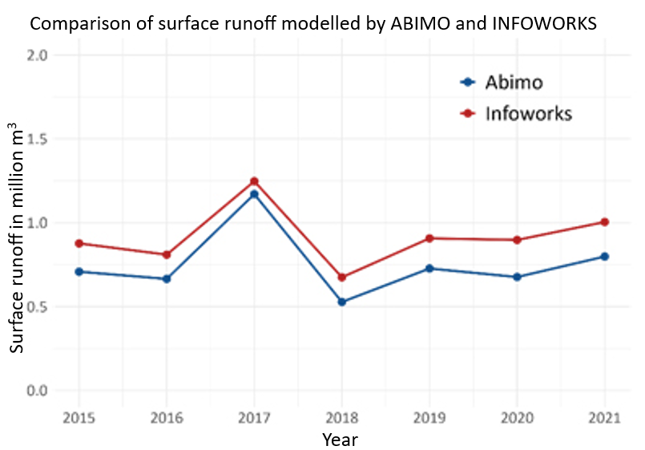
Fig. 4: Comparison of surface runoff modelled by ABIMO and INFOWORKS (KWB 2025)
The validation covered the years 2015 to 2021, corresponding to the years in which the BWB used INFOWORKS to model sewered surface runoff in the Berlin I catchment in Friedrichshain-Kreuzberg.
Using ABIMO, surface runoff was calculated for all block segment areas (ISU5) within the same catchment, excluding areas classified as water bodies.
A comparison of the annual results shows that both models respond consistently to climatic variability and display closely aligned overall trends. However, ABIMO systematically estimates lower runoff volumes than INFOWORKS, averaging around 160,000 cubic metres per year less (Mean Absolute Percentage Error, MAPE: 23 %). The MAPE indicates the average percentage by which simulated values deviate from observed ones.
Validation using wastewater treatment plant data
For the second validation, inflow data provided by the BWB was analysed for the period from 1991 to 2020.
Measured inflows were adjusted by subtracting the estimated dry-weather flow, thereby isolating the rainfall-related runoff component.
Data from three wastewater treatment plants connected exclusively to the separate sewer system, where – in theory – only dry-weather flow should occur, was used to estimate the share of improperly connected surfaces. This share was then extrapolated to all treatment plants that also receive partial inflows from the separate sewer system and subtracted from the total runoff.
Losses from combined sewer overflows (CSOs) were also incorporated. These were calculated for each year, starting from an average overflow volume of approximately 5.5 million cubic metres in 1990, and scaled linearly across the study period using summer precipitation as an adjustment factor.
To determine the urban water balance, all block segment areas within the combined sewer system (see Environmental Atlas Map 02.09, 2022) were selected, and ABIMO was applied to all climatic years under investigation.
The comparison shows a strong correlation, although ABIMO systematically overestimates surface runoff relative to the observed wastewater treatment data (MAPE 11%).
Possible causes for this include:
- an overestimation of runoff from road surfaces, since water infiltrating into adjacent green areas may not be captured;
- a systematic underestimation of rainwater inflows from improperly connected surfaces in the separate sewer system; and
- an underestimation of combined sewer overflow volumes.
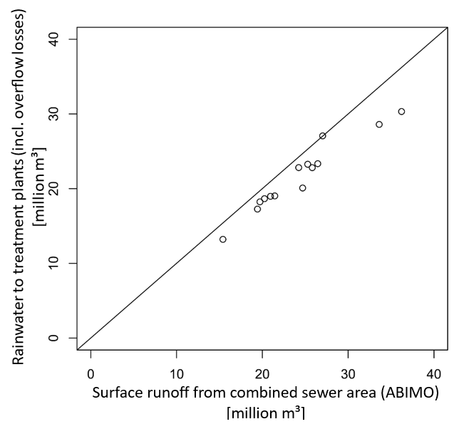
Fig. 5: Comparison of surface runoff modelled by ABIMO and wastewater treatment plant data (KWB 2025)
Despite these systematic deviations, both validation methods produce consistent and plausible results.

Literature
- Aey, W. 1993:
Zuordnung von Bodenkenngrößen zu Bodengesellschaften und Nutzungen, [Attribution of soil properties to soil associations and land uses], expert report commissioned by the Senate Department for Urban Development and Environmental Protection, Berlin.
- AfS (Amt für Statistik Berlin-Brandenburg) 2019:
Statistischer Bericht, Q I 1 - 3j / 19, Wasserversorgung und Abwasserentsorgung im Land Berlin 2019 [Statistical Report, QI 1 – 3i / 19, Water supply and wastewater disposal in the State of Berlin], November 2022.
Download
https://download.statistik-berlin-brandenburg.de/74029c18ca64f80e/17faa5a11c53/SB_Q01-01-00_2019j03_BE.xlsx [available in German only]
(Accessed on 25 August 2025)
- Bach, M. 1997:
Erfassung des Kanalisierungsgrades versiegelter Flächen für ein urbanes Niederschlags-Abfluß-Modell am Beispiel Berlin [Determining the sewer connection rate of impervious areas for an urban precipitation runoff model: the case of Berlin], Diploma thesis at the Earth Sciences Department of the Free University of Berlin.
- Bamberg, H. F., Busse, W., Ginzel, G., Glugla, G., Schlinker, K., Ziegler, G. 1981:
KdT-Empfehlung zur Ermittlung der Grundwasserneubildung [KdT recommendations for estimating groundwater recharge]. Central Geological Institute. Published as WTL Special Issue 5, Berlin.
- Berlekamp, L.-R., Pranzas, N. 1992:
Erfassung und Bewertung von Bodenversiegelung unter hydrologisch-stadtplanerischen Aspekten am Beispiel eines Teilraums von Hamburg [Quantifying and assessing impervious soil coverage from a hydrological and urban planning perspective: a case study in Hamburg]. Doctoral thesis, Hamburg.
- BGR 2005:
Bodenkundliche Kartieranleitung [Soil scientific mapping guidelines]. Hanover: Federal Institute for Geosciences and Natural Resources (BGR)
- DWA (German Association for Water, Wastewater and Waste) (n.d.):
Wasserbilanzmodell WABILA [Water Balance Model WABILA].
Internet:
https://de.dwa.de/de/Wasserbilanz.html [available in German only]
(Accessed on 25 August 2025)
- Glugla, G., Tiemer, K. 1971:
Ein verbessertes Verfahren zur Berechnung der Grundwasserneubildung [An improved approach to estimating groundwater recharge]. Wasserwirtschaft-Wassertechnik, 21 (10): pp. 349-353, Berlin.
- Glugla, G., Enderlein, R., Eyrich, A. 1976:
Das Programm RASTER – ein effektives Verfahren zur Berechnung der Grundwasserneubildung im Lockergestein [The RASTER Programme – an efficient method for calculating groundwater recharge in loose rock], Wasserwirtschaft-Wassertechnik, 26 (11): pp. 377-382, Berlin.
- Glugla, G., König, B. 1989:
Der mikrorechnergestützte Arbeitsplatz Grundwasserdargebot [A microcomputer-supported workstation for assessing groundwater resources]. Wasserwirtschaft-Wassertechnik, 39 (8): pp. 178-181, Berlin.
- Glugla, G., Eyrich, A. 1993:
Ergebnisse und Erfahrungen bei der Anwendung des BAGROV-GLUGLA-Verfahrens zur Berechnung von Grundwasserhaushalt und Grundwasserneubildung im Lockergestein Norddeutschlands [Results and experience gained from applying the BAGROV–GLUGLA method to estimate groundwater balance and groundwater recharge in the loose rock of Northern Germany]. Kolloquium Hydrogeologie 10/93 Erfurt, pp. 22-26.
- Glugla, G., Krahe, P. 1995:
Abflußbildung in urbanen Gebieten [Runoff generation in urban areas]. Document series, Hydrologie/Wasserwirtschaft 14, Ruhr University Bochum, pp.140-160.
- Glugla G., Fürtig, G. 1997:
Dokumentation zur Anwendung des Rechenprogramms ABIMO [Documentation for the use of the ABIMO computation programme] Federal Institute of Hydrology, Berlin Office.
- Glugla, G., Müller, E. 1997:
Grundwasserneubildung als Komponente der Abflussbildung [Groundwater recharge as a component of runoff generation]. In: C. Leibundgut & S. Demuth (eds.): Grundwasserneubildung. Freiburger Schriften zur Hydrologie. Vol. 5, pp. 23-35.
- Glugla, G., Goedecke, M, Wessolek, G., Fürtig, G. 1999:
Langjährige Abflußbildung und Wasserhaushalt im urbanen Gebiet Berlin [Long-term runoff generation and water balance in the urban area of Berlin]. Wasserwirtschaft, Vol. 89 No.1, 1999, pp. 34-42.
- Glugla, G., et.al. 2003:
BAGLUVA Wasserhaushaltsverfahren zur Berechnung vieljähriger Mittelwerte der tatsächlichen Verdunstung und des Gesamtabflusses [BAGLUVA: a water balance method for estimating long-term means of actual evapotranspiration and total runoff] BfG - 1342, Federal Institute of Hydrology (BfG), Koblenz.
- Goedecke, M., Gerstenberg, J., Haag, L. 2019:
Wasserhaushaltsmodell Berlin ABIMO 3.2 – Handreichung für Anwendende, Technische Anleitung zur Aufbereitung von Datengrundlagen sowie Dokumentation von Methoden und Berechnungsergebnissen des auf Berliner Verhältnisse angepassten blockbezogenen Niederschlags - Abflussmodell ABIMO der Bundesanstalt für Gewässerkunde [Water Balance Model Berlin ABIMO 3.2 – User Guide. Technical manual for data preparation and documentation of methods and results for the block-based rainfall – runoff model ABIMO, adapted to Berlin’s conditions (Federal Institute of Hydrology)], 2006 to 2019, Senate Department for Urban Development and Housing, Berlin, as of 15 April 2020.
Download: https://www.berlin.de/umweltatlas/_assets/literatur/goedecke_et_al_abimo2019_doku.pdf [available in German only]
(Accessed on 25 August 2025)
- Graf, H.-F. 1979:
Der Einfluß von Großstädten auf das Niederschlagsregime am Beispiel von Berlin [The impact of metropolitan areas on rainfall regimes: a case study of Berlin]. Doctoral thesis (A), Humboldt University of Berlin.
- Kleeberg, H.-B., Niekamp, O. 1994:
Klimaänderung und Wasserwirtschaft [Climate change and water management]. Presentation at the 3rd German Climate Conference, Proceedings pp. 136-140, Potsdam.
- Köppel, J., Deiwick, B. (TU Berlin) 2004:
Verfahren zur Bewertung und Bilanzierung von Eingriffen im Land Berlin [Methods for evaluating and accounting for land-use interventions in the State of Berlin]. Expert report commissioned by the Senate Department for Urban Development (SenStadt IE), unpublished.
- KWB (Berlin Centre of Competence for Water) (2024/25):
KWB (2024/2025). Projekt AMAREX: Projektergebnisse und Abbildungen [AMAREX Project: results and illustrations], (unpublished).
Internet:
https://www.kompetenz-wasser.de/de/forschung/projekte/amarex-anpassung-des-managements-von-regenwasser-an-extremereignisse?trk=public_post_comment-text [available in German only]
(Accessed on 25 August 2025)
- Löschner, F. 2008:
Einfluss von Versiegelung und Klimawandel auf die Abflussbildung urbaner Gebiete – untersucht am Beispiel Berlin, [Effects of impervious soil coverage and climate change on runoff generation in urban areas: a case study of Berlin.] Bachelor’s dissertation, Department of Crop and Animal Sciences: Soil Science and Site Sciences at the Humboldt University of Berlin, Berlin.
- Monninkhoff, L. 2001:
ArcSIWA 1.1 Berechnung der Grundwasserneubildung Tutorial - Einführung in ArcSIWA (SIWA on ArcVIEW) [Tutorial on the calculation of groundwater recharge – Introduction to ArcSIWA], Berlin: WASY Gesellschaft für wasserwirtschaftliche Planung und Systemforschung GmbH.
- Rachimov, C. (pro data consulting) 1996:
ABIMO 2.1, Abflußbildungsmodell, Algorithmus zum BAGROV-GLUGLA-Verfahren für die Berechnung langjähriger Mittelwerte des Wasserhaushalts [ABIMO 2.1, runoff generation model, algorithm based on the BAGROV-GLUGLA method for calculating long-term water-balance means]; commissioned by the Federal Institute of Hydrology, Berlin Branch, unpublished.
- Rachimov, C., Rachimov, M. (pro data consulting) 2006:
ABIMO 3, Abflussbildungsmodell, Algorithmus zum BAGROV-GLUGLA-Verfahren für die Berechnung langjähriger Mittelwerte des Wasserhaushalts, Programmbeschreibung [ABIMO 3, runoff generation model, algorithm based on the BAGROV-GLUGLA method for calculating long-term water-balance means, programme description] commissioned by the Senate Department of Urban Development, unpublished.
- Rachimov, C., Rachimov, M. (pro data consulting) 2009:
ABIMO 3.2, Abflußbildungsmodell, Algorithmus zum BAGROV-GLUGLA-Verfahren für die Berechnung langjähriger Mittelwerte des Wasserhaushalts, Programmbeschreibung [ABIMO3.2, runoff generation model, algorithm based on the BAGROV-GLUGLA method for calculating long-term water-balance means, programme description] commissioned by the Senate Department for Urban Development.
Internet:
https://www.berlin.de/umweltatlas/_assets/literatur/rachimow_rachimow_abimo3_2_2009.pdf [available in German only]
- Richter, D. 1979:
Informationsspeicher für die einheitliche Bestimmung der Verdunstungshöhe von freien Wasserflächen. [Database for the standardised determination of evaporation rates from open-water surfaces]. Research Institute for Hydrometeorology of the Meteorological Service of the GDR, unpublished.
- SenStadtWohn (Senate Department for Urban Development and Housing Berlin) (2017):
KURAS "Konzepte für urbane Regenwasserbewirtschaftung und Abwassersysteme". Steckbrief 1: Dachbegrünung [Concepts for urban rainwater management and wastewater systems, Information Sheet 1: Green Roofs].
Internet:
http://kuras-projekt.de/fileadmin/Dokumenten_Verwaltung/pdf/Steckbrief_01_Dachbegruenung.pdf [available in German only]
(Accessed on 25 August 2025)
- Sklorz, S., Monninkhoff, B. 2013:
Entwicklung der Grundwasserneubildung im Großraum Berlin für die Periode 2051-2060 [Development of groundwater recharge in the Berlin metropolitan region for the period 2051–2060]. In S. Kaden, O. Dietrich, & S. Theobald, Wassermanagement im Klimawandel - Möglichkeiten und Grenzen von Anpassungsmaßnahmen. Berlin.
- Verleger, H. , Limberg, A. 2013:
Einfluss des Klimawandels auf die Grundwasserstände im Urstromtal von Berlin – Orientierende Untersuchungen [The impact of climate change on groundwater levels in the Berlin Glacial Spillway – preliminary investigations]. Brandenburgische Geowissenschaftliche Beiträge. 20 (2013), 1/2. pp. 93-100. Cottbus.
Download:
https://www.berlin.de/umweltatlas/_assets/literatur/bgb_2013_verleger_limberg.pdf [available in German only]
(Accessed on 25 August 2025)
- Wessolek, G. 1994:
Auswertung von Versuchen zur Ermittlung der Abflußverhältnisse unterschiedlich versiegelter und kanalisierter Flächen Berlins [Evaluation of experiments on the runoff behaviour of surfaces with varying degrees of impervious coverage and drainage connectivity in Berlin], commissioned by the Federal Institute of Hydrology, Berlin Office, unpublished.
- Wessolek, G., Facklam, M. 1997:
Standorteigenschaften und Wasserhaushalt von versiegelten Flächen [Site characteristics and water balance of impervious areas], Zeitschrift für Pflanzenernährung und Bodenkunde 160. pp. 41-46.
Maps
- BWB (Berliner Wasserbetriebe) (ed.) 2022:
Art der Kanalisation der Straßenflächen [Type of road surface drainage], digital dataset, Berlin, as of October 2022, unpublished.
- Dyck, S. et al. 1978:
Karte der potentiellen Verdunstung [Map of potential evapotranspiration]. In: Angewandte Hydrologie, Vol. 2, Verlag für Bauwesen, 1 : 1,000,000, Berlin.
- SenStadt (Senate Department for Urban Development, Building and Housing Berlin) (ed.) 2020:
Environmental Atlas Berlin, Map 04.08.1–3 Long-Term Mean Precipitation Distribution, 1991 - 2020 Berlin.
Internet: https://www.berlin.de/umweltatlas/en/climate/precipitation-distribution/1991-2020/summary/
(Accessed on 25 August 2025)
- SenStadt (Senate Department for Urban Development Berlin) (ed.) 2009:
Environmental Atlas Berlin, Map 02.07 Depth to the Water Table, 1 : 50,000, Berlin.
Internet: https://www.berlin.de/umweltatlas/en/water/depth-to-the-water-table/2009/summary/
(Accessed on 25 August 2025)
- SenStadt (Senate Department for Urban Development, Building and Housing Berlin) (ed.) 2020:
Environmental Atlas Berlin, Map 06.01 Actual Use of Built-Up Areas, Map 06.02. Inventory of Green and Open Spaces, 1 : 50,000, Berlin.
Internet: https://www.berlin.de/umweltatlas/en/land-use/actual-land-use/2020/summary (Accessed on 25 August 2025)
- SenStadt (Senate Department for Urban Development, Building and Housing Berlin) (ed.) 2020:
Environmental Atlas Berlin, Map 06.08 Urban Structure – Area Types Differentiated, 1 : 50,000, Berlin.
Internet: https://www.berlin.de/umweltatlas/en/land-use/urban-structure/2020/summary
(Accessed on 25 August 2025)
- SenStadt (Senate Department for Urban Development, Building and Housing Berlin) (ed.) 2021:
Environmental Atlas Berlin, Map 01.02 Impervious Soil Coverage, 1 : 50,000, Berlin.
Internet: https://www.berlin.de/umweltatlas/en/soil/impervious-soil-coverage/2021/summary/
(Accessed on 25 August 2025)
- SenStadt (Senate Department for Urban Development, Building and Housing Berlin) (ed.) 2022:
Environmental Atlas Berlin, Map 02.09 Management of Rain and Wastewater, 1 : 50,000, Berlin.
Internet: https://www.berlin.de/umweltatlas/en/water/rain-and-waste-water/2022/summary/
(Accessed on 25 August 2025)
- SenStadt (Senate Department for Urban Development, Building and Housing Berlin) (ed.) 2020:
Environmental Atlas Berlin, Map 01.06 Soil-Scientific Characteristic Values, 1 : 50,000, Berlin.
Internet: https://www.berlin.de/umweltatlas/en/soil/soil-scientific-characteristic-values/2020/summary
(Accessed on 25 August 2025)

