02.12 Groundwater Levels (Edition 2002)

Overview
The exact knowledge of the current ground-water levels, and hence also of groundwater stocks, is imperative for the State of Berlin, since 100% of the drinking-water supply (approx. 220 million m³ in 2001) is obtained from groundwater. This groundwater is pumped at nine waterworks, almost entirely from the city’s own area. Only the Stolpe Waterworks on the northern outskirts obtain water from Brandenburg, but also supply Berlin.
Moreover, groundwater reserves are tapped for in-house and industrial use, as well as for major construction projects and heating-related purposes. Numerous instances of soil and groundwater contamination are known in Berlin, which can only be rehabilitated on the basis of exact knowledge of groundwater conditions.

Definitions Regarding Groundwater
Groundwater is underground water (DIN 4049, Part 3, 1994) which coherently fills out the cavities in the lithosphere, the movement of which is caused exclusively by gravity. In Berlin, as in the entire North German Plain, the cavities are the pores between the rock particles in the loose sediments. Precipitation water which seeps (infiltrates) into the ground first of fills out these pores. Only that part of the infiltrating water which is not bound as adhesive water in the non-water-saturated soil, or used up by evaporation (evaporating transpiration), can seep to the phreatic surface and form groundwater (Fig. 1).
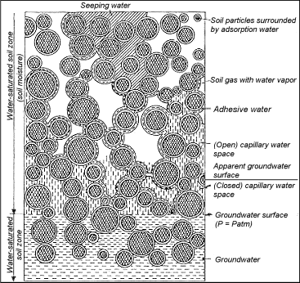
Fig. 1: Phenomenology of Underground Water (from Hölting 1996)
Aquifers are made of sands and gravels, and, as incoherent material, make the storage and movement of groundwater possible.
Aquitards consist of clay, silt, gyttja and glacial till and, as cohesive soils, hinder water movement.
Aquicludes are made of clay which is virtually impermeable to water.
Groundwater the phreatic surface of which lies within an aquifer, i.e., whose phreatic and piezometric surfaces coincide, is known as free or unconfined groundwater. If however, an aquifer is covered by an aquitard, the groundwater cannot rise as high as it might in response to its hydrostatic pressure. Under these conditions, the piezometric surface is above the phreatic surface of the groundwater, which is then referred to as confined (Fig. 2).
If an aquitard is located over a large coherent aquifer, such as a glacial till, perched groundwater may develop temporarily in sandy segments (Fig. 2).
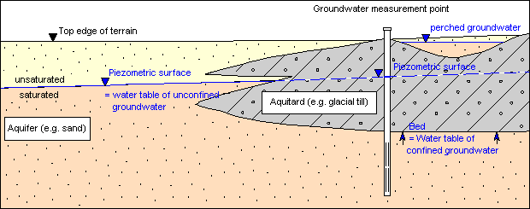
Fig. 2: Hydrogeological Terms
As a rule, groundwater flows at a low incline into the rivers and lakes (receiving bodies of water) and infiltrates into them (effluent conditions; Fig. 3a). If in the neighborhood of these surface waters groundwater is discharged, e.g. through wells, so that the phreatic surface drops below the level of that body of water, the surface water infiltrates into the groundwater as bank-filtered water. This is known as an influent condition: (Fig. 3b).
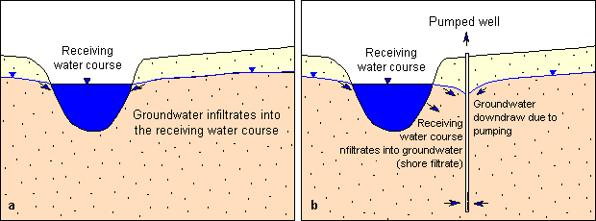
Fig. 3: Infiltration: a) Effluent condition, b) Influent condition
The groundwater velocity of flow in Berlin is about 10 to 500 m p/a, depending on groundwater incline descent and the permeability of the aquifer. However, near well facilities, these low flow velocities can increase significantly.

Geology and Hydrogeology
The present shape of the earth’s surface in Berlin was predominantly the result of the Vistula Ice Age, the most recent of the three great quaternary inland glaciations. The most important morphological units are the Warsaw-Berlin Glacial Spillway, with predominantly sandy-gravel deposits reaching to great depths, and the Barnim Plateau in the north and the Teltow Plateau with the Nauen Plate in the south, which are covered in large part by the thick glacial till or boulder clay of the ground moraines Fig. 4).
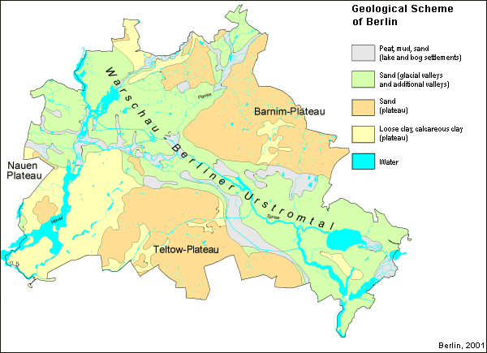
Fig. 4: Geological Outline Map of Berlin
The loose sediments dating from the tertiary and quaternary, and averaging approx. 150 m in thickness, are of special significance for the water supply and for the foundation soil. They form the freshwater stock from which all the drinking water and a large part of the process water of the city is drawn.
The tertiary rupelton clay layer beneath it is about 80 m thick, and constitutes a hydraulic barrier against the deeper saltwater tier (Fig. 5).
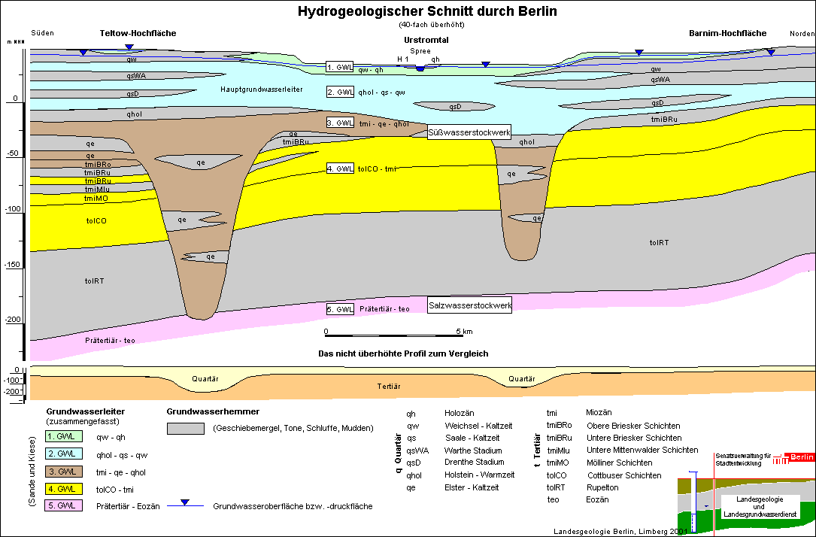
Fig. 5: Hydrogeological Cross-Section of Berlin
Due to the alternation of aquifers and aquitards, the freshwater stock in the Berlin area is broken down into four separate hydraulic aquifers (Limberg, Thierbach 2002). The second aquifer, which is largely a Saale-glaciation-era aquifer, is known as the main aquifer, since it supplies the predominant share of the drinking water. The fifth aquifer is already in the saltwater tier.
The groundwater conditions in the main aquifer are shown in the isoline map.

Statistical Base
The basic data for the preparation of the groundwater isoline map are provided by the State Geology and State Groundwater Working Groups of the Senate Department of Urban Development, and by the Berlin Water Utility in the immediate intake areas of their particular waterworks.
The regular recording of groundwater levels and their development started over 130 years ago at 29 groundwater measurement points (Fig. 6).
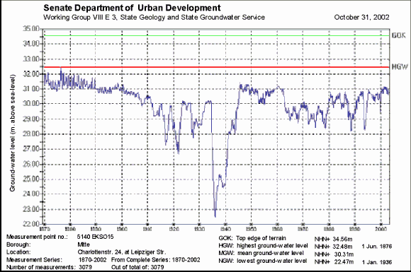
Fig. 6: Hydrographic Curve of Groundwater Levels at a Measurement Point in the Borough of Mitte, from 1870 to the Present
The Berlin groundwater measurement network grew rapidly: By 1937, measurements were already being taken at more than 2,000 measurement points. At present, following a measurement network optimization in the city area, the State Groundwater Service operates 1,140 measurement points which are screened into the five different aquifers. The measurement points are equipped with data loggers, and provide daily measurements. The Berlin Water Utility takes monthly measurements at 1,123 groundwater measurement points, predominantly in Berlin. For the most part, these are screened into the main aquifer (2nd GWL.)
The present map incorporates measurements from 1,508 groundwater measurement points, which are screened exclusively into the main aquifer (2nd GWL). At the measurement points which are measured daily, the value of May 31st 2002 was used; at the others, the monthly value for May 2002 was used.
The distribution of the measurement points is irregular: The measurement network is densest in the city center and in the immediate intake areas of the individual waterworks, and is thinner at the outskirts of the city.

Methodology
For the calculation of the groundwater isolines of the main aquifer, the irregularly distributed groundwater measurement data (base points) were transformed into an equidistant grid with the aid of a program for the calculation and graphic representation of surfaces (Surfers 7.0, by Golden Software). This was accomplished by interpolation according to the Kriging method. The 400-meter grid size produced a network of 14,241 nodes. The groundwater isolines were represented on the basis of this grid, after smoothing.

Map Description
The present map describes the groundwater situation of the main aquifer by means of groundwater isolines. These show the piezometric surface area of the unconfined and confined groundwater (see also Fig. 2).
The map basis is the General Map of Berlin, 1: 50,000, in grid format with an underlayed geological outline. In addition, the individual waterworks are indicated, with their wells and water conservation areas.

Hydrogeologic Situation
On the plateaus, the main aquifer is extensively covered by the glacial till and bolder clay (aquitards) of the ground moraines. Wherever the piezometric surface of the main aquifer lies within this aquitard, groundwater conditions are confined. This may at times result in the formation of perched groundwater in sandy areas above the glacial till (see also Fig. 2).
On the Barnim Plateau to the north, an independent coherent aquifer has developed in the Panke Valley. It is located over the main aquifer, which is covered by the glacial till of the ground moraine (aquitard). In the present map, this aquifer is indicated by an overlay (red cross-hatching). For the sake of clarity, no overlay of the isolines of this upper aquifer is shown. The incline of this groundwater also runs from northeast to southwest. A spur of the glacial till toward the Warsaw-Berlin Glacial Spillway creates an interlock of the Panke Valley aquifer with the main aquifer there.

Hydraulic Situation
As a rule, the groundwater incline in Berlin is oriented from the Barnim and Teltow Plateaus and the Nauen Plate toward the receiving bodies, the Spree and Havel Rivers.
Depression cones have formed around the wells at the waterworks; during the measurement period, they have sunk the groundwater surface below the level of the neighboring surface waters: Thus, in addition to inflowing groundwater from the shore side, the water pumped here also includes groundwater formed by infiltration from these aboveground waters (bank-filtered water) (see also Fig. 3).
However, in May 2002, the phreatic surface, which has been strongly shaped in Berlin by drinking-water discharge over the past hundred years, was, all in all, at a relatively high level, as it had been during the previous seven years. The reason for this was declining water consumption, which can be seen from the reduced raw-water discharge by the Berlin Water Utility. Five small Berlin waterworks discontinued their production altogether during the period between 1991 and 1997: Altglienicke, Friedrichsfelde, Köpenick, Riemeisterfenn and Buch. In addition, drinking water production at the two waterworks Johannisthal and Jungfernheide was discontinued temporarily in September 2001; at the latter, the same was true for artificial groundwater recharging. In the context of groundwater management by the Senate Department for Urban Development, groundwater is, however still discharged at both locations, so as not to endanger current local waste disposal and construction measures.
The overall discharge of the waterworks for drinking water purposes has dropped by over 40% in Berlin during the past 14 years (Fig. 7). In 1989, 378 million m³ were discharged, as opposed to 219 million m³ in 2002.
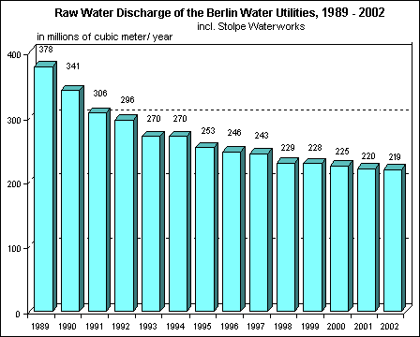
Fig. 7: Drop in Raw-Water Discharge by the Berlin Water Utility during the Past 14 Years
The drop in groundwater discharge by the Utility in the eastern boroughs was even considerably higher – at 60% – during this period. The result was a city-wide rise in the groundwater level between 1989 and 2002, which most strongly affected the areas near the wells of the waterworks in the Glacial Spillway (Fig. 8), with their deep depression cones of lowered water levels.
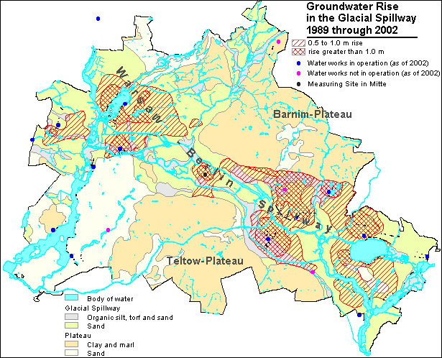
Fig. 8: Groundwater Rise in the Glacial Spillway between 1989 and 2002.

Literature
[1] DIN 4049-3 (1994):
Hydrologie Teil 3: Begriffe zur quantitativen Hydrologie. - DIN Deutsches Institut für Normung e.V.; Beuth Verlag Berlin.
[2] Hölting, B. 1996:
Hydrogeologie: Einführung in die allgemeine und angewandte Hydrogeologie. – 5., überarb. u. erw. Aufl. 114 Abb., 46 Tab.; Enke Verlag, Stuttgart.
[3] Limberg, A., Thierbach, J. 2002:
Hydrostratigrafie von Berlin - Korrelation mit dem Norddeutschen Gliederungsschema. - Brandenburgische Geowiss. Beitr., 9, 1/2, S. 65 - 68; Kleinmachnow.

