07.02 Traffic Noise
07.04 Railway Noise (Edition 2005)

Overview
Due to their close interrelationship, the present text will explain the two maps 07.02 Traffic Noise and 07.04 for Railway Noise together.
These maps constitute an update of the data of the 1993-'94 (cf. Map 07.02, Edition 1997). In addition to a representation of noise pollution due to cars, trucks, busses and streetcars, it also contains a separate representation of noise emissions from local rapid-rail and main-line railroad traffic, as well as from aboveground subway line segments.
Noise has become a permanent component of our lives, especially in major cities like Berlin. The various forms of activity in the compact area of a city – residential, commercial, transportation, etc. – almost inevitably lead to conflicts as to what is a reasonable or unreasonable level of noise. Transportation, and particularly the volume of vehicular traffic, is the main cause. During the past few years, the realization that noise is an increasingly serious ecological hazard has therefore gained ever wider acceptance. Noise can have direct or indirect effects on the well-being and even on the health of individuals. The results of noise-effect research indicate that at daytime evaluation levels of between 55 and 60 dB (A), the burdensomeness of traffic noise rises, that it increases substantially between 60 and 65 dB (A), and that health risks presumably start as of 65 dB (A); these are significantly substantiated at daytime levels over 70 dB (A). The noise effect researchers of the Federal Environmental Protection Agency consider nighttime noise impact in excess of 55 dB (A) to be the reason for damaging effects on health, because sleeplessness is a particularly serious burden on the cardiovascular system (cf. Ising et al., 1997).

How Does Noise Occur?
Described physically, sound is caused by vibrating bodies, i.e. by pressure variations within elastic media (gases, liquids, solid bodies). The pressure variations can be caused by impact, by friction, or by streaming gases (the principle of all musical instruments). The pressure variations caused disperse through the ambient medium air at high speed (330 m/s), and can be perceived by the ear if they reach sufficient intensity - if the vibrations per second (measured in hertz [Hz]) are greater than 16 and less than 20,000.
The range of pressure variations perceptible by the human ear (vibration amplitude or sound volume) is between 20 µPa (audio threshold) and 200,000,000 µPa (pain threshold). The micropascal (µPa) is the unit of measurement for this pressure.
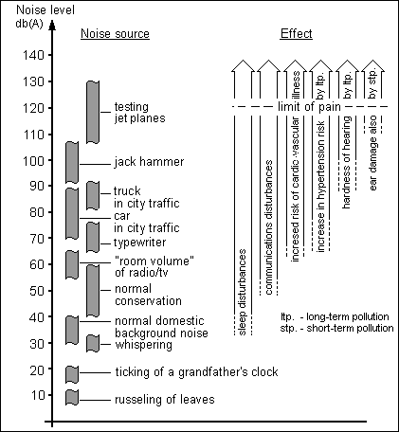
Fig. 1: Volume of Certain Noise Sources and their Possible Effects
To avoid having to deal with such huge numbers, a logarithmic unit of measurement has been introduced, the so-called decibel (dB) scale. In this case, 20 µPa, the audio threshold, equals 0 dB, and 200,000,000 µPa, the pain threshold, equals 140 dB.
The decibel scale, which describes the “sound pressure level,” is therefore not an absolute unit of measurement, such as i.e. the gram or the meter. Rather, it only specifies the relationship to the audio threshold, i.e. it tells us by how much a sound exceeds the audio threshold.
As a rule, sounds consist of a mixture of high, medium and low-frequency segments. The human ear perceives these frequency segments with various degrees of sensitivity. In order to reflect these properties of the ear, measuring devices are equipped with acoustic filters. for the usual ambient noise, the acoustic filter provides the best correspondence between the ear and the measuring device. The corrected sound volume is therefore given in “dB(A).”
The sounds which occur in our environment, including e.g. traffic noise, are rarely uniform. Rather, they exhibit fluctuation over the short term as well as in the course of the day or a week (c.f. Map 07.01 Traffic Volume, Edition 2001).
Therefore, to assess and compare sounds, it is practical to use a “mean value,” which is an average of the sound volume level occurrence.
In other words: a sound fluctuating within a particular time segment is replaced by a constant sound with a constant volume level and equivalent energy. The "assessment level" is also called the "energy equivalent constant sound volume". Thus, the mean volume is not to be understood as an arithmetic average, but as corresponding to a physically equivalent energy average. This procedure allows peak noise to be given special consideration.
The logarithmic laws are applied to calculations with sound volume. Thus e.g., the doubling of the number of similarly loud sound sources (motor vehicles) increases the sound volume by 3 dB (equals 10·log 2); a trebling by 5 dB (equals 10·log 3), ten times by 10 dB (10·log 10). A sound with a 10 dB(A) higher level is experienced as being twice as loud.
A quadrupling of the exposure time for sounds within a certain assessment period (daytime or nighttime, respectively) has a similar effect. That means that a prolongation of the exposure period, e.g. from 10 to 20 minutes, or from 2 to 4 hours, increases the mean volume by 3 dB. A shortening of the exposure period to a sound from 600 to 60 minutes would correspond to a volume reduction of 10 dB.
For comparison with limits or standards, the so-called “evaluation level” is usually given. This is distinguished from the mean or equivalent constant volume in that certain addiciton or subtraction factors are applied to take the various noise perception levels into account. In the case of traffic noise, increased perception levels for braking and acceleration sounds, especially near traffic signals, are taken into account by means of an addition factor.
The empirically demonstrated reduced perception level for rail traffic noise is taken into account by a subtraction factor, the so-called "rail bonus."

Legal Regulations
The Federal Immission Protection Law addresses precautions against noise in §§ 41 through 43, i.e. the consideration of noise-prevention interests in new construction, or significant changes in road and rail routes. These regulations have been concretized in the Traffic Noise Prevention Ordinance (16th Federal Immission Protection Ordinance (BImSchV)) and the Transportation Route and Sound Protective Measures Ordinance (24th BImSchV). If in a new construction project, or a project for significant changes in road and rail routes, the prognosis is that the limit values in Table 1 will be exceeded, noise-reduction precautions must be carried out as per these ordinances; as a rule, this means active or passive noise-protective measures.
Existing traffic noise situations are not subject to these regulations.
Under the16th BImSchV, the following pollution limits apply:
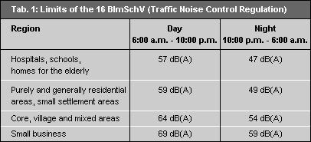
Tab. 1: Limits under the 16th Federal Immission Protection Ordinance (BImSchV) (Traffic Noise Control Regulation)
For roads maintained by the federal government - in Berlin, federal highways and city freeways - noise abatement measures are available pursuant to the "Guidelines for Traffic Noise Control on Federal Highways Subject to Federal Maintenance - VLärmSchR 97" via a voluntary obligation undertaken by the Federal Transportation Minister.
Noise abatement measures, especially the sound-proofing of windows, are possible if the assessment level exceeds the following limits:
The noise abatement measures possible under these guidelines have largely been implemented in Berlin.
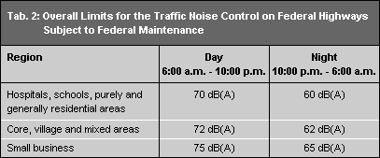
Tab. 2: Overall Limits for Traffic Noise Control on Federal Highways Subject to Federal Maintenance
Recently, an analogous regulation for noise-abatement measures on a voluntary basis for railway routes has been developed. Here, noise-abatement measures are initially intended for areas with particularly great impact. Under certain prerequisites, noise-abatement measures in the area of the transportation are also possible under traffic-law provisions according to §45 of the Road Traffic Regulation. Under this provision, the road traffic authority can impose such traffic-law regulations as a ban on truck traffic or reduced speed limits for the protection of residential population from noise and exhaust-gas pollution.

Methodology and Statistical Base

Road Traffic Noise
The Berlin road network extends over a total of approx. 5,140 km. Traffic noise levels are certified for 1,302 km of this total (as a rule, the main traffic routes; in the inner-city area, all streets with speed limits of 50 km/h; also the entire streetcar network).
The traffic-noise map "Main Road Network" portrays the calculated daytime (6 AM to 10 PM) and nighttime (10 PM to 6 AM) assessment levels. The calculations were carried out according to the technical guideline RLS 90 (Guidelines for Noise Prevention on Roads, 1990 Edition), which is applicable nationwide. The applicable limit, target and orientation values are aimed at a comparison with evaluation levels, levels which were calculated according to RLS 90. The evaluation level is obtained from the assessment levels certified in the traffic noise map by addition of correction factor with which take brake and start-up noise into account in the neighborhood of traffic signals. These correction factors are to be added as follows: for distances of up to 40 m, +3 dB; for distances of between 40 and 70 m, +2 dB; and for distance between 70 m and 100 m, +1 dB.
The basis of the calculations is the average daily traffic volume (DTV) of a route section. This value, which was determined in 1998 on the basis of extensive traffic surveys (see also Map 07.01 Traffic Volume (Edition 2001)) takes into account seasonal fluctuations share of truck traffic in the overall traffic volume, which is important for noise calculation, is also ascertained; the number of municipal public transport system busses was incorporated on the basis of the BVG's winter 2001 schedule.
Other quanta which influence the size of the assessment levels include: distance of the buildings from the roadway; types of buildings (open; closed); heights and types of the building facades (smooth or structured); numbers of lanes; speed limits; types and conditions of the road surface; possible available noise safeguards (walls; embankments); location of the road in a depression or on an embankment. The building parameters were obtained from the "Automated Berlin Real Estate Map, as of 2001" (ALK), the parameters relating to the road - as for example the structure of the road surface, the amount of the available lanes, die allowed maximum speed - were actualised in autumn 2003 by driving along the whole network.
In order to permit inclusion of the parameters mentioned as exactly as possible, the 1,302 km of the main road network which were examined was divided into 7,494 sections. The typical features were then ascertained, and roadside-referenced for each section. This also applies to the important quantum "building distance". For route sections with protruding or recessed structures, the building distance was as a rule calculated on each side in the section for the most frequently occurring distance between the buildings and the middle line of the road. For buildings with a considerably varying distance, a distance correction factor must be incorporated (rule of thumb: doubling/halving of the distance means an decrease/increase corresponding to 3 dB.
The entire streetcar network was also incorporated into the Traffic Noise Map. The evaluation level solely for streetcar traffic was calculated according to SCHALL 03 (the calculation regulation for rail-traffic noise) on the basis of the 2001 winter schedule (including non-service trips). According to the SCHALL 03 stipulations, the evaluation level was ascertained by subtracting the "rail bonus" of 5 dB from the assessment level of streetcars. The rail bonus is allocated due to the lower burdensomeness of rail traffic compared with vehicular traffic. Among other things, the calculation takes into account the building situation as well as the type of track bed (e.g., gravel bed or rail flush with the roadway), not however particular types of streetcar trains (Tatra trains, low-body trains, ...). As for vehicular traffic, evaluation levels are calculated for every track section-side for both daytime and nighttime.
For street sections affected by motor vehicle and streetcar noise, the total level is represented in the map.
In addition to the levels for the roadside buildings, standardized assessment level (motor vehicles) or evaluation level (streetcar) at 25 m distance from the respective outer right lane is stated, particularly for planning purposes. Any existing reflective buildings are not taken into account for the calculation of this level. If the required resulting air sound absorption of external structural components is to be determined on the basis of an evaluation level as per DIN 4109 obtained from the file (i.e., for determining the dimensions of windows), the "applicable external noise level" required for that purpose is obtained by adding a correction factor of 3 dB to the evaluation level.
For the presentation of the map in the Internet, the road sections of the counting network were assigned to the block sides of the digital map 1:5000 (Digk 5) facing the street. Block corners strongly angled to intersections were assigned only when a clear assignment to one side of a street was possible.

Railroad Traffic Noise
The railroad traffic noise map covers the 246 km long above-ground main-line, rapid-rail (S-Bahn) and subway (U-Bahn) network (in many cases, jointly-used routes). Station areas, loading areas for goods, and track junctions were not considered, due to unusual features which the calculation model does not cover.
The basis for the calculation are operational data of the German Railway (Deutschen Bahn AG) and the BVG, based on the 2003-'04 winter schedule. The evaluation levels at the respectively nearest buildings were ascertained according to SCHALL 03, the nationally applicable regulation for railroad traffic noise calculation. For as detailed as possible an ascertainment of the basic data needed for the calculation, the network was divided into 1,586 sections, and all required values (number of trains per a type of train, speeds, types and distances of buildings, types of track body, bridges, radii of curves, etc.) was ascertained, specific to the respective section side. As with streetcars, the evaluation level incorporated the "rail bonus" allocated under SCHALL 03 (discount of 5 dB of interference, due to the lesser burdensomeness of railroad traffic in comparison with vehicular traffic).
For route sections with protruding or recessed structures, the level was as a rule calculated at each section for the most frequently occurring distance between the buildings and the middle line of the track. For buildings with a considerably differing distance, a distance correction factor must be incorporated (rule of thumb: doubling/halving of the distance means an decrease/increase corresponding to 3 dB). A standardized evaluation level in 25 m of distance was calculated for the respectively outer right track (without consideration of buildings) in addition to the daytime or nighttime overall evaluation level of the buildings of the respective section-side, for planning purposes.
In addition to the daytime and nighttime overall assessment level at the buildings in the respective sections, a standardized assessment level at 25m distance from the respective outer track was calculated for planning purposes, with no consideration for any buildings.

Use of the Data Elements in the Noise Map
Inevitably, the noise maps themselves contain only a part of the existing data in their cartographical sections. E.g., it is not possible, at the scale 1: 50,000, to correctly represent the effect of traffic signals, which is necessary for the establishment of the evaluation level. Under RLS 90 correction factors of from 1 to 3 dB could be provided up to a distance of 100 m. This would yield the evaluation level for which the above-mentioned orientation or limit values apply. In the other areas, the evaluation level equals the assessment level represented.
The level classes represented in the Noise Map, with a class width of 5 dB (A) show the noise immissions at 3.5 m above ground, in front of the building facades affected by the traffic noise, at a distance representative of the respective road section, between the building façade and the nearest lane axis.
However, in the present new version of the Noise Maps, a possibility was created for obtaining even more detailed information about the selected section, by means of the expansion of the data indication. In addition to the code number of the section, by means of which further information can be assigned from the traffic noise register from the Senate Department of Urban development, this also contains the following parameters:
- Designation of the borough in which the section is located;
- Street name;
- Assigned Statistical Block;
- DTV for motor vehicles and trucks, right and left sides of the street ascertained separately;
- Number of BVG busses, day and night, right and left sides of the street ascertained separately;
- Number of streetcars day and night, right and left sides of the street ascertained separately;
- Distance from roadway center line to building, right;
- Distance from roadway center line to building, left;
- Distance from streetcar center axis to building, right;
- Distance from streetcar center axis to building, left;
- Overall assessment level at buildings; right and left sides of the street ascertained separately;
- 25 m overall assessment level at buildings; right and left sides of the street ascertained separately; and
- Number of residents affected.
For the area of railroad traffic:
- Name of the station, for sections which correspond to a station;
- On the route from ....;
- On the route to ....;
- Designation of the borough in which the section is located;
- overall assessment level at buildings; right and left sides ascertained separately;
- 25 m overall assessment level at buildings; right and left sides ascertained separately.
The data on the right and left, respectively, refer to the route-related evaluation direction; this is represented in Map 07.02, Edition 2005 by connection to the concerned blocs and in Map 07.04, Edition 2005 by arrow symbols. The data of the 25 m evaluation level refers to an immission location at a standardized distance from the center line of the road/track section, and is particularly designed to permit an evaluation of the noise situation in areas where no roadside buildings exist.

Note
The stated noise levels represent general information about the traffic noise burden of a street section. If certified specific information or further data on traffic noise burdens is required, please consult the department responsible, Referat IX D, of the Senate Department for Urban Development. This information is, however, provided for a fee, according to the Environmental Fee Scale.

Map Description
The present maps show clearly that the traffic, which has increased considerably, both inside the city and between the city and its surrounding areas since the political change, causes very great noise pollution. Vehicular traffic predominates, but many residents are also exposed to considerable burden due to rail traffic.
For the assessment of the impact situation, the reference values 65 dB (A) daytime and of 55 dB (A) nighttime, which have been determined by noise-effect research, are used in the following; these values have also been established as target values under the Berlin Noise Level Reduction Plan (cf. Ising et al., 1997).

Road Traffic Noise
In Table 3 the lengths of the sides of the street affected by the individual level classes, and their proportional shares of the total length, are shown.
For daytime noise, the reference value of 65 dB (A) is exceeded on 1,334 km of built-up section-sides (which corresponds to 59.8%). Assessment levels of over 80 dB (A) could no longer be ascertained; on the other hand, traffic noise below 50 dB (A) is the exception (0.9%) in the primary road network.
For nighttime noise, the following situation has been ascertained: The nighttime reference value of 55 dB (A) is exceeded at almost 80% of the road sections with roadside buildings. The predominant nighttime impact (59%) is in the range of 55-65 dB (A). Assessing the Berlin noise situation based on the above target values, it must be assumed that daytime noise pollution would have to be lowered by up to 15 db (A) for about 1,330 km of roadway, and nighttime pollution by that amount on as much as 1,780 km.
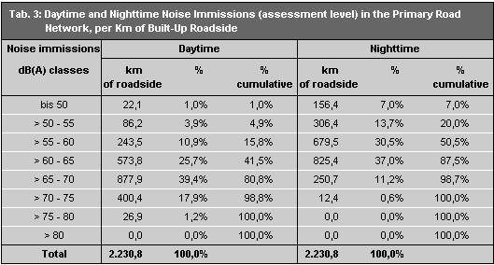
Tab. 3: Daytime and Nighttime Noise Immissions (assessment level) in the primary road network, per km of built-up roadway (* = including construction sites, tunnel routes and roadside building presence of less than 10%).
In addition to the level of impact, the number of residents impacted by traffic noise along the main road network streets was assessed.
For this purpose, the buildings present at a distance of up to 1.5 times the distance used for the level calculation were first ascertained. The numbers of affected person was calculated on the basis of the number of storeys of these buildings used for residential purposes, the number of apartments per storey, the mean household size in each borough, and with a factor for the probability of presence in the rooms adjoining the street or railway route. These data do not reflect actual populations along concrete road or track sections.
Altogether, more than 220,000 affected persons in the main road network streets examined were ascertained, who were subjected to assessment levels greater than 65 dB (A) in the daytime, and more than 280,000 such persons who were subjected to noise pollution in excess of 55 dB (A) at nighttime.
The number of persons affected in the individual level classes can be seen in Table 4, below.
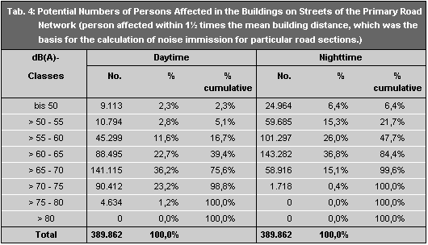
Tab. 4: Potential persons affected in the buildings on streets of the primary road network
(Persons affected within 1½ times the mean building distance, which was the basis for the calculation of noise immission for particular road sections.)

Railroad Traffic Noise
Aboveground railroad traffic, with a total of 386 km of built-up track section-sites, is far less extensive that road traffic. Nevertheless, particularly along inner-city track sections, it causes (additional) high noise pollution. The daytime noise level along 25% of the built-up sections is over 65 dB (A); nighttime levels of over 55 dB (A) have been calculated along 53% of all built-up sections. The very high speeds of passing freight trains on the Berlin outer ring are also a major factor here. In the area of the rapid rail (S-Bahn) system, with its relatively low building distances, noise levels of more than 70 dB (A), and at places with steel bridges, maximum values of over 75 dB (A), are reached. Considerable impacts are caused by the above-ground segments of subway lines. The main problem areas are the viaduct segments in Schöneberg, Kreuzberg and Prenzlauer Berg. The nighttime interruption of operation of rapid-rail and subway traffic provide a measure of relief.
The following Tables 5 and 6 show the lengths of the built-up section-sides of the streets affected, and the number of persons affected for the individual level classes.
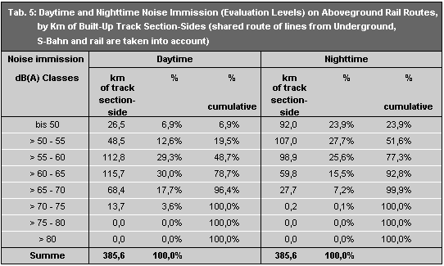
Tab. 5: Noise Immissions, (evaluation levels), Daytime and Nighttime on Abve-Ground Rail Lines, per Km of Built-Up Route Section Side
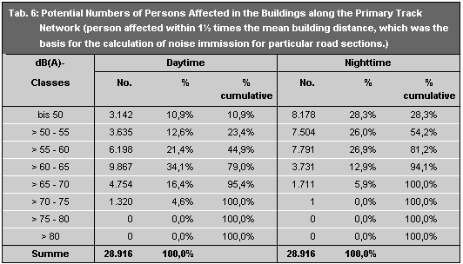
Tab. 6: Potential Number of Persons Affected in the Buildings along the Primary Track Network
(persons affected within 1½ times the mean building distance, which was the basis for the calculation of noise immission for particular track sections.)
The results of the surveys carried out support the great need for action for the development and implementation of a comprehensive noise-level reduction planning. The necessary relief is attainable - if at all - only by medium and long-term measures. In addition to improvements in vehicle technology leading to reduction in noise emissions, traffic organizational and structural measures will also have to be considered, in order to contribute to this relief. As a first step, such comprehensive noise-level reduction plans are currently being prepared in three pilot projects under contract with the Senate Department of Urban Development.

Literature
- Ising, H., Babisch, W., Günther, T., Kruppa, B. 1997:
”Risikoerhöhung für Herzinfarkt durch chronischen Lärmstreß”, Zeitschr. f. Lärmbekämpfung Bd. 44 (1997) S. 1.
- IVU (Gesellschaft für Informatik, Verkehrs- und Umweltplanung GmbH) 2002:
Verkehrslärmkarte Berlin, Berechnungsgrundlagen, Methodik, Ergebnisse, Gutachten im Auftrag der Senatsverwaltung für Stadtentwicklung IX D, Februar 2002, Berlin.
- SenStadt (Senatsverwaltung für Stadtentwicklung) 2001:
Verminderung der Lärmbelastung und Luftverunreinigung durch den Kraftfahrzeugverkehr, Mitteilung an das Abgeordnetenhaus von Berlin, Drucksachen Nrn. 13/849 und 13/1405 -Schlussbericht-,Berlin
- SenStadt (Senatsverwaltung für Stadtentwicklung) 2002:
Emissionskataster Verkehr 1998/1999, Methodik und Ergebnisse, Berlin.
- Umweltbundesamt (Hrsg.) 1993:
Umweltdaten kurzgefaßt, Berlin.

Laws and Ordinances
- Der Bundesminister für Verkehr 1990:
Richtlinien für den Lärmschutz an Straßen RLS-90, Allg. Rundschreiben Straßenbau Nr. 8/1990, Bonn.
- Der Bundesminister für Verkehr 1997:
Richtlinien für den Verkehrslärmschutz an Bundesfernstraßen in der Baulast des Bundes VLärmSchR 97, Allg. Rundschreiben Straßenbau Nr. 26/1997, Bonn.
- Verkehrslärmschutzverordnung vom 12.6.90, 16. VO zur Durchführung des Bundes-Immissionsschutzgesetzes, BGBL 1990 Teil I S. 1036.
- Verkehrswege-Schallschutzmaßnahmenverordnung vom 4.2.97, 24. VO zur Durchführung des Bundes-Immissionsschutzgesetzes, BGBL 1997 Teil I S. 172.
- Vorläufige Richtlinien des Bundesministeriums für Verkehr für straßenverkehrsrechtliche Maßnahmen zum Schutz der Bevölkerung vor Lärm (Lärmschutz-Richtlinien StVO).

Digital Maps
- SenStadtUmTech (Senatsverwaltung für Stadtentwicklung, Umweltschutz und Technologie) (Hrsg.) 1995:
Berlin Environmental Atlas, extended and revised Edition 1995, Map 07.01 Traffic Volumes, 1 : 50 000, Berlin.
Internet:
http://www.stadtentwicklung.berlin.de/umwelt/umweltatlas/ei701.htm
- SenStadt (Senatsverwaltung für Stadtentwicklung) 2001:
Berlin Environmental Atlas, extended Edition 2001, Map 07.01 Traffic Volumes, 1 : 50 000, Berlin
Internet:
http://www.stadtentwicklung.berlin.de/umwelt/umweltatlas/eia701.htm
- SenStadtUmTech (Senatsverwaltung für Stadtentwicklung, Umweltschutz und Technologie) 1997:
Berlin Environmental Atlas, Edition 1997, Map 07.02 Traffic Noise at Roadside Development, 1 : 50 000, Berlin.
Internet:
http://www.stadtentwicklung.berlin.de/umwelt/umweltatlas/ei702.htm

