06.07 Urban Structure (Edition 2008)

Overview
Both the natural landscape and the development of urban settlement have made their mark on the urban structure of Berlin.

Development of Urban Settlement of Berlin
The appearance of Berlin changed most markedly at the end of the previous century, as the city developed into an industrial center. With increasing work opportunities, many people came to Berlin, and a growing need for housing was the result. The building activity was regulated by development plans and building codes, in which street limit lines, the size of the blocks, the minimum size of courtyards and the floor spaces of buildings were stipulated. Thus, Berlin's typical dense block development with a courtyard structure emerged between 1880 and 1918 within the City Rail Circle Line. It was interspersed only by scattered decorative squares and parks, and by cemeteries.
In the then-suburbs (such as Friedenau) the building code of 1892 permitted a lesser degree of property exploitation than in the inner city. In these areas, lower and somewhat more generously-planned block developments emerged, with decorative features and a garden-court structure, as well as villa development.
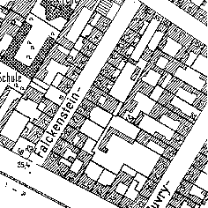  Closed block development (up to 1914), including integrated blocks with preservation-oriented rehabilitation | 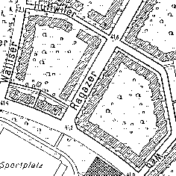  Large greened quadrangles or with loose rows (development of the '20s and '30s, or the '50s and '60s)
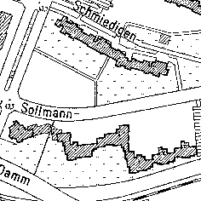
High-rise residential areas on the outskirts (development of the '70s and '80s), with generously designed green fringes between the buildings
Fig. 1: Berlin's Urban Development during Three Periods

After 1918
New designs developed extensively only after 1918, when the construction of wings and rear buildings was forbidden by law. At the same time, public housing construction companies took over from private builders the role as main actors in the area of residential construction. They replaced the until-then prevalent lot-by-lot development with the construction of larger, coherent subdivisions outside the Circle Line, in what was then the outskirts. This development was favored by the 1920 consolidation of Berlin with its surrounding communities to form Greater Berlin, which made uniform planning possible. Also, the open spaces associated with housing developments were accorded greater significance, which was manifest in the greater size, usefulness and design of these open spaces, but also in the designing of public open space. Later, the large public parks and allotment garden facilities emerged, which extended in a ring shape around the turn-of-the-century inner-city core.

After 1945
Massive destruction during World War II and the political division of Berlin in 1948 influenced the further course of urban development. Some 30 % of all buildings had been destroyed totally or severely damaged.

West Berlin
West Berlin received economic aid as part of the reconstruction program (Marshall Plan). As a result, the war-time destruction could be eliminated quickly by large-scale building activity during the fifties and sixties. In the inner city, vacant lots caused by the war were closed, and whole blocks were reshaped by large-scale reconstruction and by de-coring coupled with demolition and new building construction. The developmental goals were at that time the relief of the density of inner-city development and the dispersion of municipal functions. In the outskirts, large new self-contained subdivisions emerged with relatively high shares of open space, and with industrial areas on former open spaces between old village cores. During the seventies, construction policy concentrated on the revival of the inner city. Building activity was limited essentially to small vacant lots scattered throughout West Berlin, and on the preservation-oriented reconstruction of existing structures.

East Berlin
n East Berlin, which received no economic support, but was, on the contrary, burdened by reparations, reconstruction began on a large scale only after construction of the Wall in 1961 and with the industrialization of the East Berlin construction industry. The emphasis during the sixties was on the recreation of the center of the city on areas wiped out and cleared as the result of the war. At that time, the long-term plan was to tear down the entire pre-war building stock everywhere as the inheritance of capitalism, and to replace it with developments built in the socialist architectural style. Relatively little new living space was created during the fifties and sixties. In 1971, therefore, the housing program was proclaimed as the main focus of the social program. The large satellite towns of Marzahn, Hellersdorf etc. were erected on the outskirts of town by means of industrial prefabrication. At the same time, the existing old-building stock was once again considered living space worthy of preservation, and was rehabilitated with varying degrees of intensity.

After 1989
Altogether, approximately 181.000 apartments were built again in Berlin between 1990 and 2005, the total number of apartments raised from 1.7 million to 1.88 million. Approximately 60 percent of all reconstructions were erected as small supplements of the existing structure. Until 1992, the development with prefabricated houses situated in the east part of the city were completed. In the west part, only insignificant supplements were performed in this phase. 1993 to 1997 new suburbs in the outskirts were erected, like for example on former fields in Karow-Nord, as well as in downtown numerous big projects, like the Potsdam place or the government constructions. Since 1997, the housing reconstruction is retrograde in the entire conurbation and reached 2000 again the level of 1991 because of the reduction of finance supports. The construction of single houses is, after a maximum in the east districts and in the conurbation 1998 and 1999, also easily declining. Large parts of the city center with old buildings in the east part of the city were reconstructed by government aid, like more than 80 percent of the settlements with prefabricated houses.
The office space had also increased by 7 million m², sales area today with 1,5 million m² is clearly over the increase assumption of the masterplan of 1994 for 2010.
The 5 years period till 2005 was affected by an overall small consumption of space for construction purposes, a strong decrease of higher apartments construction in reaction to the existing vacancy of apartments and increasing consumption for commerce on great areas, single family house construction and traffic facilities.
The general urban and environmental planning is a process, what needs a continuous monitoring. The aim is to audit the presumed development on the basis of the actual progression. For the period of 1990 - 2005 these basic data are presented within a report of landuse (Stadtentwicklung 2000, Bericht zur Flächenentwicklung 1990-2000 / 2001-2005, only in german).
Unforeseen developments, like social and spatial segregation, clearance of surfaces, vacancy of apartments and decrease of financial resources, demand new strategic considerations about the planning of urban development, like it was presented with the project of the concept of urban development Stadtentwicklungskonzept Berlin 2020. It is assumed that there will be an essential reduced projected growth until 2010: stagnating rate of inhabitants and jobs, 45,000 additional apartments, 480 ha new commercial areas, 4.5 million m² and 0.4 million m² additional office and retail space.

Open spaces
Remainders of agriculturally-used areas as well as landscapes characterized by water and forest have remained undeveloped to this day: These include the Köpenick Forest in the southeast of Berlin between the Spree and the Dahme, the Grunewald Forest in the west, along the Havel, as well as large intact agricultural areas in the northeast of the city. Some residential areas with their forest and orchard stands, such as the Uncle-Tom development in Zehlendorf, show signs of the previous landscape character of the area. Of the once-plentiful brooks, culverts and wet-lands, only a few can still be found.
Over the course of time, a multilayered structure of construction and open space has emerged in Berlin. On the present map, the various urban structural types are delimited and described. They are based on various section types, which are defined according to their typical use, time of origin and construction, and open-space structure. For reasons of representability, they have been grouped together into urban structural types.
The knowledge of these various structural types forms an essential basis of all urban development and landscape-planning standards, both at the local and at higher levels. However, this knowledge also permits information to be derived regarding the formation of biotopes and vegetation structures, climate relationships, condition of the soil, and the degree of soil impermeability, and the new formation of groundwater.

Statistical Base
The map was updated on the statistical base of the edition 2005, edition 2002 and edition 1995 (see text there)
The update of the edition 2007 (data base 31.12.2005) was implemented by an external contractor. Changes of land use between 2001 and 2005 were mapped and adaptations of geometries of the Digital Map of Berlin 1:5,000 (ISU 5) were made. The following statistical bases were used:
- Digital Map of Berlin 1:5,000 of the Urban and Environmental Information System (ISU) of the Senate Department for Urban Development, IIIF; status: 2005-12. with new block segments and actual block numbers
- Geometrical changes of the blocks from the Spacial Framework (Räumliches Bezugssystem RBS) of the Department of Statistics (Amt für Statistik in Berlin-Brandenburg, formerly Statistisches Landesamt Berlin) 2002-2005
- Digital aerial photographies (orthophotographies), 2006, SenStadt Abt. III (archive for aerial views)
- Area inspection by Cornelia Nitzsche
- Update and mapping of all railroad areas, 2007, Geoinfo, Cornelia Nitzsche
With help of the data bases specified above, limitations, use and section type of altogether 806 sections and 696 railroad sections (compared to edition 2004), were defined.
The Umweltatlas Maps (Environmental Atlas) 06.01 "Actual Use of Built-up Areas", and 06.02 "Inventory of Green and Open Spaces", were compiled simultaneously with the present map and record the actual land use of Berlin on the basis of 21 different classes (cf. Tab. 1).
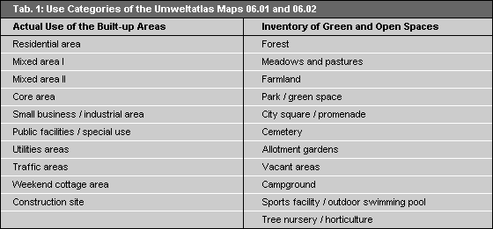
Tab. 1: Use Categories of the Umweltatlas Maps 06.01 and 06.02
These classes are shown according to the predominant use at block or block-segment level.

Methodology

Section Types
The fundamental differentiation is between section types of predominantly residential use and section types with other uses.
The section types of predominantly residential use were further broken down according to their typical construction and open-space structure and their dates of construction.
In contrast to these section types dates and structure of construction are irrelevant for all other section types. They do not have any characteristic appearance, but only a typical signature of use.
In addition, each section type is described by its soil-impermeability (i.e., "sealing") percentage, percentage of built-up surface area, and its distribution of differently permeable surface covers.
Altogether, 62 different section types were designated, and were assessed and represented on basis of the categories in the UIS records. The categories correspond to the statistical blocks, which were further subdivided, in cases of different use within a block, into uniform-use block segments.
You will find a detailed definition and description of the section types in the following pdf-document (3.4 MB)

Structure Types
or display in the present map, similar section types were grouped together to form a structure-type group. The assignment to structure types is shown in Table 2.
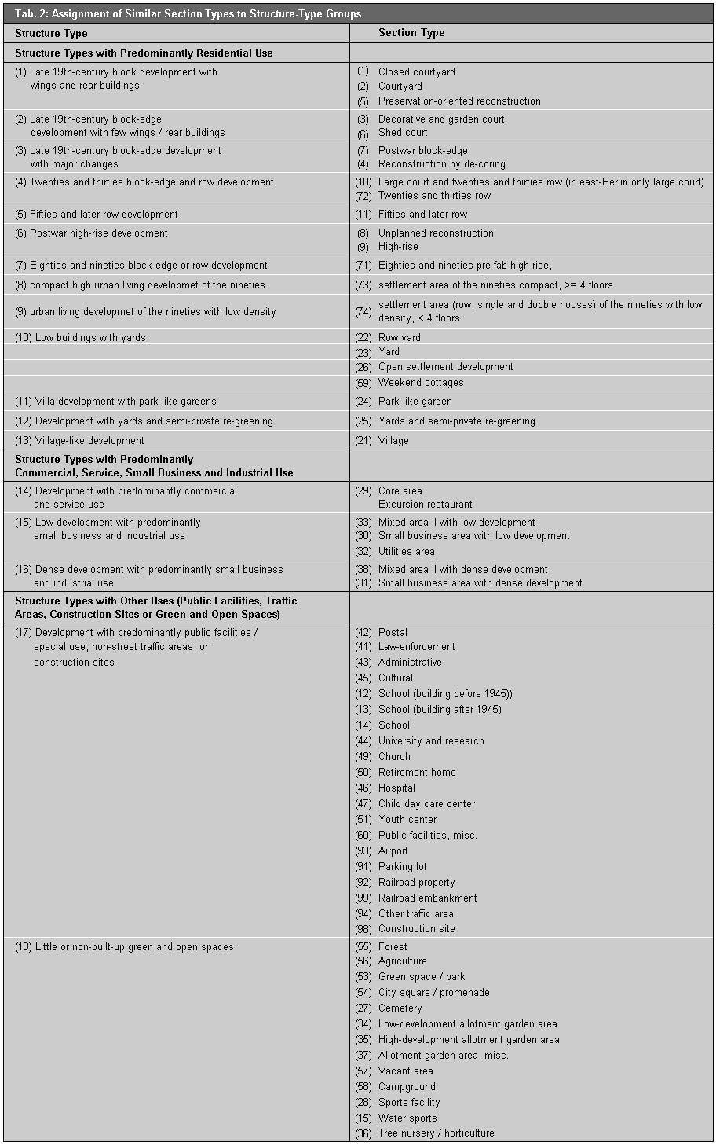
Tab.2: Assignment of Similar Section Types to Structure Type Groups
The structure types with predominantly residential use occur only in blocks or block segments which are designated in the Map "Actual Use of Built-up Areas" as residential areas, or as Mixed Areas I. The structure types with predominantly commercial, service, small business and industrial use exist only in blocks or block segments of the categories Core Area, Mixed Area II, Small Business and Industrial Area, Utilities Areas and, in individual cases, Mixed Area I. The structure types with other uses occur in blocks or block segments of the categories Public Facilities / Special Use, Traffic Areas, Construction Sites, and of all categories of Map 06.02 "Inventory of Green and Open Spaces."

Update of Section Types Based on the Digital Map of Berlin 1:5,000 (ISU5)
All information about actual land use is managed and processed at the ISU (Informationssystem Stadt und Umwelt: Urban and Environmental Information System). This makes possible a graphic data processing of the factual data on basis of a uniform spatial reference system.
The spatial reference system (edition 2007) is provided by the digital map of Berlin in a scale 1:5,000 - the ISU5 of the ISU (Urban and Environmental Information System). This map differs from former editions based on ISU50 (generalized map for the scale 1:50,000) by its higher accuracy due to its scale of 1:5,000. It shows each individual statistical block, which is as a rule delimited by streets like in the ISU50. The numbering and limitation of the blocks are carried by the State Statistical Office (Statistisches Landesamt).
The smallest reference segment is formed by the block segments, which were delimited for different land use within a statistical block.
The uniform reference system makes possible a clear spatial identification of all factual data. Over a common key, which contains, among other things, borough, block and block segment numbers, these data are assigned to the spatial reference system.
Streets do not have any area in the ISU spatial reference system. The course of the street is described by the boundaries of the individual statistical blocks.
The data on actual land use are stored in the use data base. This data base contains, in addition to a statement of the actual land use of a block and/or a block segment, further information about the area size, the section type, the sealing degree, the distribution of differently permeable surface covers.

Update of the Digital Map of Berlin 1:5,000 (ISU5)
The update of the edition 2007 was implemented by an external contractor by means of aerial photography and personal area inspections. Changes of land use between 2001 and 2005 were mapped. Adaptations of geometries and actual block numbers from the department of statistics (Amt für Statistik Berlin-Brandenburg) were made.
According to the methodology of portraying uses and types of areas of the Environmental Atlas Berlin blocks were separated into block-segments. This happened when the current use of a block area could be separated into a residential or open-space type of use. These block-segments were documented by a unique code in the GIS database and the statistical data base.
All together 806 new block/block-segments were created.
Further all railroad properties were updated in 2007, altogether 696 railroad properties and rails were marked off.
Fundamentally, a single block or block segment received only one section-type designation. If different section types existed within a block or block segment, such as "yard" and "fifties and later row," the dominant section type was chosen. The following text describes the essential attributes of the single structure types.

Structure Types with Predominantly Residential Use

Late 19th-century block development with wings and rear buildings
This construction structure is marked by closed or almost-closed, predominantly five to six-story block-edge development. According to this section type, the individual properties are built up along more than one, or even all, sides, with a front building, wings and a rear building. The development originated in the years 1870-1918. As part of the preservation-oriented reconstruction at the end of the seventies and in the eighties, former vacant lots were filled by new buildings, and old buildings were renovated. Demolition was carried out only in isolated cases. In East Berlin, the areas rehabilitated at the beginning of the seventies are included, in which relatively large-scale demolition of rear buildings and consolidation of courtyards was carried out.
The open-space structure is marked by crooked block interiors. These consist of entirely or largely enclosed, narrow courtyards, sometimes arranged in a row, and connected by court passages. The courtyards are mostly paved with concrete, asphalt or stone. Sometimes the building edges are planted with decorative flower beds, or single tree is found in the courtyard.

Late 19th-century block-edge development with few wings/rear buildings
In this construction structure, four-story, almost closed block-edge development predominates. The individual properties are built-up with a front building and wings or a rear building. The development emerged mainly between 1892 and 1918; in some cases, older buildings are integrated. The share of the "shed-court" type, which emerged before 1892 and consists mostly of two to three-story houses, some with a village-like structure, increased over time. The block edge is closed only partially. The individual properties are built-up in the rear with one- or two-story sheds.
The open-space structure is distinguished by front yards. The block interior is indented (with wings) or longitudinal (with rear buildings), and not subdivided by fences at the property boundaries. The block interior of the type "shed court" is further subdivided by closed courtyards, which are formed by walls and sheds. Cobblestone pavements prevail as the surface covering. At the edges of the court area, spontaneous vegetation prevails. Industrial use is more frequent than garden and orchard use. With the type "decorative and garden court," on the other hand, the garden-like formation with fruit trees and flower beds dominates.

Late 19th-century block-edge development with major changes
This construction structure is marked by five to six-story, largely closed block-edge development, interspersed in some cases by entrances, parking lots and scattered vacant lots. This structure developed out of previous late 19th-century courtyard development. The high share of post-World-War-II new buildings at the block edges results from the closing of vacant lots (postwar block-edge) or is a consequence of rehabilitation measures, in which buildings with poor structural soundness were demolished and were replaced by new buildings. The courtyard structure of the "postwar block-edge" type was changed by demolition of individual rear buildings and, for the "reconstruction by de-coring" type, by demolition of nearly all rear buildings.
The open-space structure has a relatively open, coherent block interior, compared with the former courtyard development. In the section type "postwar block-edge," the block interior is subdivided by fences along the non-built-up property edges. In addition to the old late 19th-century court formations, one finds, in the new or restored courts, paved parking lot areas, in some cases with landscaped edges. In the type "reconstruction by de-coring," the block interior is often designed as a common space for residents, with playgrounds, paths, and easy-to-care-for green spaces.

Twenties and thirties block-edge and row development
The construction structure is mostly three to four-story, closed or almost-closed block-edge or open development with parallel longitudinal rows of houses. For exposure, the rows extend mainly in east-to-west direction. In some cases, the severity of the row development is loosened up by cross buildings at the block ends, or by a mixture of row and edge development. This section type emerged mainly in the twenties and early thirties.
The open-space structure is marked by large, coherent block quadrangles or by longitudinal, non-closed intervals between the rows. Typical is the distinctive landscaping, with green space areas and scattered trees, as well as hedges along the entrance areas and around the playgrounds and trash-can areas; in some cases, the courts are used as tenant gardens. A low proportion of paved area is typical, since the block interiors are not to be used as parking lots.

Fifties and later row development
In this construction structure, rows of four-story houses prevail. They were laid out initially mainly in an east-to-west direction; later, they were also built staggered in displaced order, or along curved blocks.
Relatively large, longitudinal, non-closed open spaces between the rows of houses characterize the open-space structure. About a third of the open space is used as parking lots and for access driveways. Ornamental green spaces with scattered trees and bushes predominate. Playgrounds, trash-can areas and parking lots are mostly lined by bushes and trees. In the developments built during the seventies, the share of green space was reduced in favor of raised flower beds along broad access driveways.

Postwar high-rise development
Large, high rows and single houses with varying floor-spaces mark the construction structure. The type "high-rise" means at least eight floors in West Berlin, and at least six floors in East Berlin. For the West Berlin types "unplanned reconstruction" and "high-rise," the order of the buildings within the block appears open, without recognizable rules. The prefab concrete buildings laid out in East Berlin as large-scale developments were built partly in semi-open block-edge style, and partly mixed with row development. The section type "unplanned reconstruction " emerged after 1945 on blocks of former late 19th-century block-edge development, while the type "high-rise" emerged in West Berlin predominantly during the sixties and seventies, and in East Berlin during the seventies and the beginning of the eighties, mostly in the form of large-scale developments.
The open-space structure of the large-scale developments in East Berlin in semi-open block-edge development of the type "high-rise," displays a relatively large block interior, which is partly broken up by building rows in the block interior. For the type "unplanned reconstruction," undeveloped areas are used relatively sparingly, mostly as parking lots; the remaining open areas are green edge-strips. The share of the non-built-up areas is relatively large for the type "high-rise." Half of the area is paved by large access driveways and parking lots, the other half is landscaped as ornamental green space, geometrically designed with trees and shrubs.

Eighties and nineties block-edge or row development
Three to five-story, semi-open or closed block-edge development, or a mixture of rows and block-edge development in pre-fab concrete-type construction characterize the construction structure. These large-scale developments were built in East Berlin during the eighties and nineties.
The open-space structure consists of relatively large open spaces. The block interior is partly subdivided by building rows. Approx. a third of the non-built-up area is used as parking lots or for access driveways; otherwise, ornamental green spaces with landscaped trees and bushes predominate.

Compact, high urban living development of the nineties and urban living development with low density of the nineties
The big settlements created since the beginning of the nineties differ considerable from the typical big settlements with prefabricated houses erected almost exclusively in East Berlin. They include a wide span of city structures, (e.g. block edge development row development, row-house development, villa development). To enable a differentiation of the big settlements with prefabricated houses of the younger reconstruction areas, two new section types were defined on the basis of the height of the buildings. These areas are usually bigger housing projects in the framework of city development (e.g. water city Spandau, Rummelsburger bay or Karow north).
The section type compact, high development of the nineties is characterized by houses with more than 4 floors with closed yards or half closed yards, partially also with row development. These developments are erected with common infrastructure installations (shopping center, school, kindergartens, energy supply, waste disposal facilities etc) and sometimes in a ecological way of constructing. The structure of open spaces consists of big, publicly usable lawns with rainwater seepage facilities, partially with roof and facade greening and small, privately usable terrace gardens. The average seal degree for 250 areas is approximately 54 %, (spans 20 % until 90 %), the average development degree 33 %, (spans 10 % until 75 %).
The section type urban living development with low density of the nineties consists of rows -, double and one-family houses with fewer than 4 floors, erected mainly at the outskirts. Carports and private gardens etc. are usually on the small private properties, in the case of block structures in the interior areas. The share of publicly usable open spaces is rather low. The average seal degree for approximate 80 appraised areas lies at 50 % (spans 25 % until 80 %), the average development degree is 30 % (spans 10 % until 60 %). The inhabitant density is clearly lesser than in the compact, high development of the nineties.

Low buildings with yards
Mostly one to two-story developments with row houses and closely-built semi-detached houses, single family houses and smaller apartment houses or weekend cottages characterize this construction structure. Until 1945, the buildings were built around the block edge along a uniform building line. After the war, the row houses were frequently staggered along access streets and walkways in the block interior, and the single family houses were erected at irregular distances from the street and, ever more frequently, in the rear of the property, as second houses (hammer-shaped lot). With this type of "open settlement development", single-family houses, workshops, garages and summer homes appeared at various times, without any planning.
The open-space structure of settlements erected before the war of the types "row-yards" and " yards " is marked by uniformly broad front yards and a large block interior, which is broken up only by property enclosures. With all other settlements of this type, the block interior is interspersed with houses. The non-built-up areas are as a rule used as fruit, vegetable, or ornamental gardens.

Villa development with park-like gardens
Predominantly two-story, open block-edge developments with villas behind a uniform building line mark the construction structure. For the buildings, which emerged between 1890 and 1930, a large building volume is typical.
The open-space structure is marked by uniformly broad front yards and the large block interior, and property enclosures with dense hedges or old masonry. The large yard properties have old tree populations on green spaces, in some cases also vegetable gardens and flower beds.

Development with yards and semi-private re-greening
This construction structure is marked by open, multi-story block development with rental and studio apartment houses between single family houses and villas. This type has emerged since 1950 by demolition and condensation of the development of the types "yards " and "park-like garden."
A block interior interspersed by larger buildings characterizes the open-space structure. The non-built-up areas are used as yards, or are landscaped uniformly with creepers and ornamental bushes, with pathways reinforced by concrete pavement, and parking lots as well as by gravel strips surrounding the houses.

Village-like development
This construction structure can be described as mostly one or two-story - or, near the city, multistory - development. Between the houses of the former village cores, new buildings of different size have emerged.
The open-space structure is characterized by the preservation of such village elements as the lay-out of the streets, the village green, the village pond, the manor park, or the church grave-yard. The open spaces are used as vegetable gardens or orchards, garden cafés, warehouses for commercial enterprises, workshops etc..

Structure Types with Predominantly Commercial, Service, Small Business and Industrial Use

Development with predominantly commercial and service use
Typically; this type has a high, 75-100% proportion of commercial and service enterprise. The "core area" type is as a rule built very compactly, and occurs mainly in the center of Berlin. The non-built-up parts of the core areas are used intensively, mostly as supply areas and as car parking spaces for staff members, customers and visitors; accordingly, they are often reinforced with asphalt, concrete or stone pavement systems. The section type "excursion restaurants" covers larger excursion restaurants in rest areas. For the non-built-up areas of this section type, large terraces, yards and access driveways, as well as many parking spaces for cars are typical.

Low development with predominantly small business and industrial use
These areas are marked by industrial development with predominantly one or two-story halls and building complexes and generous marginal areas. Under the category "utilities areas," this also includes the buildings and property areas of the electricity, gas, water and sewage works, the sanitation department and others. Residential use is largely absent. The properties are at most 50% built-up. The large, non-built-up areas serve for storage, as shipment areas for goods, or as car and truck parking spaces. Large, unused, mostly vegetation-covered areas also occur.

Dense development with predominantly small business and industrial use
The main feature of these areas is industrial use. The property areas are built-up to more than 50% with multi-story, predominantly industrial and industrially-used buildings. One finds commercial complexes with factory lofts, factory lofts in rear buildings and wings, or lots with industrial buildings. The non-built-up area is intensively used for delivery traffic and is accordingly paved to a very great degree. These heavily built-up industrial areas frequently emerged during the late 19th-century.

Structure Types with Other Uses (Public Facilities, Traffic Areas, Construction Sites or Green and Open Spaces)
According to these structure types, all areas designated as " public facilities/ special use," "traffic areas," or "construction sites" block and/or block segments in the Map 06.01 "Actual Use of Built-up Areas" are grouped together into one structure-type category, and all green and open-space inventory use types shown in Map 06.02 "Inventory of Green and Open Spaces" are grouped together to form a further structure type (cf. Tab. 2).
The construction carried out in West Berlin during the eighties and nineties was fitted into the existing structure types. For instance, the IBA buildings on Lindenstrasse in the borough of Kreuzberg are classed as section type "reconstruction by de-coring." The development on Osdorfer Strasse at Lichterfelder Ring was assigned to the section type "fifties and later row."
Some section types appear only in East or only in West Berlin. The section type "closed courtyard" is included under the section-type "courtyard" in East Berlin. The section type "reconstruction by de-coring" exists only in West Berlin, since in East Berlin, fewer court buildings were torn down. Also, the section type "unplanned reconstruction" developed only in West Berlin. On the other hand, the type "Eighties and nineties block-edge or row development" emerged only in East Berlin. The section type "open development" was reintroduced. In West Berlin, it occurs only rarely, and was included mostly under the type "yard".

Map Description
Since the edition 2007 is based upon the geometry of the digital map of Berlin 1:5,000 (ISU5) it is not directly comparable with former editions (e.g. edition 2005) with the geometry of the digitized work map 1:50,000 (ISU50). Particularly with regard to railway- and traffic areas there is a difference in shares of the different structure types.
The thirteen structure types with predominantly residential use cover approximately half of the built-up area of Berlin.
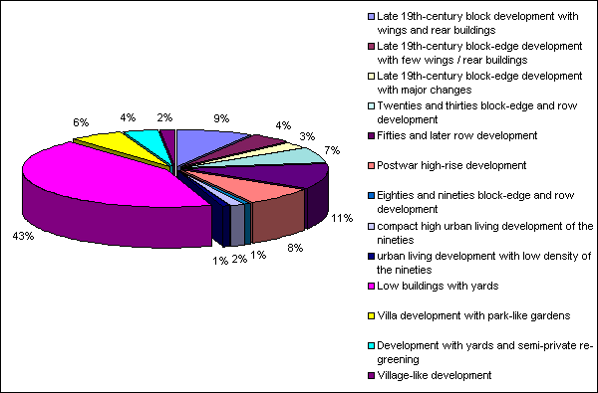
Fig. 2: Shares of Structure Types with Predominantly Residential Use in their Total Area, in Percent,
height of areas based on ISU5, segment block map
With 43 %, "low buildings with yards" accounts for by far the largest share of residential areas, followed by "fifties and later row" (11 %). "Block-edge" and "eighties and nineties row" have the smallest shares (1 %) (cf. Fig. 2).
In terms of the distribution among the Berlin boroughs, a different picture emerges, however (cf. Fig. 3).To be able to draw a comparison with other editions the figures are shown for the boroughs before the administrative reform from 2001.
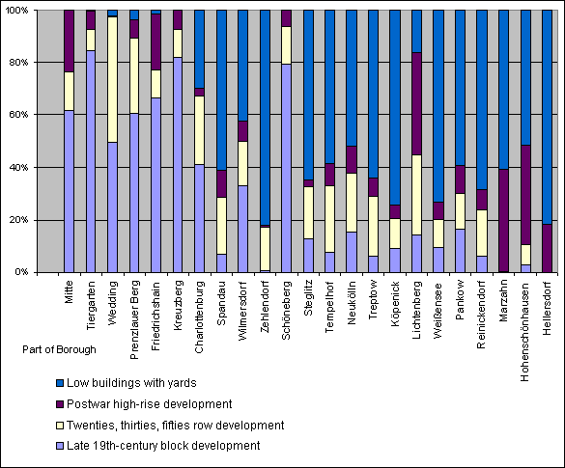
Fig. 3: Shares of the Structure Types with Predominantly Residential Use in their Total Area, in the Berlin districts (Boroughs before the administrative reform from 2001), in Percent
Low buildings with yards (Structure type 9-13),
Postwar high-rise development (Structure type 6-8),
Twenties and thirties and fifties and later row development (Structure type 4-5),
late 19th-century block development (Structure type 1-3)
In Tiergarten, Kreuzberg and Schöneberg, a relatively high share of the residential area - approx. 80 % - is preserved as late 19th-century block development, much of which has, however, been altered massively. In the district of Wedding, late 19th-century block development and row development account for half the residential area. The district of Reinickendorf has the greatest share of row-type construction, followed by Spandau and Neukölln. The high-rise development of the postwar era occurs is no where to be found in Zehlendorf, but is an outstandingly high share of approx. 40 % in Lichtenberg, Marzahn, Höhenschönhausen and Hellersdorf. The low buildings with yards structure is entirely absent in the inner-city districts of Mitte, Friedrichshain, Kreuzberg and Schöneberg, while accounting for approx. three-fourths of the residential area in the outskirts districts Zehlendorf, Köpenick, Weissensee and Hellersdorf.
One finds the late 19th-century closed block development with wings and rear buildings, hardly changed since their origin, in large parts Charlottenburg and Wilmersdorf between the Lietzensee (Lake), Kurfürstendamm, Richard-Wagner-Strasse and Spandauer Damm. The narrow development with the typical courtyard structure has also survived to a large degree in Moabit and Wedding, in Friedrichshain between the City Rail Circle Line and Petersburger/Warschauer Strasse, as well as in the districts of Kreuzberg, Neukölln and Schöneberg between the corridors Neukölln Schiffahrtskanal (Ship Canal), Skalitzer Strasse, Gitschiner / Karl-Marx-Strasse, Gneisenaustrasse, Yorckstrasse and Potsdamer/Hauptstrasse.
One finds the late 19th-century closed development with few wings / rear buildings, including the section types "decorative/garden court" and "shed court," in the former suburbs of Berlin outside the City Rail Circle Line. This construction structure, too, has hardly changed since its origin. Large areas exist in Friedenau, Steglitz, Tempelhof, Friedrichshagen, Oberschöneweide, Karlshorst, Pankow, Niederschönhausen, Spandau and in the borough of Reinickendorf west of Provinzstrasse.
Large areas of late 19th-century closed block-edge development with major changes, which emerged as the result of war-time destruction and reconstruction, or of reconstruction with massive demolition of late 19th-century block development, are found within the City Rail Circle Line, particularly in Charlottenburg between Otto-Suhr-Allee and Bismarckstrasse and along Spandauer Damm, in Tiergarten around the Spree Bend and Invalidenstrasse, and south of the Landwehrkanal (Canal) around Potsdamer Strasse, in Wedding between the City Rail Line between Nordbahnhof, Gesundbrunnen and Bernauer Strasse, and in Friedrichshain west of the Warschauer / Petersburger Strasse corridor and, east of these streets, in the area of Frankfurter Allee. Also in the districts of Schöneberg and Wilmersdorf, there are many areas in which the typical late 19th-century courtyard structure was changed significantly by reconstruction and renovation.
In terms of the distribution among the existing Berlin boroughs, no different picture emerges. The shares are displaced for example in Mitte where the high share of row development in the former borough Wedding reduces the total share due to the low share from Tiergarten and former Mitte.
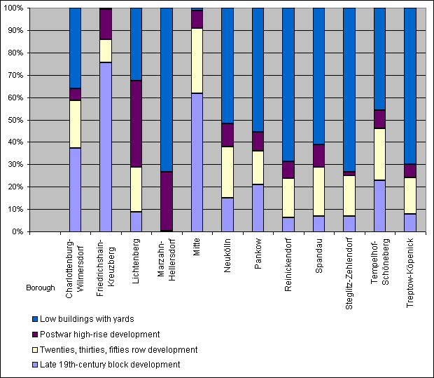
Fig. 3a: Shares of the Structure Types with Predominantly Residential Use in their Total Area, in the Berlin districts, in Percent
Low buildings with yards (Structure type 9-13),
Postwar high-rise development (Structure type 6-8),
Twenties and thirties and fifties and later row development (Structure type 4-5),
late 19th-century block development (Structure type 1-3)
Fig. 4 shows the late 19th-century structure types "late 19th-century block development with wings and rear buildings" and "late 19th-century block development with major changes" differentiated according to their section types at the borough level for selected districts. In the eastern boroughs Mitte, Prenzlauer Berg and Friedrichshain, the section type "closed courtyard" does not appear, since it was recorded under the type "courtyard."
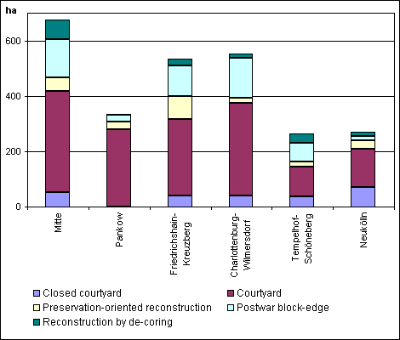
Fig. 4: Area Distribution of Various Late 19th-centurySection Types, in ha
In Prenzlauer Berg, Kreuzberg, Charlottenburg and Neukölln, very much late 19th-century development of the section types "closed courtyard" and "courtyard" is still preserved in its original form. The share of very dense development of the type "closed courtyard" is relatively high in Neukölln, Wedding and Kreuzberg. Late 19th-century preservation-oriented reconstruction, under which the original block structures were largely preserved, occurred most prominently in the borough of Kreuzberg. In the districts of Tiergarten, Friedrichshain and Wilmersdorf, war-damaged late 19th-century block development was largely eliminated and replaced, particularly by new buildings of the "postwar block-edge" type. "Late 19th-century development with major changes" and "reconstruction by de-coring" became increasingly common in the district of Wedding.
The twenties and thirties block-edge and row development type is found mainly outside the City Rail Circle Line. Frequently, the rows and large courts were erected in neighborhoods dominated by the "late 19th-century block-edge development with few wings and rear buildings" type, at the edge of the former suburbs of Berlin. They are as a rule connected to the City Rail and subway network.
The fifties and later row developments were erected mostly in the Berlin outskirts, outside the City Rail Circle Line. They were laid out on former open spaces (agriculture areas, etc.) without regard to existing transportation corridors or construction structures. Within the Circle Line, formerly built-up areas were replaced by row development. This includes large areas in Kreuzberg, Mitte and Friedrichshain, but isolated areas with row development on top of former late 19th-century block structure also exist in other inner-city districts.
One finds postwar high-rise development of the "unplanned reconstruction" type in the western parts within the City Rail Circle Line. Large areas of this type exist in Wilmersdorf around Bundesallee, in the district of Schöneberg in the area of Nollendorfplatz and Kleiststrasse, and in Kreuzberg between Wilhelmstrasse and Stresemannstrasse. Otherwise the high-rise development of the postwar era occurred within the City Rail Circle Line only in Kreuzberg, Mitte and Friedrichshain. Here smaller developments of the section type "high-rise" emerged. As a rule, the high-rise developments were erected outside the City Rail Circle Line. Such large complexes erected in West Berlin include Gropiusstadt in Neukölln, developments in Lichtenrade, Marienfelde, Lichterfelde and Spandau as well as the Märkisches Viertel in Reinickendorf. In East Berlin the largest developments are found in Hohenschönhausen, Marzahn, Hellersdorf and Lichtenberg.
The eighties and nineties block-edge and row development of the prefab concrete construction type occurs mainly in Hellersdorf and Marzahn. Smaller settlements were built in Köpenick and Hohenschönhausen.
The areas of the type compact, high urban living development of the nineties, realized usually in the framework of town-planning development projects, are located mainly at the edge of the eastern part of the city, as in Karow north and Buchholz. Some of the big housing projects like e.g. the Rummelsburger Bucht are situated also in the city center. The biggest project in the west part of the city is the water city Spandau.
The structure type urban living development with low density of the nineties with approximately 90 separate areas, also was erected normally in the east part and at the outskirts in Pankow or Treptow-Köpenick. However, you can find this type isolated also in Steglitz-Zehlendorf and Spandau.
Construction structures with yards are as a rule found only on the outskirts of town. These low, single-family and duplex houses with yards are to be found in the entire outskirts area.
The villa development with park-like gardens emerged mainly during the late 19th-century in scenically attractive areas; this has hardly changed since then. One finds larger areas of this type near the Grunewald Forest in Nikolassee, Zehlendorf, Dahlem and Grunewald, in Lichterfelde, near the Tegel Forest in Hermsdorf and Frohnau, along the Dahme at Grünau, and in the area the Müggelspree at Rahnsdorf.
Development with yards and semi-private re-greening, in which villa development and/or low single family houses are interspersed with larger rental and studio-apartment houses, occurs mainly in the southern urban area, particularly in the transitional areas between villas and single family housing in West Lichterfelde and Zehlendorf.
Village-like development is still preserved on the outskirts of town only in the old village cores; in the eastern boroughs more and larger village structures can generally be found.
One finds the development with predominantly commercial and service use frequently in the old central business districts of the various parts of town. This applies particularly to both the city center areas of West and East Berlin concentrated around the Kurfürstendamm/ Tauentzienstrasse and/or around the Alexanderplatz/ Friedrichstrasse.
Structure types with predominantly small business and industrial use are concentrated along waterways and railroad lines. Heavily built-up small business areas occur less frequently than small business areas with low development.
Development with predominantly public facilities and special use is to be found relatively evenly distributed throughout the urban area. Obviously, green and open spaces are more available in the outskirts area than in the inner city. As traffic areas, the airports Tempelhof and Tegel, and the right-of-ways of the City Rail lines stand out.
Detailed information about structure types which do not serve predominantly the residential use are found in the Umweltatlas Maps 06.01 "Actual Use of Built-up Areas" and 06.02 "Inventory of Green and Open Spaces."

Literature
[1] Geoinfo - C. Nietzsche: 2006
Aktualisierung der ISU5 im Auftrag der Senatsverwaltung für Stadtentwicklung, III F 1, Berlin, 2006
[2] SenStadt (Senatsverwaltung für Stadtentwicklung Berlin), Abt. III Luftbildarchiv, 2006:
Digitale Luftbilder (Orthophotos) 2006, Berlin.
[3] SenStadt (Senatsverwaltung für Stadtentwicklung Berlin) 2003:
Stadtentwicklung 2000, Bericht zur Flächenentwicklung 1990-2000 / 2001-2020, 2003.
[4] SenStadt (Senatsverwaltung für Stadtentwicklung Berlin) 2005:
Flächentypen. Eine Beschreibung der im Informationssystem Stadt und Umwelt (ISU) der Senatsverwaltung für Stadtentwicklung erfassten und verwalteten Struktur- und Flächennutzungskategorien von Berlin. [Area Types. A description of the structural and land-use categories maintained by the Urban and Environmental Information System (ISU) of the Berlin Senate Administration for Urban Development].
Internet:
Download PDF

Maps
[5] SenStadtUm (Senatsverwaltung für Stadtentwicklung und Umweltschutz Berlin) (Hrsg.) III F, 2001:
Digitale Karte von Berlin 1:5000 (ISU5), Stand:31.12.2005, Berlin.
[6] Amt für Statistik Berlin-Brandenburg, (ehemals Statistisches Landesamt Berlin), 2002-2005:
Blockänderungen der Geometrien des Räumlichen Bezugssystemes (RBS), 2002 - 2005, Berlin

[7] SenStadtUm (Der Senator für Stadtentwicklung und Umweltschutz Berlin) (Hrsg.) 1985a:
Umweltatlas Berlin, Bd. 2, Karte 06.01 Reale Nutzung der bebauten Flächen, 1:50 000, Berlin.
[8] SenStadtUm (Der Senator für Stadtentwicklung und Umweltschutz Berlin) (Hrsg.) 1985b:
Umweltatlas Berlin, Bd. 2, Karte 06.02 Grün- und Freiflächenbestand, 1:50 000, Berlin.
[9] SenStadt (Senatsverwaltung für Stadtentwicklung Berlin) (Hrsg.) 2008:
Digitaler Umweltatlas Berlin, aktualisierte und erweiterte Ausgabe 2008, Karte 06.01 Reale Nutzung der bebauten Flächen, Berlin.
Internet:
https://www.berlin.de/umweltatlas/en/land-use/actual-land-use/2007/maps/artikel.994364.en.php
[10] SenStadt (Senatsverwaltung für Stadtentwicklung Berlin) (Hrsg.) 2008:
Digitaler Umweltatlas Berlin, aktualisierte und erweiterte Ausgabe 2008, Karte 06.02 Grün- und Freiflächenbestand Berlin.
Internet:
https://www.berlin.de/umweltatlas/en/land-use/actual-land-use/2007/maps/artikel.994366.en.php

