04.08 Long-term Mean Precipitation Distribution 1981-2010 (Edition 2021)

Introduction
The mean precipitation distribution provides key information on the development of precipitation in an area. In individual events, however, the precipitation distribution may deviate greatly from the mean precipitation distribution. This applies in particular to heavy rainfalls, as they are usually confined to smaller areas and not evenly distributed (cf. Spektrum.de online 2016, only in German). They occur during the summer months as a result of convective air flows reinforcing themselves. Although physiographic characteristics may contribute to the development of heavy rain cells, their formation is highly coincidental.
Heavy rainfalls can thus contribute to small-scale changes in the connected annual or semi-annual means. Considering the long-term period from 1981 to 2010, however, the impact of individual events is rather insignificant, as heavy rainfalls are quite rare and random in their distribution.
The weather conditions in an area are greatly influenced by its topography (surface structure of the earth). Mountain ranges, smaller hill chains, and even lower ridges already have an impact on the amount of precipitation. Other influencing factors include forests, lakes, fields and such (cf. Flohn 1954, only in German). Furthermore, cities with their agglomerations of buildings influence the quantity and distribution of precipitation once they reach a certain size.
Increased precipitation due to, for example, relief rainfalls within a confined area are mainly caused by the influence of soil friction, i.e. the surface roughness parameter. Soil friction slows down the lower air layers, causing subsequent air masses to accumulate and rise. Adiabatic cooling may effect the formation of clouds and precipitation. Additionally, aerosols tend to accumulate above urban areas more often. As condensation nuclei, they influence the formation of clouds and precipitation. In addition, the heat emanating from urban areas may contribute to convective precipitation, if additional constraints come into play.
In contrast to the evaluations of the previous update of 1990 for the reference period from 1961 to 1990, the evaluations in the current update are based on grid data provided by Germany’s Meteorological Service (DWD). Due to the different data bases and resulting differences in methodology, the current results and these of the long-term mean precipitation distribution between 1961 and 1990 of the Berlin Environmental Atlas may only be compared to a very limited extent.

Effects of precipitation
Precipitation is an essential component of nature. Animals, plants, and indeed us humans cannot survive without it. To analyse the effects of precipitation, however, a differentiated approach is needed. On the one hand, precipitation causes a cleaning process of the air. On the other hand, highly impervious surfaces and their according use cause precipitation to flush out a variety of pollutants. The latter are then able to enter rainwater drains and combined sewerage systems and eventually make their way into our bodies of water, too.
A lack of precipitation affects animals and plants alike, which may lead to permanent damage. This is especially true if dry periods occur increasingly, as has been the case in recent years. The simultaneous increase in heavy rainfalls, however, does not compensate for the lack of precipitation in the water balance. Soils, especially when dry, are unable to absorb this copious amount of precipitation. The precipitation therefore largely runs off superficially and does not contribute to the regeneration of the soil water store. What is more, heavy rain can also cause soil erosion. Flash floods resulting from heavy rain also pose a danger to people, animals and property.

Regional Classification of Precipitation Conditions in Berlin
Berlin is located in an area of transition, where the climate shifts from continental to predominantly oceanic. This is reflected in Berlin’s precipitation conditions on a regional scale. Berlin is one of the drier regions of Germany. Incidentally, the annual mean precipitation for Germany was 789 mm per square metre for the standard reference period from 1961 to 1990, whereas it ranged between 551 and 600 mm per square metre for Berlin for the same period (cf. Fig. 1).
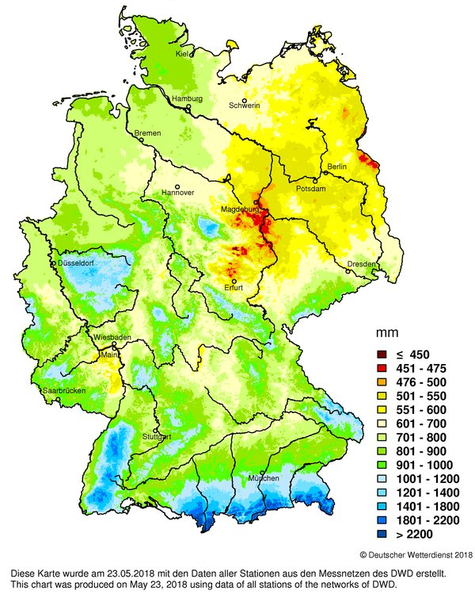
Fig. 1: Distribution of the amount of precipitation per year in Germany – multi-annual mean, 1961-1990 (DWD Klimakarten Deutschland, (Climate Maps for Germany) only in German, accessed on 19 January 2021)
In addition to the above-mentioned factors, the global climate change is also expected to influence our regional water supply more and more in the future. Over the past 10,000 years, changes in climate have altered the geographical distribution of precipitation dramatically. Forecasts of potential developments largely depend on future greenhouse gas emissions and are being studied by authorities such as the DWD (cf. DWD 2020, only in German). According to the DWD, the annual precipitation is predicted to increase slightly (+6%) in Germany by the end of the century. The winter months and the transitional seasons are expected to see an increase in precipitation. Depending on the scenario, precipitation is predicted to remain unchanged or even decrease during the summer.

Statistical Base
The REGNIE grids of multi-annual precipitation for Germany covering the period from 1981 to 2010 were used as the statistical base (retrieved on September 29, 2020). The DWD provides these as part of a freely available data set via the Climate Data Center (CDC).
The REGNIE data is embedded in a geographic grid, with a latitudinal spatial resolution of 60 geographical seconds and a longitudinal spatial resolution of 30 geographical seconds. In the ETRS 1989 UTM zone 33N projection, this corresponds roughly to a 1 km x 1 km grid.
Precipitation data is available for multiple reference periods (1961-1990, 1971-2000, 1981-2010) and reflects the 30-year mean amount of precipitation (in millimetres) for each calendar month, the four seasons and the entire year per period. In order to be able to balance the amount of precipitation for the water years 1981-2010 (see below), the monthly REGNIE grids for November and December of the years 1980 and 2010 were also taken into account.
The DWD has ensured that the precipitation data used in the REGNIE method is complete and consistent and has corrected the data where necessary. The REGNIE grids do not correct for systematic precipitation losses due to wetting, evaporation and wind effects, however. Measurement errors are influenced by many factors, including the station type, installation site, precipitation pattern and precipitation type. For conventional precipitation gauges (Hellmann) across the Nordostdeutsches Tiefland (Northeast German Plain), the precipitation measurement error in the annual mean ranges between 8.6 and 16.6 %, depending on wind exposure (cf. Richter 1995, only in German).
The REGNIE regionalisation method is essentially based on the interpolation of anomalies in relation to long-term means. For this purpose, background fields are determined for precipitation distributions. Based on these, the amount of precipitation is then calculated. Background fields are calculated by multiple linear regression taking into account geographical location, altitude, slope and direction of slope that may influence the amount of precipitation and its distribution. As a next step, the measured station precipitation and the background fields are interpolated to calculate regionalised precipitation.
The REGNIE method is described in detail in Rauthe et. al. 2013 (only in German). See DWD 2017 (only in German) for a brief description focussing on data provision and use. See DWD 2018 for a description of the data set.

Methodology
The following steps were taken to evaluate the precipitation distributions for the purpose of the Environmental Atlas (cf. Figure 2):
- converting and transforming the REGNIE source data,
- converting the balance period from calendar years to water years,
- increasing the spatial resolution of the precipitation distribution by using a suitable interpolation procedure, and
- deriving a mode of presentation suitable for the map based on isolines and isosurfaces.
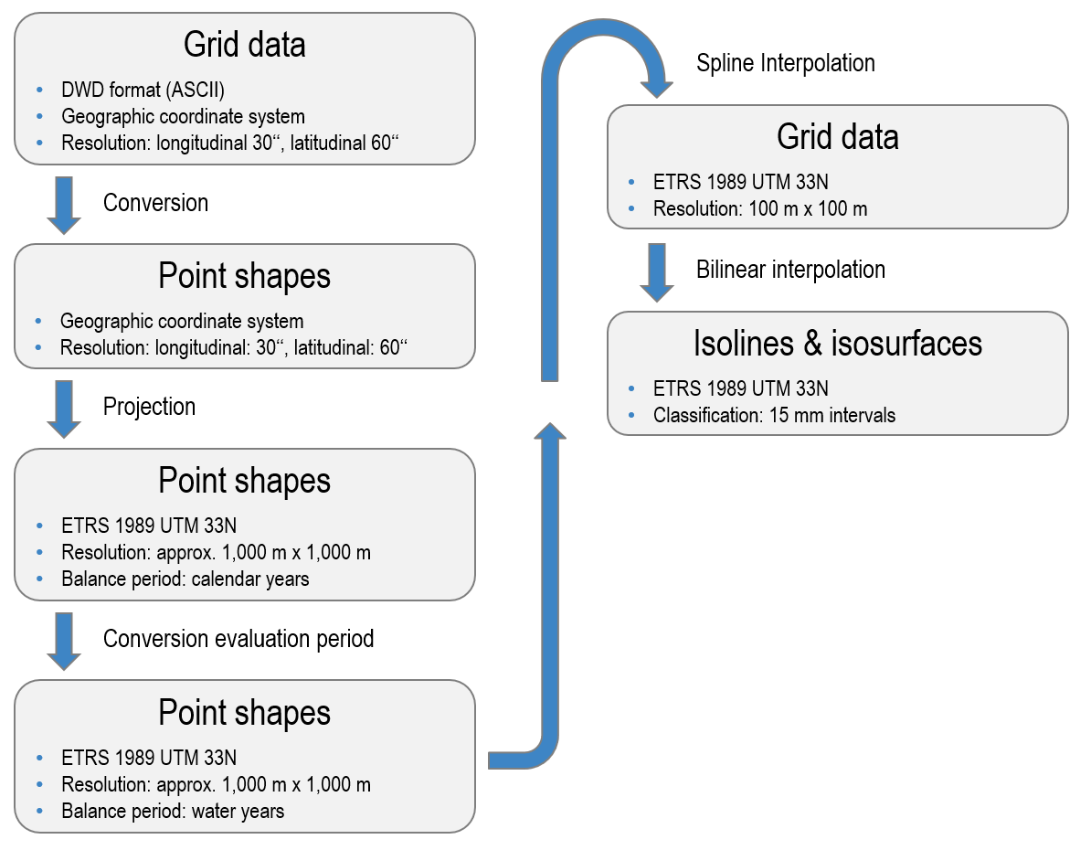
Fig. 2: Diagram of how the multi-annual mean grids of precipitation are processed for Berlin, 1981-2010 (ProAqua using statistical base from DWD 2018).
The source data was available in an ASCII format specific to the DWD and in the geographic coordinate system WGS1984. The data was converted into the ESRI shape format using a DWD script and then projected into the ETRS1989 UTM 33N coordinate system that is used in Berlin.
Precipitation data serves as an important base for water balance analyses. The latter is usually balanced according to the water year (discharge year, hydrological year), starting on 1 November. This classification is used as late autumn and early winter precipitation is stored as snow or ice. It does not run off until the following spring.
The 30-year means of the REGNIE precipitation data, however, refer to calendar years and monthly means for the period from 1981 to 2010. As the water year of 1981 begins in November 1980, the means for each month of November and December from 1981 to 2010 had to be converted into monthly means for the period from 1980 to 2009. For this purpose, the monthly precipitation for November and December of 2010 was weighted by 1/30 and then subtracted. Subsequently, the monthly precipitation for 1980, which was weighted the same, was added. The sum of the individual monthly means was then used to derive the 30-year mean precipitation according to water years and its two halves from 1981 to 2010 as presented in Table 1.
Technically, the REGNIE data is grid data. According to DWD documentation, however, the precipitation data should be considered point data, which refers to the centre of each grid cell (grid point). Precipitation is a physiographic process. Its distribution is continuous and steady. Therefore, the transitions between the different precipitation data points in the individual grid cells should also be gradual. To this end, the source data (1 km x 1 km resolution) was interpolated to a resolution that is ten times higher, i.e. 100 m x 100 m. A Spline interpolation of the type “Tension” with a weight of 1 and a search radius of 4 points was chosen as the interpolation method (cf. ESRI 2019a). This method is a good compromise between smoothing values on the one hand and representing the original values in the grid points as accurately as possible on the other.
Isolines and isosurfaces were generated from the interpolated 100 m x 100 m grid data using bilinear interpolation (cf. ESRI 2019b). Isolines are lines that connect points of equal value. In relation to precipitation, these lines are also referred to as isohyets, i.e. they connect points of the same precipitation. Isosurfaces comprise the areas between two isolines and thus indicate areas with precipitation within a specific range of values.

Map Description
The maps present the total precipitation averaged over the period from 1981 to 2010 according to water years (hydrological years, discharge years). A water year ends in October of the year in its title; it begins, however, in November of the year prior to that. The evaluations for the water years from 1981 to 2010 thus refer to the period from November 1980 to October 2010.
In addition, the totals for the winter and summer halves of the water year are also presented. Table 1 displays the evaluation periods.

Tab. 1: Evaluation periods for the long-term mean precipitation distribution, 1981-2010
Map | Evaluation period | Months | Period
04.08.1 | Annual precipitation | November – October | November 1980 – October 2010
04.08.2 | Summer half | May – October | May 1981 – October 2010
04.08.3 | Winter half | November – May | November 1980 – May 2010
Tab. 1: Evaluation periods for the long-term mean precipitation distribution, 1981-2010
For the period from 1981 to 2010, Berlin’s mean annual precipitation ranges between 543 mm and 625 mm, depending on the location. The mean precipitation for the urban area is 580 mm/a (cf. Table 2). Precipitation in the Grunewald area (575-605 mm) and on the Teltow (590-620 mm) and the Barnim plateaus (575-605 mm) are above average for the most part. In the Berlin glacial valley, which extends from the southeast to the northwest (545-575 mm), on the other hand, precipitation is below average, sometimes even dramatically so (Map 4.08.1).
Overall, similar characteristics have been observed for the summer half (Map 04.08.2) and the winter half (Map 04.08.3) of the year, albeit less pronounced. Especially in the winter half, the spatial variance is noticeably decreased. In the summer half, with an average of 322 mm, the mean precipitation is distinctly higher than in the winter half with an average of 259 mm.
A correlation may be derived between the wind direction distribution predominant in the Berlin area and the influence of the city’s topography.
Figure 3 (SenUVK 2019) presents the mean wind direction distribution at the DWD station in Berlin-Tempelhof for all four seasons, differentiated by wind speed. Westerly winds of maritime and sometimes humid air occur frequently throughout the year. During the winter months, the influence of continental, often dry currents moving from the south to the east increases.
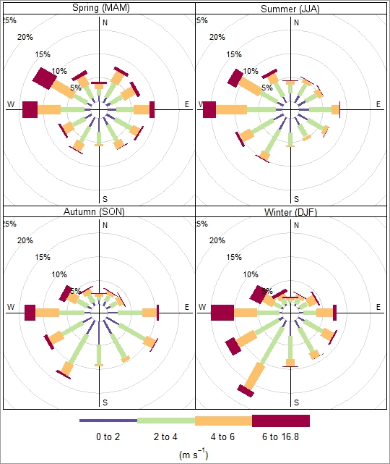
Fig. 3: Mean wind direction distribution at the Berlin-Tempelhof DWD station for all four seasons, differentiated by wind speed (SenUVK 2019)

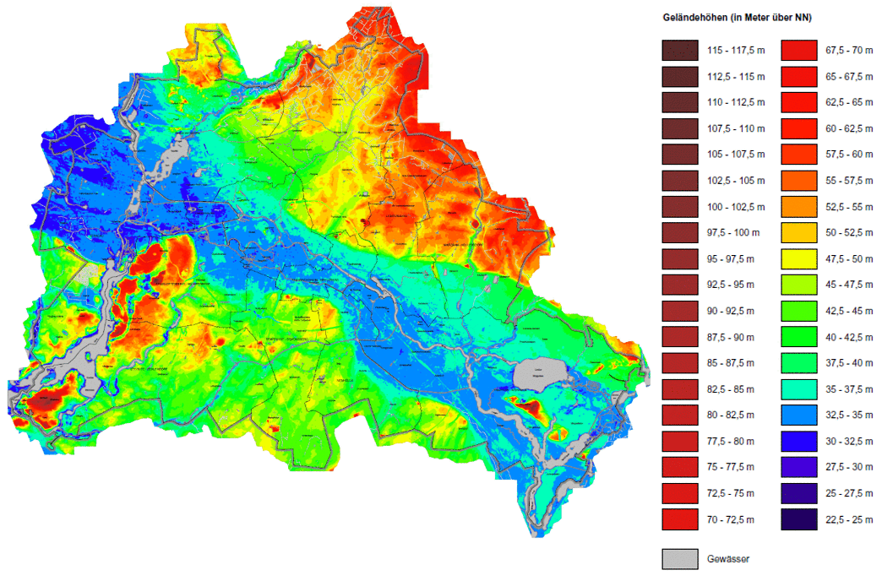
Fig. 4: Terrain elevations, Berlin (SenStadtUm 2010)
The aforementioned relationship between topography and the distribution of wind flows can be seen in the influence of the elevations in the area of the Grunewaldhöhenzug (hill in the Grunewald) and the Schäferberg (103.5 m). Here, precipitation is well above average, but drops by more than 30 mm towards the glacial valley. Shifting towards the east and beyond city boundaries, a continuous rise in precipitation becomes evident again.
The map characteristics do not provide any evidence that urban development impacts upon the precipitation distribution, as has been indicated by studies (cf. Introduction). Berlin’s development is still rather homogeneous in regard to height. This means that, on the one hand, there have been no artificial alterations of the soil roughness locally, alterations that could cause relief rainfalls. If the latter do occur, however, they are locally confined and rather spontaneous events that do not appear to have a noticeable impact on the long-term mean.
In addition to the described regional variation of precipitation distributions, local anomalies stand out (e.g. in the annual precipitation distribution (Map 04.08.1)). These appear as small-scale, concentric isolines or isosurfaces with precipitation totals that deviate greatly from their immediate surroundings. Examples are to be found at Schönefeld Airport (a lot drier) and in Berlin-Staaken (a lot wetter). These anomalies are due to the REGNIE data set used here. In the REGNIE method, the amount of precipitation measured at multiple stations are spatially interpolated using background fields. A measurement taken in the immediate vicinity of its precipitation measurement station has a very high weight attached to it. Therefore, precipitation station measurements that deviate significantly from their surroundings may distort the calculated precipitation distributions, which can have a local impact on the result.
Table 2 presents a selection of statistic characteristic values for the long-term precipitation distribution from 1981 to 2010 for the evaluation periods indicated. The evaluations refer to the area of Berlin excluding surrounding areas.

Tab. 2: Statistic characteristic values for the long-term precipitation distribution in Berlin, 1981-2010
 | Annual precipitation | Summer half | Winter half
Minimum [mm/a] | 543 | 301 | 236
Maximum [mm/a] | 625 | 348 | 277
Mean [mm/a] | 580.1 | 321.6 | 258,5
Standard deviation [mm/a] | 13.4 | 8.0 | 6.6
Tab. 2: Statistic characteristic values for the long-term precipitation distribution in Berlin, 1981-2010
The Environmental Atlas evaluations of the long-term precipitation distribution from 1961 to 1990 were based on station-referenced precipitation measurement series provided by the DWD and other authorities. Processing and interpolating the data from the different stations was extremely onerous but necessary to be able to derive area-related precipitation distributions. With their REGNIE products, however, the DWD provides area-related precipitation data. This data forms the basis for the current update of the Environmental Atlas. Due to the different data bases and resulting differences in methodology, the current results and these of the previous edition of the Environmental Atlas can only be compared to a very limited extent.

Literature
[1] DWD [Germany’s Meteorological Service] 2017:
REGNIE: Regionalisierte Niederschläge – Verfahrensbeschreibung und Nutzeranleitung [REGNIE: Regionalised precipitation – description of methods and user guide]. Deutscher Wetterdienst, Abteilung Hydrometerologie [Germany’s Meteorological Service, Hydrometerology Department], internal report, Offenbach.
Internet:
https://opendata.dwd.de/climate_environment/CDC/help/REGNIE_Beschreibung_20170304.pdf [only in German]
(Accessed on 15 May 2023)
[2] DWD [Germany’s Meteorological Service] 2018:
Data Set Description: REGNIE grids of multi-annual precipitation. Deutscher Wetterdienst [Germany’s Meteorological Service] CDC – Vertrieb Klima und Umwelt [CDC – Climate and Environment Distribution Centre], Offenbach.
[3] DWD [Germany’s Meteorological Service] 2020:
Nationaler Klimareport [National Climate Report]. 4th revised edition, Deutscher Wetterdienst [Germany’s Meteorological Service], Potsdam.
Internet:
https://www.dwd.de/DE/leistungen/nationalerklimareport/download_report_auflage-4.pdf [only in German]
(Accessed on 3 February 2021)
[4] ESRI 2019a:
ArcGIS Desktop 10.7 Tool reference: How Spline works. Environmental System Research Institute, Redlands, CA.
Internet:
https://pro.arcgis.com/en/pro-app/latest/tool-reference/3d-analyst/how-spline-works.htm
(Accessed on 3 February 2021)
[5] ESRI 2019b:
ArcGIS Desktop 10.7 Tool reference: How Contouring works. Environmental System Research Institute, Redlands, CA.
Internet:
https://desktop.arcgis.com/en/arcmap/10.7/tools/3d-analyst-toolbox/how-contouring-works.htm
(Accessed on 1 February 2021)
[6] Flohn, H. 1954:
Witterung und Klima in Mitteleuropa [Weather and climate in central Europe]. Forschungen zur Deutschen Landeskunde [Research on German regional studies], Stuttgart.
[7] Rauthe et. al. 2013:
A Central European precipitation climatology – Part I: Generation and validation of a high-resolution gridded daily data set (HYRAS). Meteorologische Zeitschrift, Vol. 22, No. 3, 235–256.
Download PDF (4 MB)
(Accessed on 3 February 2021)
[8] Richter, D. 1995:
Ergebnisse methodischer Untersuchungen zur Korrektur des systematischen Messfehlers des Hellmann-Niederschlagsmessers [Results of methodological studies to correct the systematic measurement error of the Hellmann precipitation gauge]. Berichte des Deutschen Wetterdienstes 194 [DWD reports 194]. Selbstverlag des Deutschen Wetterdienstes, Offenbach.
Download PDF (17 MB)
(Accessed on 3 February 2021)
[9] SenUVK 2019 (Berlin Senate Department for the Environment, Transport and Climate Protection) 2019:
Luftreinhalteplan [Clean Air Plan], 2nd update, Berlin.
Internet:
https://www.berlin.de/senuvk/umwelt/luft/luftreinhaltung/luftreinhalteplan_2025/download/Luftreinhalteplan.pdf [only in German]
(Accessed on 3 February 2021)

Maps:
[10] SenStadtUm (Berlin Senate Department for Urban Development and the Environment) (ed.) 2014:
Berlin Environmental Atlas, Edition 2010, Map 01.08 Terrain Elevations, Berlin.
Internet:
https://www.berlin.de/umweltatlas/en/soil/terrain-elevations/

