08.09 Solar Energy Systems

Introduction
Renewable energy sources – most notably solar, geothermal, biomass and wind – offer an effectively inexhaustible supply and are set to play an increasingly central role in meeting Berlin’s energy needs now and in the future. Among these renewable sources, the expansion of solar energy has become a key pillar of Berlin’s climate strategy. The Berlin Senate has set an ambitious target: a net-zero energy supply by 2045.
To help achieve this, the city has placed strong emphasis on expanding renewable energy, especially by unlocking its urban solar potential, through the BEK 2030 (Berlin Energy and Climate Protection Programme 2030). A central tool for addressing the barriers that have limited solar uptake so far is the Masterplan Solarcity, which entered its second implementation phase (2025-2030) on 6 May 2025. Published by the Senate Department for Economic Affairs, Energy and Public Enterprises after extensive stakeholder consultation, the updated catalogue of measures continues to guide the city’s solar rollout. Berlin is gradually approaching its target of generating 25 % of its electricity from solar power by 2035 (Masterplan Solarcity). Progress has been documented in annual monitoring reports since 2020 (SenWEB 2025; reports available in German only).
Section 19 of the EWG Bln of 19 August 2021 (Berlin Climate Protection and Energy Transition Act) sets out a clear mandate: to expand the generation and use of renewable energy on public buildings. To support this effort, the Senate Department for Economic Affairs, Energy and Public Enterprises assists the boroughs through the SolarReadiness funding programme, which helps ensure that buildings are structurally prepared and equipped with the necessary infrastructure for installing solar energy systems. By accelerating solar deployment across public buildings, Berlin underscores the public sector’s role as a frontrunner in the energy transition.
For the private sector, the SolarG Bln (Berlin Solar Act) of 5 July 2021 has required, since 1 January 2023, that major roof renovations and new buildings include solar installations. Owners of roofs with more than 50 m² of usable space must install and operate a photovoltaic (PV) system. Further information and a practical guide to the SolarG Bln are available here. To support compliance with the Act and improve the economic feasibility of PV systems, the city offers the SolarPLUS funding programme as part of the Masterplan Solarcity. Since the programme launched in September 2022, a total of 24,153 grants had been approved by May 2025.
In May 2019, the SolarZentrum Berlin opened as an independent advisory centre offering comprehensive support on all aspects of solar energy (SolarZentrum Berlin). Operated by the Berlin-Brandenburg Chapter of the German Solar Energy Society (DGS) and funded by the Senate Department for Economic Affairs, Energy and Public Enterprises, it is a key element of the Masterplan Solarcity’s implementation framework.
At the national level, the JStG 2022 (Annual Tax Act) introduced a zero-percent VAT rate on the supply and installation of solar modules, including all necessary components and storage systems (JStG 2022; Section 12(3) UStG). The measure applies to systems on residential buildings, public buildings, and properties dedicated to public-service use. Systems with an installed capacity of up to 30 kWp automatically qualify. The regulation has been in force since 1 January 2023.
Additional momentum came with Solarpaket I, Germany’s first dedicated solar package, which entered into force on 15 May 2024. It bundles a range of measures designed to simplify and accelerate PV deployment, with a particular focus on plug-in systems used for self-consumption (often referred to as ‘balcony power plants’ in Germany). The package also permits electricity generated on one’s own roof to be offered to tenants at reduced rates, while any surplus electricity can be fed into the grid free of charge and without compensation, significantly reducing hurdles for owners of small-scale systems. For larger installations, certification is required for capacities above 270 kW for grid feed-in or for total generation capacities of 500 kW or more.
By the end of 2024, solar power accounted for 4.7 % of Berlin’s total electricity generation (SenWEB 2025).
As energy-related geodata and usage information, such as solar datasets, were previously presented inconsistently and scattered across multiple platforms, the Energieatlas Berlin (energy atlas) has been available since July 2018 as a dedicated resource to support the energy transition. It provides key information in a user-friendly, clearly structured format and is updated on an ongoing basis.
The information on:
• photovoltaics (PV) – the direct conversion of solar energy into electricity, and
• solar thermal systems (ST) – the generation of heat from solar irradiation,
presented in this Environmental Atlas topic is based on datasets from the Energieatlas Berlin. The collection cut-off dates are as follows: PV system location data as of 7 October 2024, and solar thermal system data as of 31 December 2015 or 29 March 2023 for the aggregated BAFA solar thermal data.
As the Energieatlas Berlin continues to develop, improving the quality of solar energy system data – particularly for PV systems – and maintaining regular updates remain key priorities.
Please note that all links in the Introduction section point to resources in German.

Map 08.09.1 Photovoltaics

Compared with solar thermal systems, Berlin has installed far more photovoltaic (PV) systems. By 31 December 2024, a total of 41,723 PV installations had been recorded across the city, with a combined capacity of around 380.6 MWp. The estimated annual electricity yield from these systems is roughly 343 GWh, accounting for a 5 % reduction in generator performance and an average yield of 900 kWh per kW each year. In theory, this could supply around 131,000 households, assuming an average annual electricity consumption of 2,500 kWh per household.

Since its launch, the Energieatlas Berlin has replaced the data collection system of the Solaranlagenkataster (solar installation register) that integrates multiple sources and evaluation methods (see Statistical Base section). Figure 1 illustrates how installation levels vary across the boroughs (see Fig. 1a). Boroughs dominated by single- and two-family homes exhibit the highest installation rates. Reflecting this pattern, the smallest capacity class – up to 30 kWp – clearly predominates, accounting for roughly 37,438 of a total of 38,798 systems (see Fig. 1b). This class mainly comprises plug-in systems on balconies or modules installed on small roofs.

In 2019, the annual number of new PV systems installed nationwide under the EEG (Renewable Energy Sources Act) again exceeded 100,000 for the first time in several years. From 1 July 2022, the EEG levy was reduced to zero and, with the 2023 amendment, abolished entirely. According to BNetzA (Federal Network Agency) data, Berlin recorded its largest annual increase to date in 2024, with 15,556 new systems added.
The most recent data on PV systems in Berlin, including system locations and borough-level deployment statistics, are available in map and chart form via the Energieatlas Berlin (available in German only).
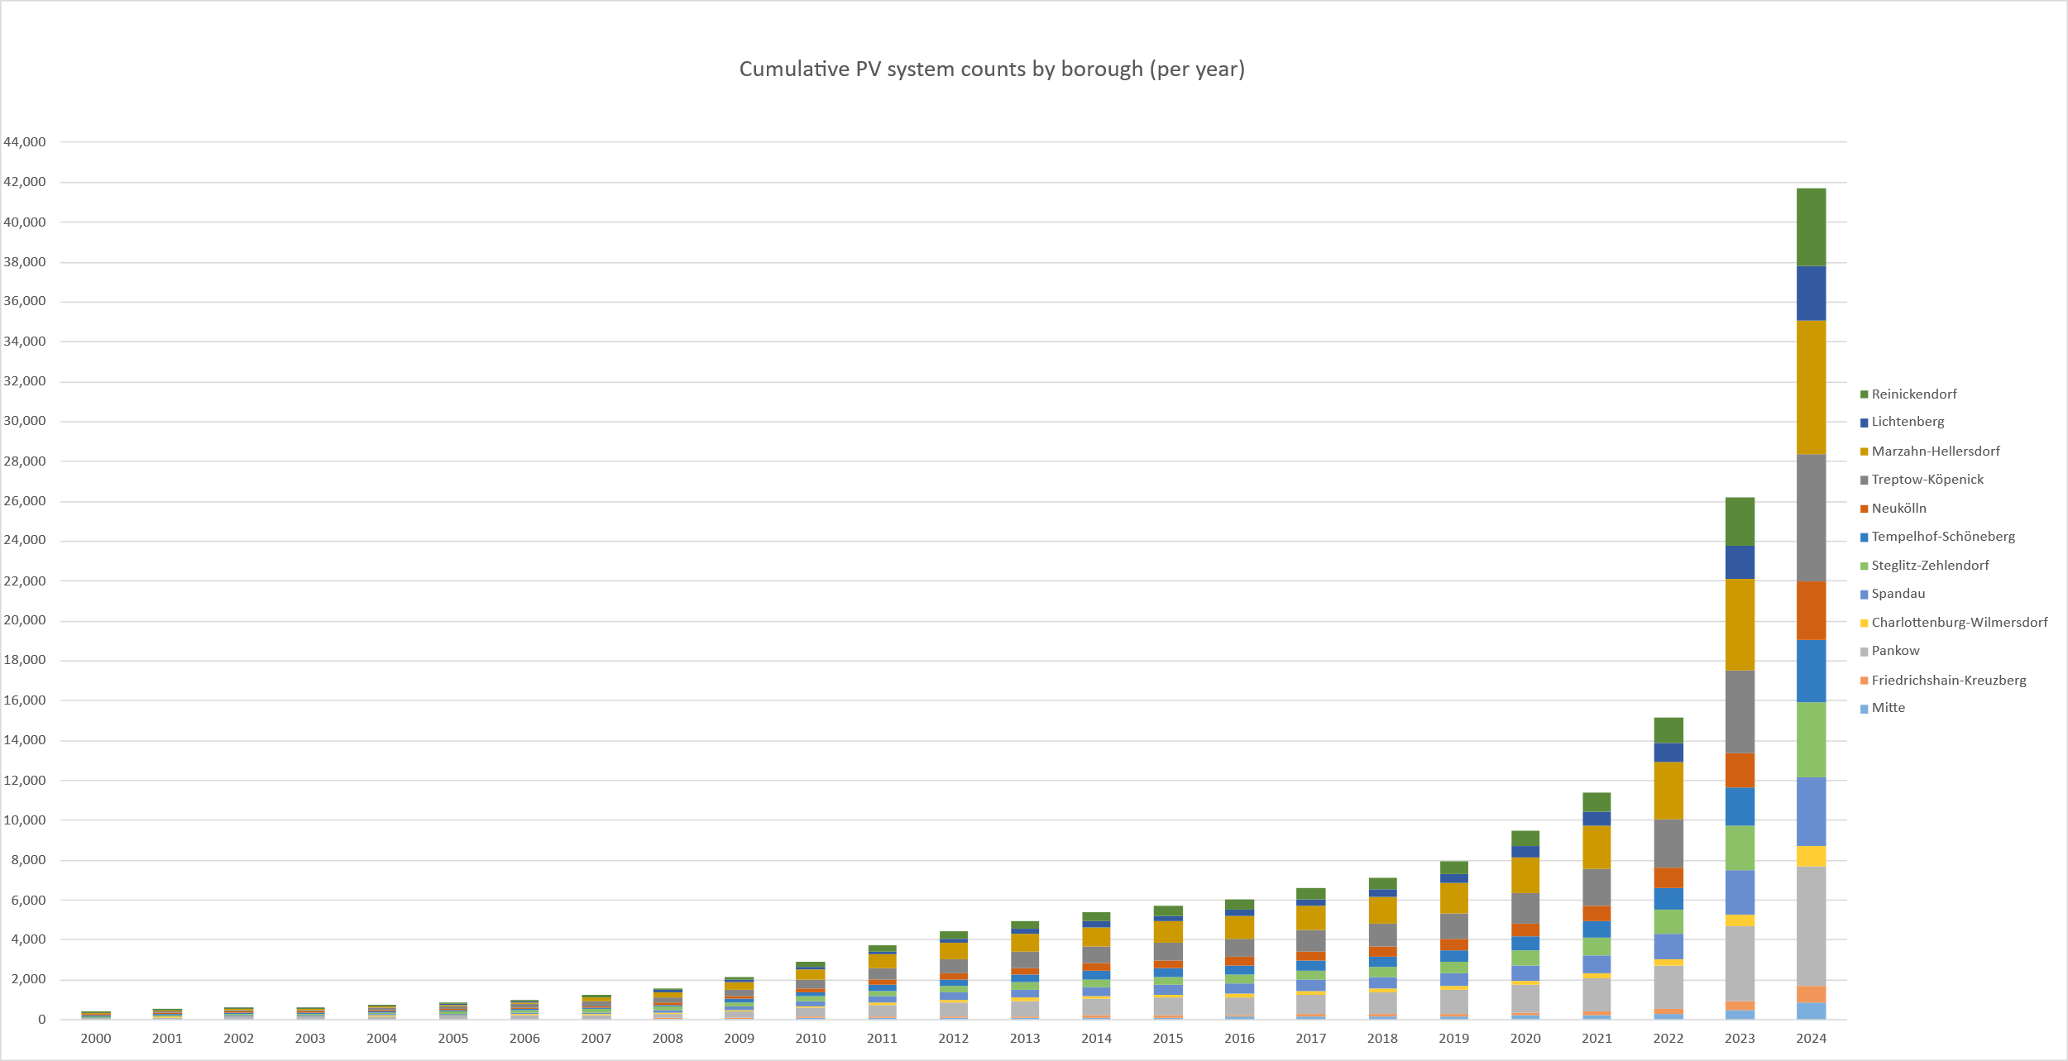
Fig. 1a: Development by borough (data as of 6 March 2025). Data source: Energieatlas Berlin, based on MaStR data of the BNetzA.

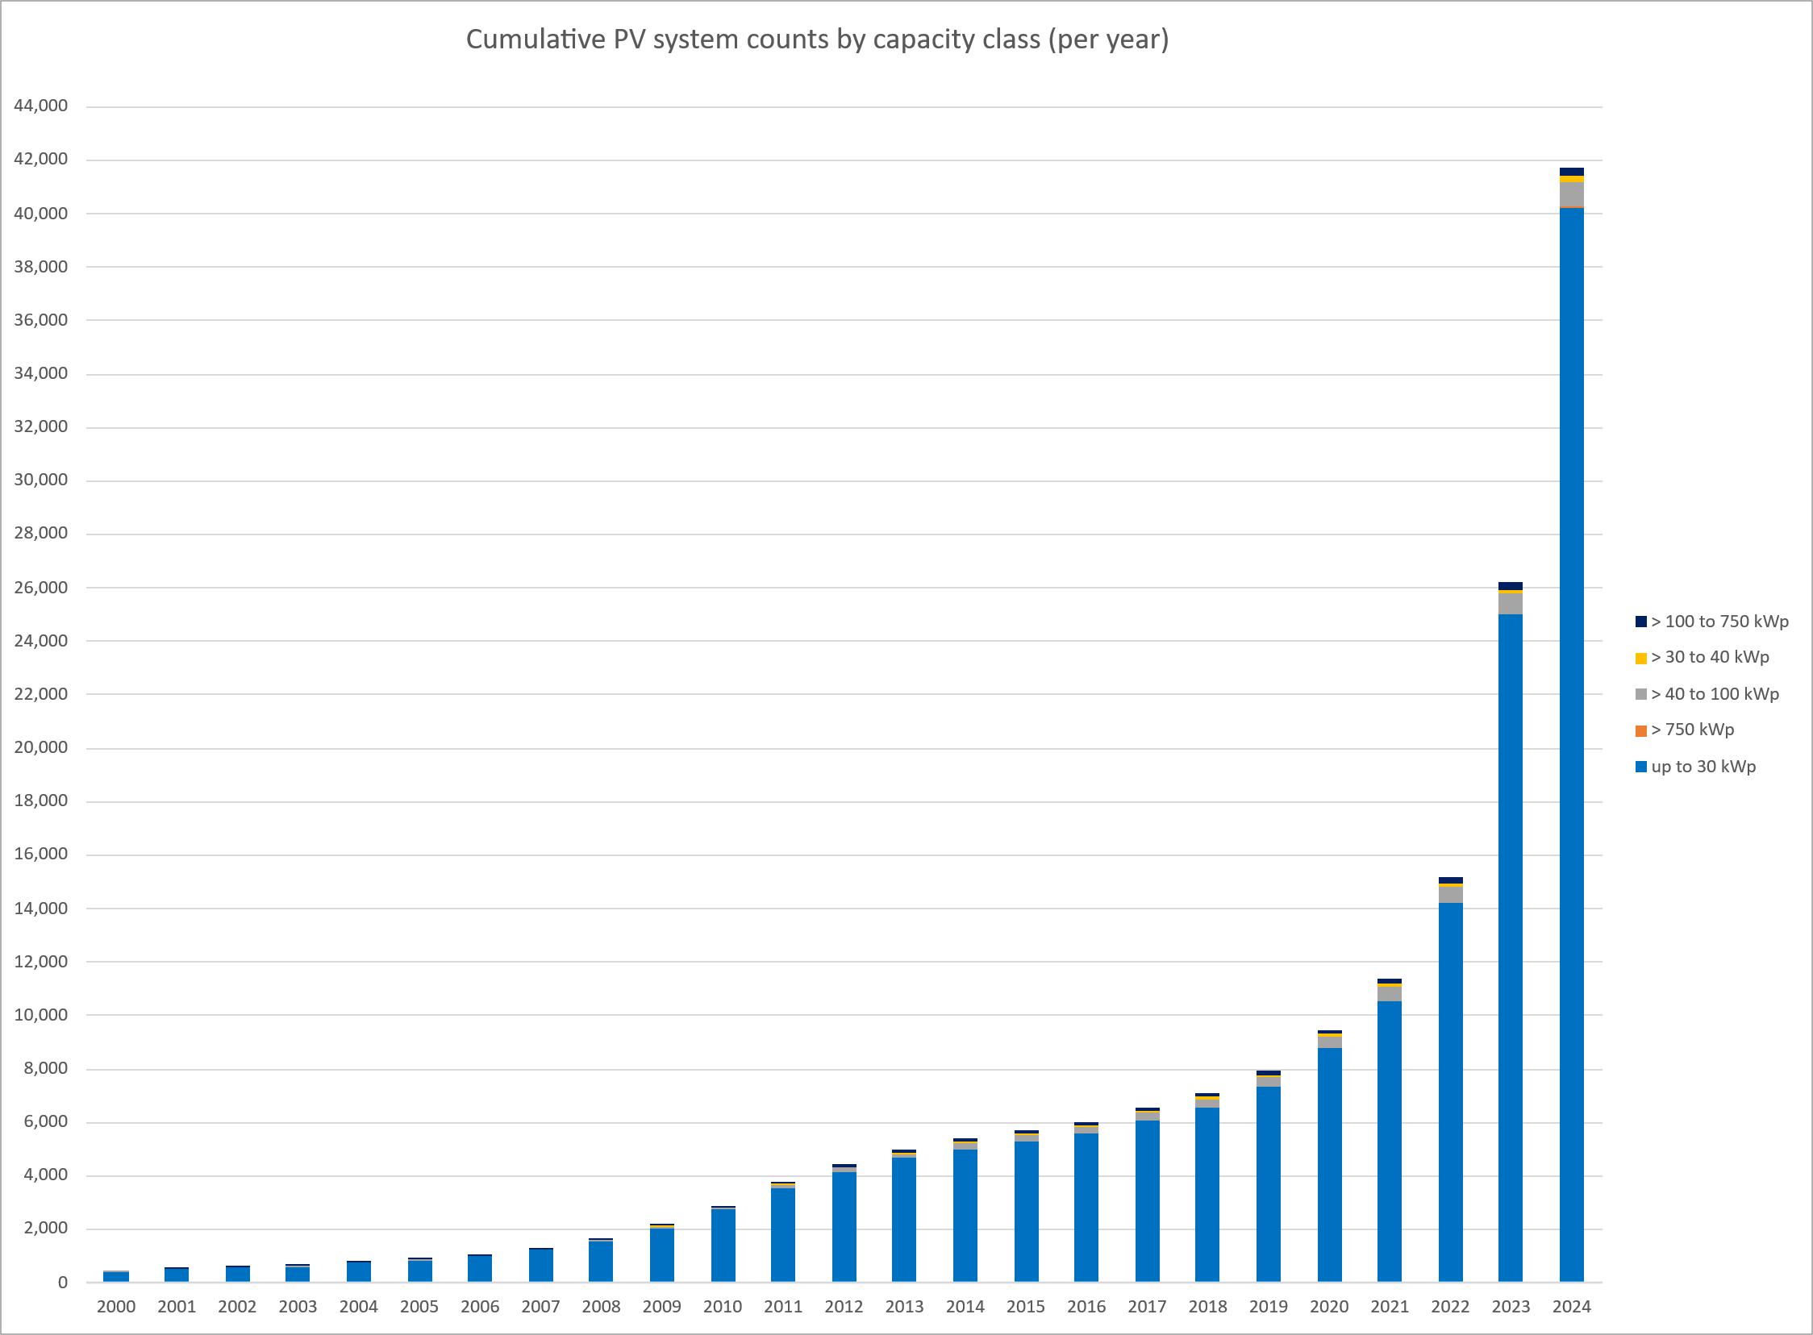
Fig. 1b: Development by capacity class (data as of 6 March 2025). Data source: Energieatlas Berlin, based on MaStR data of the BNetzA.
The public sector plays a leading role in driving PV expansion in Berlin. Under the EWG Bln (Berlin Climate Protection and Energy Transition Act), amended in 2021, all new public buildings must be fitted with solar energy systems on every technically suitable roof. Existing public buildings are generally expected to be retrofitted with solar systems by 31 December 2024. Exceptions apply where roof orientation or structure makes installation unfeasible, or where legal provisions prevent it. According to the Masterplan Solarcity study, the State of Berlin owns around 5.4 % of the city’s buildings, which together account for 8.3 % of the total rooftop solar potential (SenWEB 2019). Current progress on the installation of solar systems on public buildings can be explored in the Energieatlas Berlin (available in German only).
As of 31 December 2024, a total of 1,029 PV systems with a combined capacity of 64.6 MWp had been installed on public buildings across Berlin (Solarcity Monitoringbericht). In 2024, around 17 % of the city’s total installed PV capacity was located on public buildings owned by the State of Berlin.
The majority of Berlin’s 42,723 PV systems are installed on privately owned buildings, representing approximately 92 % of all installations. While the buildings themselves are privately owned, the PV systems may not always belong to the same individuals, as roof areas are sometimes leased to third parties. Around 5 % of systems are installed on buildings owned by companies or housing cooperatives. PV systems on private buildings account for roughly 55 % of Berlin’s total installed capacity, with a further 31.3 % found on company and cooperative buildings. Together, these two groups represent the bulk of the city’s installed PV capacity.
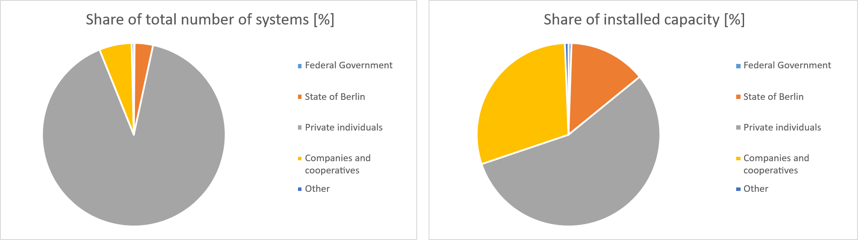
Fig. 2: Ownership distribution of PV systems by total number and installed capacity (data as of 31 December 2024, Data source: Energieatlas Berlin, based on MaStR data of the BNetzA.

Map 08.09.2 Solar Thermal Energy
Since its launch, the Energieatlas Berlin has replaced the data collection system of the Solaranlagenkataster (solar installation register) that integrates multiple sources (see Statistical Base section) and presentation methods. By 31 December 2024, around 8,900 solar thermal systems had been recorded across the city. At present, new installations are not systematically monitored. Additional gaps have emerged following the transfer of funding responsibility for solar thermal systems from the Federal Office for Economic Affairs and Export Control (BAFA) to the state-owned development bank KfW. Figure 3 shows that the number of new installations has declined sharply since around 2013 compared with previous years, reflecting an overall downward trend. In Berlin, solar thermal systems are mainly used for domestic hot water and to supplement space heating. There are also several larger systems designed to heat drinking water or swimming pools, as well as solar ventilation and cooling systems. As with PV systems, solar thermal installations are concentrated in the city’s outer boroughs, where housing remains predominantly low-density and landscape-oriented. (For a closer look at data by postcode, see the ‘Solaranlagen – Solarthermie’ map in the Geoportal Berlin and activate the ‘Summe der solarthermischen Anlagen pro Postleitzahl’ layer).
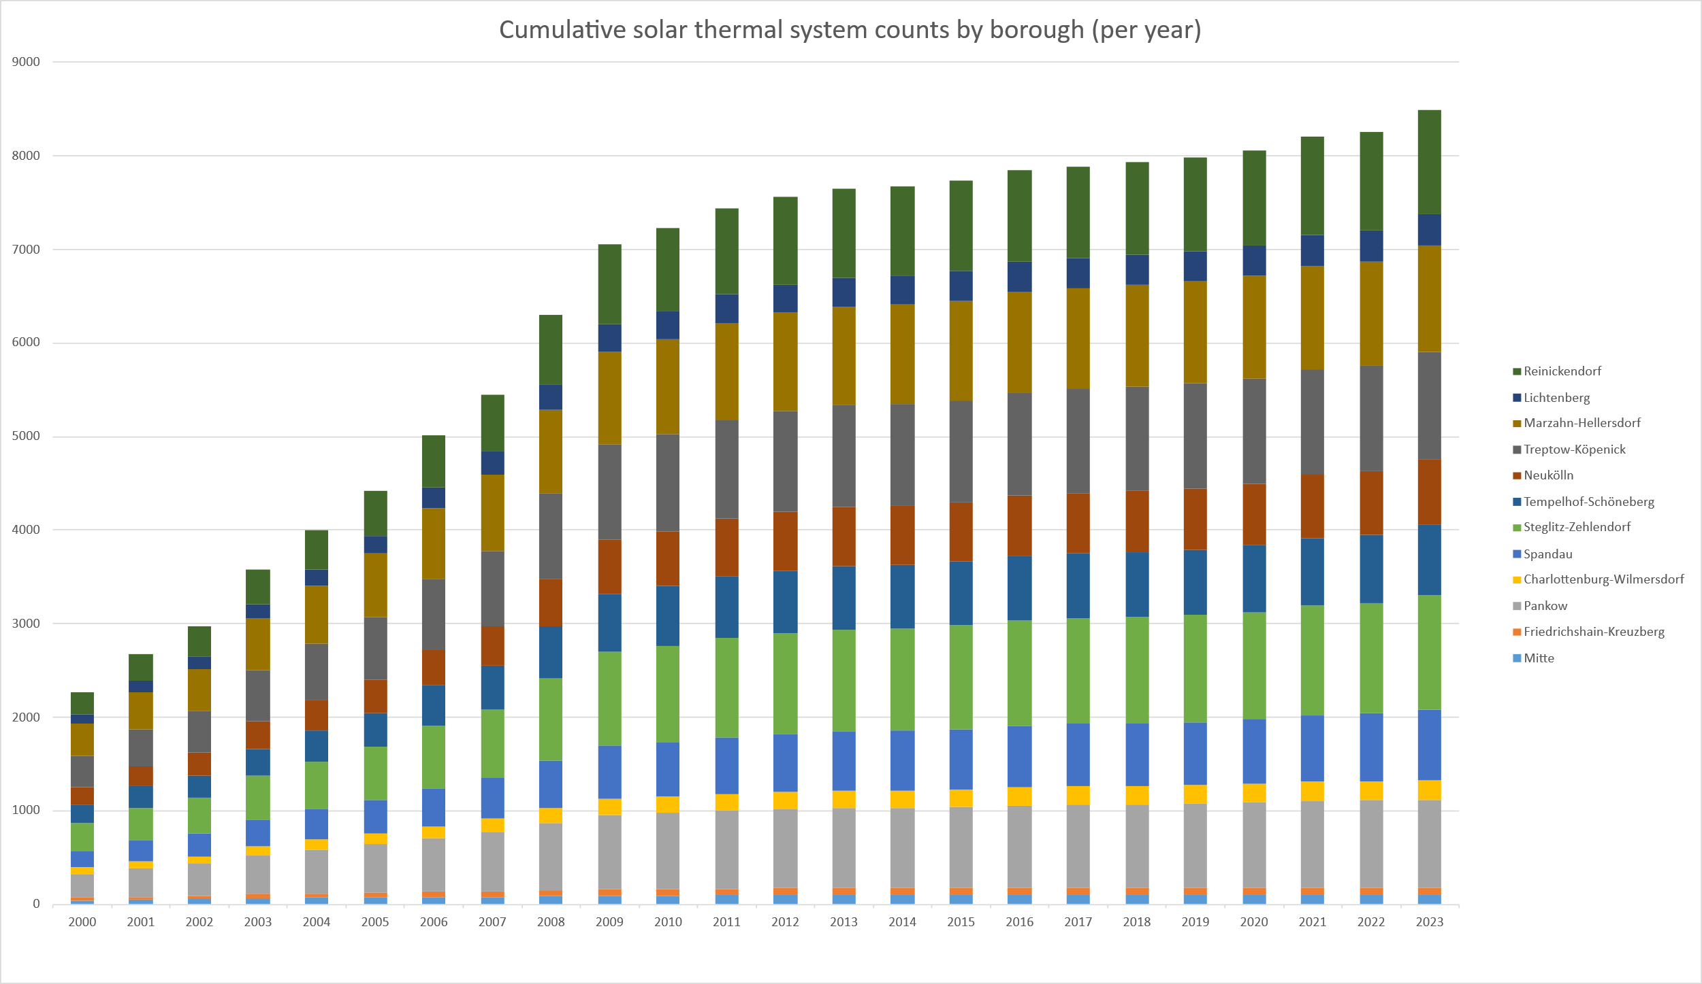
Fig. 3: Development of solar thermal systems in the State of Berlin, by number of systems per borough
(data as of 20 February 2024), Data source: Energieatlas Berlin, based on MaStR data of the BNetzA.

The recorded list of solar thermal systems used exclusively for domestic hot water is not exhaustive, meaning the actual number of installations in Berlin is likely higher than official figures indicate. Most systems employ flat-plate collectors and are found on single-family homes. For the years after 2015, only aggregated data from BAFA is available for Berlin, which does not allow distinctions by collector type, building type, or collector area.

Since 2013, the rate of new installations in Berlin has fallen sharply. By 2024, around 8,900 systems with a combined collector area of roughly 94,300 m² had been recorded (SenWEB / Masterplan Solarcity Monitoringbericht, 2024). This figure does not fully reflect all new installations in recent years, suggesting that the true total is somewhat higher.

At the national level, growth in solar thermal collector area has slowed since 2015, reaching an increase of about 0.22 million m² in 2024. Overall, the expansion of both system numbers and collector area has levelled off noticeably in recent years (German Solar Association 2024).

Map 08.09.3 Solar Irradiation
A thorough assessment of solar irradiation (expressed as annual totals) provides the foundation for estimating how much energy Berlin can realistically harness from the sun (IP SYSCON 2022). For the Berlin area, the German Weather Service (DWD) has reported an average annual global irradiation, i.e. the sum of varying proportions of direct and diffuse solar radiation, of 1081 to 1100 kWh/m² on a horizontal surface for the current long-term reference period from 1991 to 2020. Within the national context, Berlin lies roughly at the midpoint of the overall irradiation range (see Fig. 4). Comparing two recent reference periods (1981-2010 and 1991-2020) reveals a clear upward trend: global irradiation in Berlin and Brandenburg has increased by 40 to 50 kWh/m² per year (roughly 5 %) a shift attributed to ongoing climate change. The amount of irradiation received on a horizontal surface depends on local conditions (see Methodology section).
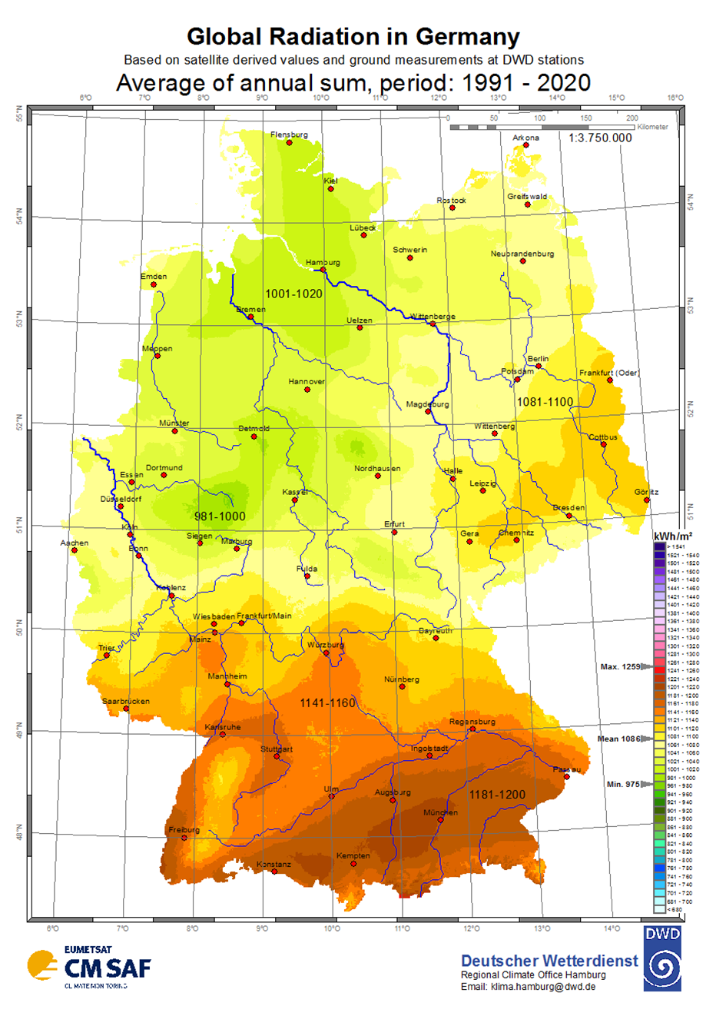
Fig. 4: Average annual sums of global irradiation in Germany for the long-term period from 1991 to 2020 (unaltered reproduction; source: DWD 2022).

Statistical Base
As previously mentioned, the Energieatlas (energy atlas) marks a departure from the data collection approach employed for the Solaranlagenkataster (solar installation register). Rather than relying on a single source, the new system draws together several datasets and presentation methods. In future, this role will be taken on by the Energiedatenbank database that underpins the Energieatlas.
The individual data sources included in the system are listed below:
Photovoltaics:
- Energieatlas Berlin, Senate Department for Economics, Energy and Public Enterprises (SenWEB), online version as of December 2024
- Locations and deployment status of PV systems: data provided by the BNetzA according to the MaStR (core energy market data register), as of 7 October 2024
- Data on the public sector: survey conducted by the Berliner Energieagentur GmbH among public institutions, as of 31 March 2024
- PV feed-in: data provided by Stromnetz Berlin GmbH, as of 1 July 2024
- Installed vs potential PV capacity: expert estimate for the Masterplan Solarcity Berlin, Fraunhofer ISE (2019), commissioned by the State of Berlin, Senate Department for Economic Affairs, Energy and Public Enterprises (baseline scenario)
- Postcode areas: data as of 30 June 2023
- Solar potential assessment for Berlin, IP SYSCON, commissioned by the SenWEB, as of 8 December 2021
- Locations and deployment status of landlord-to-tenant PV systems: data from the BNetzA according to the MaStR, as of 7 October 2024
Solar thermal energy:
- Locations of solar thermal systems: data based on the Solaranlagenkataster Berlin, as of 31 December 2015
- Number of systems, by borough or postcode: location data from 31 December 2015; supplemented by data from the Federal Office for Economic Affairs and Export Control for the years from 2016 to 2023, as of 20 February 2024
- Postcode areas: data as of 30 June 2023
- Solar thermal potential: solar potential assessment for Berlin, IP SYSCON, commissioned by the SenWEB, as of 21 March 2022
- Locations and total number of solar thermal systems for the public sector, by borough: survey conducted by the Berliner Energienetzagentur among public institutions, as of 31 March 2023
- Solar potential assessment for Berlin, IP SYSCON, commissioned by the SenWEB, as of 21 March 2022
- Postcode areas: data as of 30 June 2023
It is likely that not all solar installations in Berlin were recorded in the respective survey year. This applies in particular to off-grid systems, such as photovoltaic modules installed on parking meters, park lighting, or systems located within allotment gardens.
Solar irradiation:
- Energieatlas Berlin, Senate Department for Economic Affairs, Energy and Public Enterprises (SenWEB), online version as of July 2022
- Solar potential assessment for Berlin, IP SYSCON, commissioned by the SenWEB, as of 21 March 2022.

Methodology
Each of the three maps consists of multiple layers, with each layer covering a distinct topic and spatial extent. This design reflects both data-protection considerations and scientific methodology. The layers are self-contained, meaning that overlaying multiple two-dimensional layers does not provide additional information beyond that offered by each individual layer.
The maps include the following specialised layers:
Translator’s note: the titles of the map layers listed below are English translations provided for reference. The actual layer names and map data in the Geoportal Berlin are available in German only; these German titles are cited later in this section within the relevant descriptions of each layer.
Map 08.09.1 Photovoltaics (PV) contains 15 layers:
- Locations of PV systems over 30 kWp
- Clustered locations of PV systems up to 30 kWp
- Locations of PV systems, public sector
- Locations of landlord-to-tenant PV systems over 30 kWp
- Approximate locations of landlord-to-tenant PV systems up to 30 kWp
- Installed PV capacity, by borough [MWp]
- Installed PV capacity, by postcode area [kWp]
- Installed PV capacity for the public sector, by borough [MWp]
- Installed capacity of landlord-to-tenant PV systems, by borough
- PV feed-in, by borough [MWh]
- PV feed-in, by postcode [MWh]
- Installed vs potential PV capacity, by borough [%]
- Theoretical PV potential, by borough [MWp]
- Theoretical PV potential, rooftops
- Theoretical PV potential, buildings
Map 08.09.2 Solar Thermal Energy contains 7 layers:
- Locations of solar thermal systems
- Locations of solar thermal systems, public sector
- Number of solar thermal systems, by borough
- Number of solar thermal systems, by postcode
- Number of solar thermal systems for the public sector, by borough
- Theoretical solar thermal potential, rooftops
- Theoretical solar thermal potential, buildings
Map 08.09.3 Solar Potential – Solar Irradiation contains 1 layer
- Solar potential – Solar irradiation

Map 08.09.1 Photovoltaics
The methodology used for the PV maps was shaped significantly by the 2014 amendment to the EEG. Since August of that year, the BNetzA has been responsible for publishing PV system data as a central authority uniform throughout Germany. Previously, grid operators were responsible for publishing such data, typically providing system addresses and generator capacities on their own websites. For systems below 30 kWp, the BNetzA only publishes the postcode of the system’s location for data protection reasons. The precise address (street and house number) is published only for systems with a capacity of 30 kWp or more.
Map layer – Locations of photovoltaic systems over 30 kWp
Standorte der Photovoltaikanlagen größer 30 kWp
The location of systems with an output of over 30 kWp is based on the address data recorded at registration. In some cases, minor spatial discrepancies may occur because the exact location of the rooftop could not always be determined. For data protection reasons, systems with an output of up to 30 kWp are not displayed at their exact locations but are aggregated to the centre of the corresponding postcode area.
Off-grid systems – such as PV modules on parking meters or park lighting, and units installed in allotment gardens – that do not feed electricity into the grid and are used solely for self-consumption, are not included.
Map layer – Clustered locations of PV systems up to 30 kWp
Standorte (zusammengefasst) der Photovoltaikanlagen bis 30 kWp
Systems that do not feed electricity into the grid and are used solely for self-consumption, are not shown in this layer. This applies to off-grid systems, such as PV modules on parking meters or park lighting, and units installed in allotment gardens.
For data protection reasons, systems with an output of up to 30 kWp are not displayed at their exact locations but are aggregated to the centre of the corresponding postcode area.

Map layer – Locations of landlord-to-tenant PV systems over 30 kWp
Standorte PV-Mieterstromanlagen [> 30kWp]
This layer shows the locations of landlord-to-tenant PV systems. These positions are based on the address of each system as recorded in the MaStR (core energy market data register). In some cases, there may be minor deviations from the actual position, or the exact location may not have been determined.
The tenant electricity model typically involves the installation of PV systems on the roofs of multi-family homes. These are usually operated by an energy service provider or contractor, who sells the solar electricity directly to the tenants. If the amount of electricity produced is insufficient, the public grid supplies any additional demand.
The dataset underpinning this map layer exclusively includes PV systems that have been registered in the MaStR with a landlord-to-tenant electricity premium, also known as Mieterstromzuschlag. It covers systems with an installed capacity above 100 kWp that were registered from 2023 onwards.
The location of systems with an output of over 30 kWp is based on the address data recorded at registration. In some cases, minor spatial discrepancies may occur because the exact location of the rooftop could not always be determined.
The landlord-to-tenant electricity premium was first introduced in 2017. Prior to the amendment to the EEG in 2023, larger systems (with an output of over 100 kWp) were not eligible for subsidies and were therefore not included in the dataset. The number of landlord-to-tenant systems corresponds to the number of objects registered in the MaStR. It is important to note that larger systems are often registered as multiple smaller units for metering reasons or to comply with the 100 kWp limit. As a result, the dataset provides an indicative rather than a complete picture of the development of recent landlord-to-tenant PV systems.
Map layer – Approximate locations of landlord-to-tenant PV systems up to 30 kWp
Standorte PV-Mieterstromanlagen [<=30 kWp nicht lagetreu]
This layer shows the locations of landlord-to-tenant PV systems. These positions are based on the address of each system as recorded in the MaStR (core energy market data register). In some cases, there may be minor deviations from the actual position, or the exact location may not have been determined.
The tenant electricity model typically involves the installation of PV systems on the roofs of multi-family homes. These are usually operated by an energy service provider or contractor, who sells the solar electricity directly to the tenants. If the amount of electricity produced is insufficient, the public grid supplies any additional demand.
The dataset underpinning this map layer exclusively includes PV systems that have been registered in the MaStR with a landlord-to-tenant electricity premium, also known as Mieterstromzuschlag. It covers systems with an installed capacity below 100 kWp, provided they have been in operation since 2017.
For data protection reasons, systems with an output of up to 30 kWp are not displayed at their exact locations but are aggregated to the centre of the corresponding postcode area.
The landlord-to-tenant electricity premium was first introduced in 2017. Prior to the amendment to the EEG in 2023, larger systems (with an output of over 100 kWp) were not eligible for subsidies and were therefore not included in the dataset. The number of landlord-to-tenant systems corresponds to the number of objects registered in the MaStR. It is important to note that larger systems are often registered as multiple smaller units for metering reasons or to comply with the 100 kWp limit. As a result, the dataset provides an indicative rather than a complete picture of the development of recent landlord-to-tenant PV systems.
Map layers – Installed PV capacity, by borough [MWp]
Leistung der Photovoltaikanlagen pro Bezirk [MWp]
This layer shows the total installed capacity of PV systems, aggregated by borough. Systems that do not feed electricity into the grid and are used solely for self-consumption are not included. This exclusion applies to off-grid installations, such as PV modules on parking meters or park lighting, and units installed in allotment gardens.
Map layers – Installed PV capacity, by postcode [kWp]
Installierte Leistung der Photovoltaikanlagen pro Postleitzahl [kWp]
This map layer shows the total installed capacity of PV systems, aggregated by postcode. Off-grid systems – such as PV modules on parking meters or park lighting, and units installed in allotment gardens – that do not feed electricity into the grid and are used solely for self-consumption, are not included.
Map layer – Installed PV capacity for the public sector, by borough [MWp]
Installierte Leistung der Photovoltaikanlagen pro Bezirk - Öffentliche Hand [MWp]
This map layer illustrates the current level of PV deployment on public buildings in Berlin. It shows the number of systems and the total installed capacity in MWp, aggregated by borough.
This includes borough-owned buildings and those managed by the state-owned property management company BIM. Also included are premises belonging to Berlin’s public law institutions and buildings owned by municipal housing cooperatives and other state-affiliated companies. Each system is shown at the specific address where it is installed. Please note that not all of the 57 relevant institutions and companies have yet reported on their PV installations.
Map layer – Installed capacity of landlord-to-tenant PV systems, by borough
Installierte Leistung der PV-Mieterstromanlagen pro Bezirk
This map layer shows the total installed capacity of landlord-to-tenant PV systems, aggregated by borough.
The tenant electricity model typically involves the installation of PV systems on the roofs of multi-family homes. These are usually operated by an energy service provider or contractor, who sells the solar electricity directly to the tenants. If the amount of electricity produced is insufficient, the public grid supplies any additional demand.
The dataset underpinning this map layer exclusively includes PV systems that have been registered in the MaStR with a landlord-to-tenant electricity premium, also known as Mieterstromzuschlag. It covers systems with an installed capacity below 100 kWp, provided they have been in operation since 2017.
The landlord-to-tenant electricity premium was first introduced in 2017. Prior to the amendment to the EEG in 2023, larger systems (with an output of over 100 kWp) were not eligible for subsidies and were therefore not included in the dataset. The number of landlord-to-tenant systems corresponds to the number of objects registered in the MaStR. It is important to note that larger systems are often registered as multiple smaller units for metering reasons or to comply with the 100 kWp limit. As a result, the dataset provides an indicative rather than a complete picture of the development of recent landlord-to-tenant PV systems.
Map layer – PV feed-in, by borough [MWh]
Photovoltaik-Stromeinspeisung pro Bezirk [MWh]
The data shown here represents the volumes of electricity fed into the grid, as recorded and billed by Stromnetz Berlin GmbH, aggregated by borough. The figures include both measured volumes and officially settled amounts determined through the relevant market processes. Please note that the annual totals are not final, as subsequent corrections to individual invoices may have led to adjustments.
In some boroughs, feed-in volumes can fluctuate greatly from year to year due to factors such as weather conditions, new system installations, or outages. The available data does not allow these variations to be confidently attributed to specific causes.
Map layer – PV feed-in, by postcode [MWh]
Photovoltaik-Stromeinspeisung pro Postleitzahl [MWh]
The data shown here represents the volumes of electricity fed into the grid, as recorded and billed by Stromnetz Berlin GmbH, aggregated by postcode. The figures include both measured volumes and officially settled amounts determined through the relevant market processes. Please note that the annual totals are not final, as subsequent corrections to individual invoices may have led to adjustments.
In some boroughs, feed-in volumes can fluctuate greatly from year to year due to factors such as weather conditions, new system installations, or outages. The available data does not allow these variations to be confidently attributed to specific causes.
Map layer – Theoretical PV potential, by borough [MWp]
Photovoltaik - Potenzial (theoretisch) pro Bezirk [MWp]
This layer illustrates the theoretical photovoltaic potential that could be realised on Berlin’s rooftops, aggregated by borough.
These figures are based on a 2019 study conducted by the Fraunhofer Institute for Solar Energy Systems as part of the Masterplan Solarcity Berlin. These calculated potentials provide an important basis for monitoring the implementation of the Masterplan Solarcity (further information available in German only). The assessment did not include protected (listed) buildings.
Map layer – Theoretical PV potential, rooftops
Photovoltaik-Potenzial (theoretisch) – Dachfläche
This layer illustrates the photovoltaic potential that could be realised on Berlin’s rooftops. In addition to the site-specific global solar irradiation, other key parameters for system planning include shading, roof orientation and slope. Suitable rooftops were identified as part of a solar potential assessment. The levels of solar irradiation are represented by a colour scale, providing an initial indication of the suitability for solar energy use.
However, this information does not replace the need for a professional assessment of each building prior to the detailed planning or installation of a PV system, particularly with regard to parameters such as the structural integrity of the roof. Technical suitability must be verified in each case. Further information and free advice are available in German from the SolarZentrum Berlin.
Existing datasets such as aerial imagery and ALKIS building footprints were used to determine solar potential, combined with transparent calculation methods described in detail in the final report (IP SYSCON 2022, available in German only). Only rooftops identified as suitable are displayed. Selection criteria include a minimum available area of 7 m² and a specific yield of at least 650 kWh/kWp. Roofs already fitted with PV systems are not differentiated in the map. Buildings that were constructed, modified, demolished or added to ALKIS after the data collection date (22 April 2021) could not be represented.
Map layer – Theoretical PV potential, buildings
Photovoltaik - Potenzial (theoretisch) – Gebäude
This layer provides information on the theoretical photovoltaic rooftop potential that could be realised on Berlin’s buildings. More information on each building may be accessed through the data display. In addition to an assessment of how suitable a building is for the installation of a PV system, the installable capacity [kWp], the number of installable modules and the potential electricity yield per year [kWh/a] are indicated. However, this information does not replace the need for a professional assessment of each building prior to the detailed planning or installation of a PV system, particularly with regard to parameters such as the structural integrity of the roof. Technical suitability must be verified in each case. Further information and free advice are available in German from the SolarZentrum Berlin.
In addition to the site-specific global solar irradiation, other key parameters for system planning include shading, roof orientation and slope.
Existing datasets such as aerial imagery and ALKIS building footprints were used to determine solar potential, combined with transparent calculation methods described in detail in the final report (IP SYSCON 2022, available in German only). Only rooftops identified as suitable are displayed. Selection criteria include a minimum area of 7 m² and a specific yield of at least 650 kWh/kWp. Roofs already fitted with PV systems are not differentiated in the map. Buildings that were constructed, modified, demolished or added to ALKIS after the data collection date (22 April 2021) could not be represented.
Map layer – Installed vs potential PV capacity, by borough [%]
Relative Deckungsrate der Photovoltaik-Leistung pro Bezirk
The map illustrates the extent to which each borough has realised its PV potential. It expresses the ratio of installed PV capacity to the estimated theoretical potential for that borough.
The theoretical rooftop PV potential for the city was modelled in 2019 in the Masterplan Solarcity Berlin study by the Fraunhofer Institute for Solar Energy Systems. These values were aggregated at the borough level and compared with the PV capacity actually installed to derive the percentages shown.
Although the resulting ratios appear low at first glance, this mainly reflects discrepancies between the theoretical potential and the share of PV potential that can technically be implemented in practice. More detailed analyses and modelling would be required to reduce this discrepancy and refine the underlying estimates.

Map 08.09.2 Solar Thermal Energy
Please note that the Solaranlagenkataster (solar installation register, final version as of 31 December 2015) does not capture all systems that were actually installed at that time.
Map layer – Locations of solar thermal systems
Standorte der solarthermischen Anlagen
The display of system locations (data as of 31 December 2015) is subject to data protection regulations. For this reason, solar thermal systems are only shown on maps at a scale of 1:15,000 or larger.
While it is assumed that the majority of solar thermal systems operating in Berlin at the time of data collection were recorded, minor discrepancies or missing installations cannot be ruled out.
The data is sourced from the Solaranlagenkataster Berlin (records up to 2016).
Map layer – Locations of solar thermal systems, public sector
Standorte der solarthermischen Anlagen - Öffentliche Hand
This layer shows the locations of solar thermal systems installed on public buildings (data as of 31 March 2025). These include borough-owned buildings and those managed by the state-owned property management company BIM. Also included are premises belonging to Berlin’s public law institutions and buildings owned by municipal housing cooperatives and other state-affiliated companies. Please note that not all of the relevant institutions and companies have yet reported on their solar thermal installations. Each system is shown at the specific address where it is installed.
Map layer – Number of solar thermal systems, by borough
Summe der solarthermischen Anlagen pro Bezirk
This map layer shows the total number of solar thermal systems in Berlin, aggregated by borough. While it is assumed that the majority of solar thermal systems operating in Berlin at the time of data collection were recorded, minor discrepancies or missing installations cannot be ruled out.
The displayed data also includes updates for the years 2016 to 2023 based on additional information from the Federal Office for Economic Affairs and Export Control (BAFA). However, this data is only available at the postcode level, which is the smallest spatial unit provided. As a result, location of individual systems was not possible, but totals for boroughs and postcodes could be included.
Map layer – Number of solar thermal systems, by postcode
Summe der solarthermischen Anlagen pro Postleitzahl
This layer shows the total number of solar thermal systems in Berlin, aggregated by postcode. While it is assumed that the majority of solar thermal systems operating in Berlin at the time of data collection were recorded, minor discrepancies or missing installations cannot be ruled out.
The displayed data also include updates for the years 2016 to 2023 based on additional information from the Federal Office for Economic Affairs and Export Control (BAFA). However, this data is only available at the postcode level, which is the smallest spatial unit provided. As a result, location of individual systems was not possible, but totals for boroughs and postcodes could be included.
Map layer – Number of solar thermal systems for the public sector, by borough
Summe der solarthermischen Anlagen pro Bezirk - Öffentliche Hand
This map layer illustrates the level of solar thermal deployment on public buildings across Berlin’s boroughs, as of 31 May 2025. These include borough-owned buildings and those managed by the state-owned property management company BIM. Also included are premises belonging to Berlin’s public law institutions and buildings owned by municipal housing cooperatives and other state-affiliated companies. Please note that not all of the relevant institutions and companies have yet reported on their solar thermal installations. Each system is shown at the specific address where it is installed.
For this layer, address data was aggregated by borough. For reference, the total number of solar thermal systems installed on public buildings across the whole city is also provided.
Map layer – Theoretical solar thermal potential, rooftops
Solarthermie-Potenzial (theoretisch) – Dachfläche
This layer illustrates the solar thermal potential that could be realised on Berlin’s rooftops. In addition to the site-specific global solar irradiation, other key parameters for system planning include shading, roof orientation and slope. Suitable rooftops were identified as part of a solar potential assessment. The levels of solar irradiation are represented by a colour scale, providing an initial indication of the suitability for solar energy use.
Existing datasets such as aerial imagery and ALKIS building footprints were used to determine solar potential, combined with transparent calculation methods described in detail in the final report (available in German only). Only rooftops identified as suitable are displayed in the map. Selection criteria include a minimum available area of 4 m² and a potential heat output of 350 kWh/kWp per m². Buildings that were constructed, modified, demolished or added to ALKIS after the data collection date (22 April 2021) could not be represented.
Map layer – Theoretical solar thermal potential, buildings
Solarthermie-Potenzial (theoretisch) - Gebäude
This layer provides information on the theoretical solar thermal rooftop potential that could be realised on Berlin’s buildings. In addition to the site-specific global solar irradiation, other key parameters for system planning include shading, roof orientation and slope.
More information on each building may be accessed through the data display. In addition to an assessment of how suitable a building is for the installation of a solar thermal system, the potential heat output [kWh/a] is indicated. However, this information does not replace the need for a professional assessment of each building prior to the detailed planning or installation of a solar thermal system, particularly with regard to parameters such as the structural integrity of the roof. Technical suitability must be verified in each case. Further information and free advice are available in German from the SolarZentrum Berlin.
Existing datasets such as aerial imagery and ALKIS building footprints were used to determine solar potential, combined with transparent calculation methods described in detail in the final report (available in German only). Only rooftops identified as suitable are displayed in the map. Selection criteria include a minimum area of 4 m² and a potential heat output of 350 kWh/kWp per m². Buildings that were constructed, modified, demolished or added to ALKIS after the data collection date (22 April 2021) could not be represented.

Map 08.09.3 Solar Potential – Solar Irradiation
The solar irradiation model for Berlin encompasses all types of surfaces found in the city, extending beyond buildings and their components. This makes it suitable for a range of analyses beyond assessing solar potential alone. The method used to generate the high-resolution grid data is described in detail in the final report of the solar potential assessment (IP SYSCON 2022) and is summarised here.
The assessment is based on aerial survey data from 2020 (SenStadtWohn 2020), which was used to create a detailed 3D model of the city. A key feature of the model is its three-dimensional analysis, which accounts for shading from trees and buildings as well as changes in the sun’s altitude – factors that can have a significant impact on solar irradiation, depending on the season. The model was calibrated using long-term monthly averages of global solar irradiation, provided by the DWD, covering the period from 1991 to 2020 (see Fig. 4).
In addition to the annual totals presented here, irradiation levels were also calculated for the heating period (1 October to 30 April) to assess the potential contribution of solar thermal energy to space heating.

Map Description
The maps show both solar thermal and photovoltaic (PV) systems. Solar thermal data is limited to installations that have been registered for subsidies.
Off-grid PV systems – such as solar-powered parking meters, park lighting, and other units that do not feed electricity into the grid – are recorded separately and are not included here.

Map 08.09.1 Photovoltaics (PV)
By 31 December 2024, Berlin had 41,723 registered PV systems. Most are small-scale, under 30 kWp (40,234 systems), while only 329 exceed 100 kWp. Together, they provide around 380.64 MWp of installed capacity, with larger installations contributing roughly 22 % (84.75 MWp) of the city’s total. Across the boroughs, Marzahn-Hellersdorf, Treptow-Köpenick, and Pankow are far ahead both in number of systems and total capacity. Lichtenberg is notable in terms of installed capacity: although it hosts fewer installations overall, a small number of high-capacity systems brings its total to 35.4 MWp. At the more detailed postcode level, suburban neighbourhoods dominated by single-family homes show the highest number of systems and the greatest number of postcode areas exceeding 1,000 kWp.
By 31 March 2024, 1,021 of the above-mentioned PV systems had been installed on public buildings across the city, with a combined capacity of 61.94 MWp. Lichtenberg has the highest system count (190), followed by Marzahn-Hellersdorf (158) and Pankow (138). Lichtenberg also ranks highest in installed capacity (11.32 MWp), with Charlottenburg-Wilmersdorf (8.76 MWp) and Marzahn-Hellersdorf (8.39 MWp) close behind. The public sector also operates several buildings outside the city that together host four PV systems with a total capacity of 1.14 MWp.

Borough | Number of systems | Total capacity [MWp] | Average capacity [MWp] | PV feed-in  (as of 2023)  [GWh] | Number of systems, public sector | Total capacity, public sector [MWp] | Average capacity, public sector [kWp]
Mitte | 838 | 12.88 | 15.37 | 3,459.54 | 64 | 5.51 | 86.134
Friedrichshain-Kreuzberg | 864 | 6.67 | 7.72 | 1,265.79 | 50 | 2.51 | 50.110
Pankow | 5992 | 46.78 | 7.81 | 10,062.78 | 138 | 5.07 | 36.750
Charlottenburg-Wilmersdorf | 1047 | 17.15 | 16.38 | 2,153.68 | 71 | 8.76 | 123.367
Spandau | 3449 | 32.78 | 9.50 | 6,617.68 | 62 | 4.02 | 64.900
Steglitz-Zehlendorf | 3750 | 26.99 | 7.20 | 4,618.97 | 41 | 3.52 | 85.897
Tempelhof-Schöneberg | 3124 | 31.61 | 10.12 | 6,585.04 | 46 | 2.91 | 63.314
Neukölln | 2902 | 23.71 | 8.17 | 5,238.35 | 55 | 2.66 | 48.424
Treptow-Köpenick | 6392 | 54.75 | 8.56 | 10,278.80 | 105 | 4.58 | 43.613
Marzahn-Hellersdorf | 6725 | 59.71 | 8.88 | 13,836.84 | 158 | 8.39 | 53.104
Lichtenberg | 2700 | 35.42 | 13.12 | 7,457.81 | 190 | 11.32 | 59.566
Reinickendorf | 3940 | 32.19 | 8.17 | 6,827.34 | 41 | 2.68 | 65.358
Outside Berlin | - | - | - | - | 4 | 1.14 | 285.365
Total | 41,723 | 380.64 | 121.00 | 78,402.61 | 1,021 | 61.94 | 61.54
Tab. 1: PV system counts and installed capacity in Berlin’s boroughs (data as of 6 March 2025 for PV system deployment; 31 March 2024 for systems on public buildings, by borough; 17 January 2024 for PV feed-in), Data source: Energieatlas Berlin, based on MaStR data of the BNetzA.
As many PV systems generate more electricity than is used for self-consumption, the surplus is fed into the public grid. Between 2012 and 2023, this total volume of surplus electricity rose steadily from around 43 GWh to 78.4 GWh (see Fig. 5). According to the latest data, the highest absolute numbers are recorded in the boroughs of Marzahn-Hellersdorf (13,836.8 MWh) and Treptow-Köpenick (10,278.8 MWh) (see Tab. 3). Overall, electricity fed into the grid is concentrated in the northern and eastern boroughs. By contrast, Friedrichshain-Kreuzberg records the lowest volume, reflecting its position as the borough with the fewest systems and a comparatively low total capacity. At the more detailed postcode level, residential areas dominated by single-family homes again stand out, mirroring the pattern observed for installed capacity.
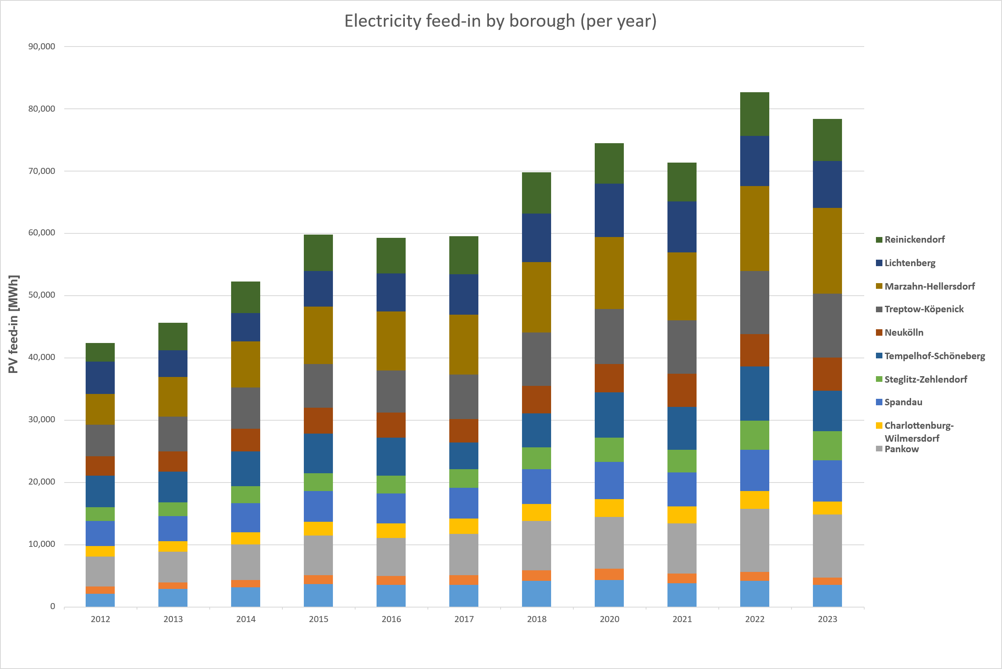
Fig. 5: PV feed-in, by borough (as of 1 July 2024). Data source: Energieatlas Berlin, based on MaStR data of the BNetzA.
The ratio of installed to potential PV capacity varies across the boroughs, ranging between 2.4 % in Mitte and 12 % in Marzahn-Hellersdorf (see Tab. 4).
At first glance, these low figures reveal a marked gap between installed capacity and the calculated potential, visible both at the borough and the postcode level. This gap largely stems from discrepancies between the theoretical potential and the share of PV potential that can technically be implemented in practice. More detailed analyses and modelling would be required to reduce this discrepancy and refine the underlying estimates.

Borough | Installed vs potential PV capacity [%]
Mitte | 2.4
Friedrichshain-Kreuzberg | 2.3
Pankow | 7.7
Charlottenburg-Wilmersdorf | 3.4
Spandau | 6.0
Steglitz-Zehlendorf | 4.4
Tempelhof-Schöneberg | 4.6
Neukölln | 4.5
Treptow-Köpenick | 9.1
Marzahn-Hellersdorf | 12.0
Lichtenberg | 7.6
Reinickendorf | 5.7
Total | 5.81
Tab. 2: Installed vs potential PV capacity, by borough. Data source: Solarcity Monitoringbericht, based on MaStR data of the BNetzA, as of 6 March 2024.
The most recent data on PV systems in Berlin, including system locations and borough-level deployment statistics, are available in map and chart form via the Energieatlas Berlin. A detailed annual analysis of PV expansion in the city is published separately in the Masterplan Solarcity Monitoringbericht (available in German only).
Results of the Rooftop PV Potential Assessment
Of approximately 536,000 buildings analysed, around 421,000 were identified as suitable for photovoltaic installations. If the 45.7 km² of theoretically suitable roof areas were fully fitted with PV modules (assuming a module efficiency of 19.5 %), they could generate roughly 7,929 GWh of electricity per year, avoiding an estimated 4.3 million tonnes of CO₂ emissions.

Suitable PV module area in m² | kWp capacity | Electricity yield in GWh/a (with an efficiency of 19.5 %) | CO₂ savings in t per year (with an efficiency of 19.5 %)
45,679,550 | 8,894,703 | 7,929 | 4,313,594

Tab. 3: Results of Berlin’s rooftop PV potential assessment (flat roofs assumed with elevated, south-facing systems; IP SYSCON 2022).

Map 08.09.2 Solar Thermal Energy (ST)
As there is no central register for solar thermal systems, a comprehensive dataset for Berlin is not currently available. Various approaches are being developed to strengthen the data foundation as part of the Masterplan Solarcity monitoring programme. Based on these methods, it is estimated that around 8,900 solar thermal systems were installed in Berlin in 2024, with a total collector area of approximately 94,300 m².
The majority of systems are located on the city’s outskirts. This pattern is evident in both detailed and aggregated map representations, which show system distribution by postcode and borough (data as of 31 March 2024). At the borough level, the highest concentrations are found in Steglitz-Zehlendorf (1,224 systems), Treptow-Köpenick (1,155), Marzahn-Hellersdorf (1,133) and Reinickendorf (1,122) (see Tab. 4). As with PV installations, most of these are smaller systems installed on privately owned single- and two-family homes (data as of 31 March 2024). By contrast, substantially fewer systems are recorded in the inner city, such as in the boroughs of Friedrichshain-Kreuzberg (76 systems), Mitte (104) and Charlottenburg-Wilmersdorf (209). These inner-city systems, however, often have higher rated capacity and/or greater heat generation potential, with collector areas typically ranging from 15 to 37 m², and are generally located on public-sector or commercial/industrial buildings (data as of 31 March 2024).

Borough | Number of systems | Number of systems,  public sector
Mitte | 104 | 38
Friedrichshain-Kreuzberg | 76 | 7
Pankow | 940 | 14
Charlottenburg-Wilmersdorf | 209 | 20
Spandau | 752 | 6
Steglitz-Zehlendorf | 1,224 | 11
Tempelhof-Schöneberg | 750 | 21
Neukölln | 697 | 12
Treptow-Köpenick | 1,155 | 22
Marzahn-Hellersdorf | 1,133 | 5
Lichtenberg | 333 | 5
Reinickendorf | 1,122 | 5
Total | 8,495 | 166
Tab. 4: Solar thermal system counts in Berlin’s boroughs (data as of 31 March 2024) and in the public sector (data as of 20 February 2024) for the year 2023. Data source: Energieatlas Berlin.
The most recent data on solar thermal systems in Berlin, including system locations and borough-level deployment statistics, are available in map and chart form via the Energieatlas Berlin (available in German only). A detailed annual analysis of solar thermal expansion in the city is published separately in the Masterplan Solarcity Monitoringbericht (available in German only).
Results of the Solar Thermal Potential Assessment
Of approximately 536,000 buildings analysed, more than 464,000 were identified as suitable for solar thermal installations, corresponding to a total potential collector area of 66.2 km².

Suitable collector area in m² | Number of buildings | Potential heat output in GWh/a
66,264,578 | 464,826 | 40,553
Tab. 5: Results of Berlin’s rooftop solar thermal potential assessment (flat roofs assumed with elevated, south-facing systems; IP SYSCON 2022).

Map 08.09.3 Solar Potential – Solar Irradiation
The calculated annual totals of global solar irradiation across Berlin’s urban surfaces span a broad range, from roughly 246 to about 1,220 kWh/(m²/a). For context, Germany’s National Meteorological Service (DWD) reports a mean annual total of 1,032 kWh/(m²/a) for the city. Extremely low rooftop values occur only where trees or surrounding structures cast significant shade (see Fig. 6).
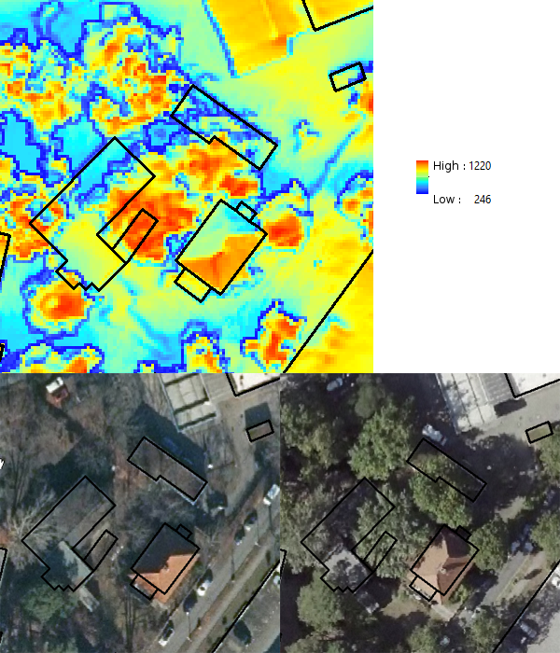

Fig. 6: Effect of tree shading and roof orientation on calculated rooftop solar irradiation (mean annual totals in kWh/(m²/a)). Top: calculated solar irradiation for surface grids at 0.5 × 0.5 m² spatial resolution, with building footprints outlined in black. Bottom left: cropped section from an aerial image (February 2021); bottom right: cropped section from an aerial image (August 2020).
Sources: aerial imagery from the Geoportal Berlin, DOP20RGBI (bottom left) and TrueDOP20RGB – summer survey (bottom right).
The highest levels of solar irradiation are found on south-facing pitched roofs fully exposed to the sun, as well as on open vegetated areas such as the Tempelhofer Feld, where values can reach about 1,000 kWh/(m²/a). By contrast, forested and tree-covered areas receive much less sunlight, typically between 250 and 300 kWh/(m²/a), due to shading and surface characteristics.
These patterns closely reflect urban climate effects, as illustrated in the Urban Climate Atlas (see Climate Analysis Maps: Surface Temperature, 2022).
The Solar Potential – Solar Irradiation Map (08.09.3) can therefore be used for a wide range of applications.

Literature
[1] Abgeordnetenhaus Berlin [Berlin House of Representatives] 2016:
Berliner Energie- und Klimaschutzprogramm 2030 – Umsetzungszeitraum 2016 – 2020, Vorlage – zur Beschlussfassung – [Berlin Energy and Climate Protection Programme 2030] – implementation period 2016 – 2020, draft – for resolution –], printed matter 17/2987, 7 June 2016.
Internet:
http://www.parlament-berlin.de/ados/17/IIIPlen/vorgang/d17-2987.pdf [available in German only]
(Accessed on 8 September 2022)

[2] Amt für Statistik (AfS) Berlin-Brandenburg [Statistical Office for Berlin-Brandenburg] 2016:
Regionales Bezugssystem RBS [RBS Spatial Reference System].
Internet:
https://www.statistik-berlin-brandenburg.de/regionales/rbs/berlinklein.asp?Kat=4002 [available in German only]
(Accessed on 8 September 2022)
[3] Amt für Statistik (AfS) Berlin-Brandenburg [Statistical Office for Berlin-Brandenburg] 2021:
Energie- und CO₂-Daten im Land Berlin 2020 [Energy and CO₂ data in the State of Berlin, 2020], Potsdam.
Internet:
https://download.statistik-berlin-brandenburg.de/cba6353763ccd5d2/f1c40867da86/SB_E04-05-00_2020j01_BE.xlsx [available in German only]
(Accessed on 8 September 2022)
[4] Berliner Energiewendegesetz (EWG Bln) [Berlin Energy Transition Act] of 22 March 2016:
In the version of the first law to amend the Berlin Energy Transition Act of 26 October 2017, Law and Ordinance Gazette p. 548 ff.
Internet:
https://www.berlin.de/sen/justiz/service/gesetze-und-verordnungen/2017/ausgabe-nr-29-vom-7-11-2017-s-541-556.pdf [available in German only]
(Accessed on 8 September 2022)
[5] Business Location Center Berlin (BLC) 2011:
Solarpotenzialanalyse Berlin – Datendokumentation [Assessment of Berlin’s solar potential – data documentation].
Internet:
https://energieatlas.berlin.de/Energieatlas_Be/Docs/Datendokumentation-Solarkataster_BLN.pdf [available in German only]
(Accessed on 8 September 2022)
[6] Bundesnetzagentur (BNetzA) [Federal Network Agency] 2020:
EEG in Zahlen [EEG in numbers].
Internet:
https://data.bundesnetzagentur.de/Bundesnetzagentur/SharedDocs/Downloads/DE/Sachgebiete/Energie/Unternehmen_Institutionen/ErneuerbareEnergien/ZahlenDatenInformationen/eeginzahlen_2019.xlsx [available in German only]
(Accessed on 27 January 2025)
[7] Bundesnetzagentur (BNetzA) [Federal Network Agency] 2023:
Statistiken ausgewählter erneuerbarer Energieträger zur Stromerzeugung – Juni 2023 [Statistics of selected renewable energy sources to generate electricity – June 2023].
Internet:
https://www.bundesnetzagentur.de/SharedDocs/Downloads/DE/Sachgebiete/Energie/Unternehmen_Institutionen/ErneuerbareEnergien/ZahlenDatenInformationen/EEStatistikMaStRBNetzA_XLS.xlsx?__blob=publicationFile&v=7 [available in German only]
(Accessed on 31 August 2023)
- Bundesnetzagentur (BNetzA) [Federal Network Agency] 2024:
Statistiken ausgewählter erneuerbarer Energieträger zur Stromerzeugung – Juni 2023 [Statistics of selected renewable energy sources to generate electricity – June 2023].
Internet:
https://www.bundesnetzagentur.de/SharedDocs/Downloads/DE/Sachgebiete/Energie/Unternehmen_Institutionen/ErneuerbareEnergien/ZahlenDatenInformationen/EEStatistikMaStR.pdf?__blob=publicationFile&v=28 [available in German only]
(Accessed on 27 January 2025)
[9] Bundesamt für Wirtschaft und Ausfuhrkontrolle (BAFA) [Federal Office for Economic
Affairs and Export Control] 2020:
Online presence.
Internet:
https://www.bafa.de/EN/Home/home_node.html
(Accessed on 8 September 2022)
[10] Bundesverband Solarwirtschaft (BSW) e.V. [German Solar Association] 2024:
Aktueller Bestand an Solarwärmesystemen und Solarkollektorfläche in Deutschland Deutschland [Existing solar thermal systems and collector area in Germany], Berlin.
Internet:
https://www.solarwirtschaft.de/presse/marktdaten/ [available in German only]
(Accessed on 30 June 2025)
[11] Deutscher Wetterdienst (DWD) [Germany’s National Meteorological Service] 2022:
Online presence regarding maps and information on radiation.
Internet:
https://www.dwd.de/EN/ourservices/solarenergy/maps_globalradiation_sum_new.html
(Accessed on 27 October 2022)
[12] Gesetz für den Ausbau erneuerbarer Energien (EEG 2014) [2014 German Renewable Energy Sources Act]:
Renewable Energy Sources Act of 21 July 2014 (Federal Law Gazette I p. 1066), as last amended by Article 4 of the Act of 26 July 2023 (Federal Law Gazette I 2023 No. 202).
Internet:
https://www.gesetze-im-internet.de/eeg_2014/EEG_2023.pdf [available in German only]
(Accessed on 16 August 2023)
[13] Jahressteuergesetz 2022 (JStG 2022) [2022 Annual Tax Act]:
Jahressteuergesetz vom 16. Dezember 2022 [Annual Tax Act of 16 December 2022] (Federal Law Gazette I 2022 p. 2294)
Internet:
https://www.bundesfinanzministerium.de/Content/DE/Gesetzestexte/Gesetze_Gesetzesvorhaben/Abteilungen/Abteilung_IV/20_Legislaturperiode/2022-12-20-JStG-2022/4-Verkuendetes-Gesetz.pdf?__blob=publicationFile&v=2 [available in German only]
(Accessed on 16 August 2023)

[14] IP SYSCON 2016:
Solaranlagenkataster Berlin 2015. Ergebnisbericht 2016 [Berlin’s solar installation register, 2015. Results report, January 2016], commissioned by the Senate Department for Urban Development and the Environment, Berlin, unpublished.
[15] Reusswig, F./ Hirschl, B./ Lass, W./ Becker, C./ Bölling, L./ Clausen, W./ Haag, L./ Hahmann, H./ Heiduk, P./ Hendzlik, M./ Henze, A./ Hollandt, F./ Hunsicker, F./ Lange, C./ Meyer-Ohlendorf, L./ Neumann, A./ Rupp, J./ Schiefelbein, S./ Schwarz, U./ Weyer, G./ Wieler, U. 2014:
Climate-Neutral Berlin 2050, Results of a Feasibility Study, commissioned by the Senate Department for Urban Development and the Environment, 2014.
Internet:
https://www.berlin.de/sen/uvk/_assets/klimaschutz/publikationen/machbarkeitsstudie_berlin2050_en.pdf
(Accessed on 8 September 2022)
[16] SenK (Senatskanzlei Berlin) 2021:
Senat beschließt Solargesetz Berlin [Senate passes Berlin Solar Act], press release from 2 March 2021.
Internet:
https://www.berlin.de/rbmskzl/aktuelles/pressemitteilungen/2021/pressemitteilung.1058907.php [available in German only]
(Accessed on 8 September 2022)
[17] SenUMVK (Senate Department for Urban Mobility, Transport, Climate Action and the Environment Berlin) 2022:
Berliner Energie- und Klimaschutzprogramm 2030 (BEK 2030) Umsetzungszeitraum 2022 bis 2026 [Berlin Energy and Climate Protection Programme 2030 (BEK 2030) implementation period from 2022 to 2026].
Internet:
https://www.berlin.de/sen/uvk/klimaschutz/klimaschutz-in-der-umsetzung/bek-2030-umsetzung-2022-bis-2026/ [full version in German]
https://www.berlin.de/sen/uvk/en/climate-action/berlin-energy-and-climate-protection-programme-2030-bek-2030/ [overview in English]
(Accessed on 8 September 2022)
[18] SenWEB (Senate Department for Economics, Energy and Public Enterprises Berlin) 2013:
Solaratlas Berlin [Berlin Solar Atlas], compiled by the Berlin Partner für Wirtschaft und Technologie GmbH.
Offline.
[19] SenWEB (Senate Department for Economics, Energy and Public Enterprises Berlin) 2024:
Energieatlas Berlin [Berlin Energy Atlas], as of December 2024.
Internet:
https://energieatlas.berlin.de/ [available in German only]
(Accessed on 20 December 2024)
[20] SenWEB (Senate Department for Economics, Energy and Public Enterprises Berlin) 2019:
Masterplan Solarcity [Solar city master plan].
Internet:
https://www.berlin.de/sen/energie/energiepolitik/masterplan-solarcity/expertenempfehlung_masterplan_solarcity_berlin.pdf?ts=1684734313 [available in German only]
(Accessed on 13 July 2023)
[21] SenWEB (Senate Department for Economics, Energy and Public Enterprises Berlin) 2023:
Monitoring Masterplan Solarcity, current.
Internet:
https://www.berlin.de/sen/energie/erneuerbare-energien/masterplan-solarcity/ [available in German only]
(Accessed on 27 January 2025)
[22] Umsatzsteuergesetz (UStG) [Value Added Tax Act]:
Value Added Tax Act in the version promulgated on 21 February 2005 (Federal Law Gazette I p. 386), as last amended by Article 2 of the Act of July 19, 2023 (Federal Law Gazette I 2023 No. 194).
Internet:
https://www.gesetze-im-internet.de/ustg_1980/UStG.pdf [available in German only]
(Accessed on 16 August 2023)
- Verordnung über ein Register für Anlagen zur Erzeugung von Strom aus erneuerbaren Energien und Grubengas (Anlagenregisterverordnung – AnlRegV) [Ordinance on a register of installations for generating electricity from renewable energy and mine gas (Installation Register Ordinance)], 2017:
The Installation Register Ordinance of August 1, 2014 (Federal Law Gazette I p. 1320), last amended by Article 10 of the law of December 22, 2016 (Federal Law Gazette I p. 3106), expired on September 1, 2017 pursuant to Article 2 of the Core Energy Market Data Register Ordinance (MaStRVEV).
- Gesetz zur Änderung des Erneuerbare-Energien-Gesetzes und weiterer energiewirtschaftsrechtlicher Vorschriften zur Steigerung des Ausbaus photovoltaischer Energieerzeugung [Act to Amend the Renewable Energy Sources Act and Other Energy Industry Regulations to Promote the Expansion of Photovoltaic Energy Generation]:
Renewable Energy Sources Act of 21 July 2014 (Federal Law Gazette I p. 1066), last amended by Article 4 of the law of 23 October 2024 (Federal Law Gazette 2024 I No. 327).

Maps:
[24] SenStadtWohn (Senate Department for Urban Development and Housing Berlin) (ed.) 2024:
True Orthophoto images 2020 (TrueDOP20RGB), summer survey
Internet:
https://gdi.berlin.de/view/truedop_2020_sommer [available in German only]
(Accessed on 20 October 2022)
[25] SenStadtWohn (Senate Department for Urban Development and Housing Berlin) (ed.) 2021:
Orthophoto images 2021 (DOP20RGBI)
Internet:
https://gdi.berlin.de/view/dop_2021 [available in German only]
(Accessed on 20 October 2022)

